HYDRAULIC ANALYSIS AND STRUCTURE SELECTION | Project No. PCN  XX-0-000(000)000 12345  Existing Structure ####-###.### (Enter Existing Structure ID)  Proposed Structure ####-###.### (Enter Proposed Structure ID)    XX  Prepared by  NORTH DAKOTA DEPARTMENT OF TRANSPORTATION  BISMARCK, NORTH DAKOTA  http://www.dot.nd.gov/  DIRECTOR  Ronald J. Henke, P.E.  PROJECT DEVELOPMENT DIRECTOR  Jon Ketterling, P.E.  Principal Author: (Consulting Firm OR name, NDDOT Division name)  MONTH, YEAR
23 USC § 407
NDDOT Reserves All Objections

XX-0-000(000)000
PCN 12345

NAME OF FEATURE INTERSECTED (e.g. PIPESTEM CREEK)
PROJECT LOCATION (e.g. NORTH OF JCT US 52)
COUNTY

CERTIFICATION


Contents
1 Introduction 1
2 Existing Structure 2
2.1 Location 2
2.2 Project Construction History 3
2.3 Existing Conditions 3
3 Hydrology & Hydraulics 4
3.1 Flood Frequency Discharges 4
3.2 Minimum Flood Frequency 5
3.3 Site Conditions 5
3.4 Floodplain/Floodway/Permitting 5
4 Structure Selection 7
4.1 Project Strategy/Scope of Work 7
4.2 Hydraulic Modeling 7
4.3 Alternatives Considered 8
4.4 Summary of Recommendations 9
4.5 Channel Excavation/Construction Impacts (if applicable) 11
4.6 Scour Analysis 12
4.7 Miscellaneous 13

Appendices
Appendix A: Hydraulic Calculation Data
Appendix B: Estimated Flood Extents
Appendix C: Miscellaneous Coverage Plots
Appendix D: Structure Comparison Summary
Appendix E: Hydraulic Design Data for Bridges or Hydraulic Design Data for Culverts
Appendix F: Watershed Area Map
Appendix G: Structure Inspection Report
Appendix H: FEMA FIRM Map
Appendix I: Miscellaneous

Introduction
This report documents the hydraulic analysis of the proposed replacement of Structure ####-###.###. Information about the (study area, methodology, existing/proposed condition modeling results, etc) will be discussed.
Describe purpose of report.

Existing Structure

Location
The existing structure is a (structure description) with a skew of __ degrees. The structure is located (enter generalized location, e.g. North of Jct US 52 near Sykeston) at the (cardinal direction)¼ Section __, Township __N, Range __W in __ County. The structure conveys the flows of (enter features intersected) under Highway __ at reference point __. The section of highway being evaluated is classified as (enter functional classification).
Describe location and include project location map identifying stream crossings, structure location, intersecting roadways, nearby towns, other relevant data.
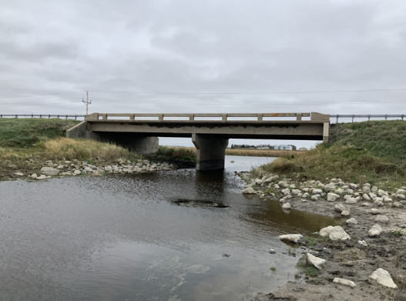


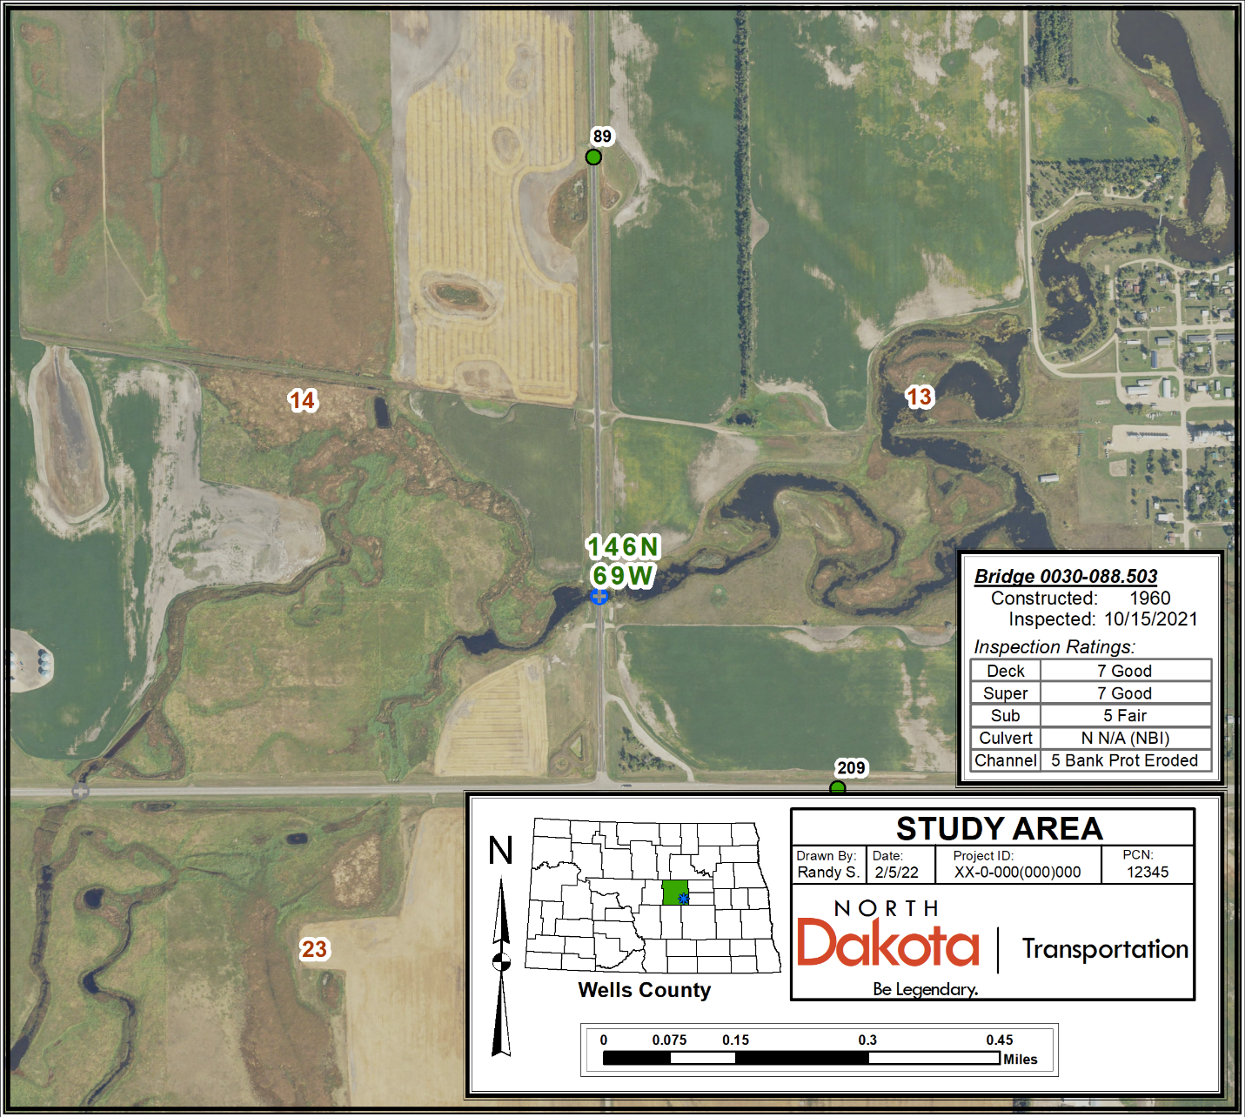
RRVW Railroad (abandoned)
Structure 0030-088.503
2-span 65’x30’ Concrete T-Beam Bridge
52
Sykeston
Pipestem Creek
30
Figure _: Project Location Map

Project Construction History
The existing (enter structure description) was constructed in ____. The structure was (rehabilitated, widened, extended, etc) in ____ (delete as applicable).
The structure ID of the existing structure is ####-###.###. The structure ID of the proposed structure is ####-###.###. The existing structure ID will be used for the remainder of the report.
Indicate what the existing structure ID number is and what the new structure ID number will be after approval by Bridge Management Section (refer to New Bridge ID Template spreadsheet on NDDOT References & Forms Page). Note the existing structure’s construction year and briefly discuss construction and maintenance history.

Existing Conditions
The existing structure has a measured minimum vertical clearance of __ feet and a clear roadway width of __ feet (delete as applicable). The structure was last inspected in ____. At the time, the (delete following items as applicable) culvert was assigned a condition rating of _ (enter code description, i.e. good/fair/poor/etc condition), the bridge deck was assigned a condition rating of _ (___ condition), the superstructure was assigned a condition rating of _ (___ condition), and the substructure was assigned a condition rating of _ (___ condition). The channel was assigned a condition rating of _ (___ condition). Defects noted on the structure at the time included ___. A chaining survey was completed ____ and recorded to have ___% delamination (delete as applicable).

Skew: _ degrees
Current ADT (year) = (enter current ADT)
Future ADT (year) = (enter forecast ADT)

Fill out the appropriate table below:

Table _ – Structure Inventory (for existing bridges)
Structure No. | Crossing | Size | Year Built | Condition Ratings
 |  |  |  | Deck | Super | Sub | Channel
####-###.### | Feature Intersected (e.g. Pipestem Creek) | L’ x W’ (Insert Bridge Description) | #### | # | # | # | #

OR:

Table _ – Structure Inventory (for existing culverts)
Structure No. | Crossing | Size | Year Built | Condition Ratings
 |  |  |  | Culvert | Channel
####-###.### | Feature Intersected (e.g. Pipestem Creek) | Span’ x Rise’ x L’ or  Diameter’ x L’  (Insert Culvert Description) | #### | # | #

Specify existing structure details including type, size, location, skew, year built, waterway opening, condition ratings, AADT, etc. Make note of any observed scour or any other critical deficiencies.

Hydrology & Hydraulics

Flood Frequency Discharges
(ArcGIS, QGIS, etc) software was utilized to map the contributing drainage area using (topographic maps, LiDAR elevation data, etc). The drainage area for this structure was determined to be approximately ___ square miles with a stream gradient of ___ feet per mile and is located in Hydrologic Zone _. A map of the drainage area is provided in the appendix. Peak flood frequency discharge values were determined in accordance with USGS Scientific Investigations Report 2015-5096. The calculated results at the structure using the 2015 Regression Equations are shown below in Figure _. (Note that for ungaged sites on a gaged stream that has 10 or more years of peak-flow record, an area-weighted equation may be used as an alternative to the Regression Equations for an improved estimate)
Include brief description of drainage area size, stream gradient, Hydrologic Zone, roadway classification, and corresponding design flood frequency event. Include table of flood frequency discharge values (example utilizing 2015 Regression Equations provided below) and map of drainage area in appendix.

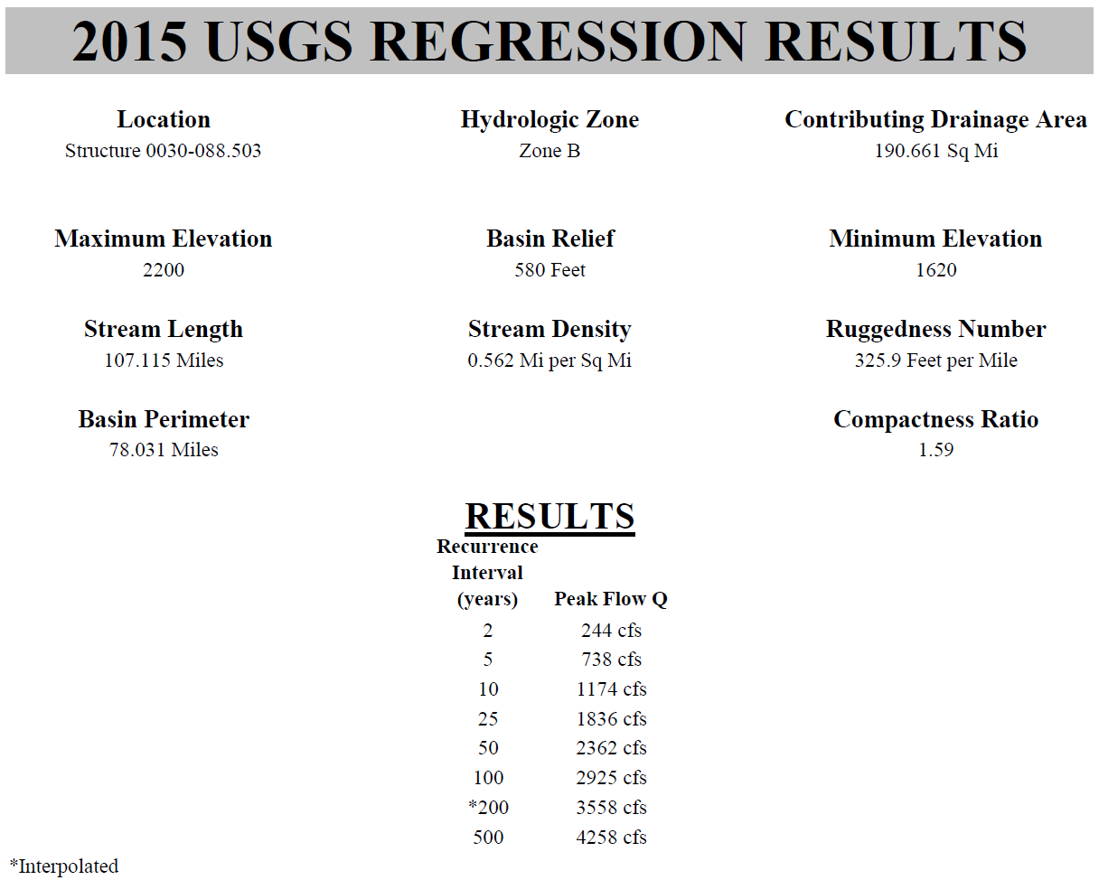
Figure _: USGS Regression Peak Discharges

Minimum Flood Frequency
As per Article 89-14 of the North Dakota Administration Code (ND Stream Crossing Standards), based on the functional classification of (insert classification) for Highway ##, a ##-year minimum design flood frequency was used for this analysis. The minimum design flood frequency requirements as stated by ND Administrative Code 89-14 are shown below in Figure _.

Figure _: Minimum Design Flood Frequency

Site Conditions
The (drain, creek, river)’s watershed is situated in a (rural, urban, etc) area comprised of (insert description of contributing watershed, e.g. primarily cultivated land with some pastureland and numerous trees interspersed throughout). The stream channel for the (drain, creek, river) has a (insert description of stream slope, e.g. relatively mild, steep, etc) stream gradient.

Describe the project site conditions and any special circumstances (upstream/downstream drainage structures, dams, levees, erosion, scour, sedimentation, channel changes, protected lands, residential structures, etc). Provide additional exhibits of unique features as figures or in appendix if necessary.

Floodplain/Floodway/Permitting
According to the FEMA Flood Map Service Center, Structure XXXX-XXX.XXX is situated within FEMA Flood Hazard Zone _, which is classified as the (enter FEMA zone description, i.e. Area of Minimal Flood Hazard, 100-yr Floodplain, etc). Therefore, a (Floodplain Authorization, Floodway Permit, etc) will/will not be required due to the proposed structure work. A USACE 404 Permit may be required if the proposed work results in impacts to jurisdictional wetlands or other waters. Include the following only if waterway is classified as Sovereign Lands: The (insert waterway name) is included in the State Navigable Waters list, and any proposed activities below the Ordinary High Water Elevation will require a Sovereign Lands Permit.

Note if the project is located within or discharges into a floodplain/floodway. Discuss any permit requirements and include an exhibit of the FIRM map in the appendix.

Structure Selection

Project Strategy/Scope of Work
Project XX-0-000(000)000 is currently scheduled for a MM/DD/YY project completion date and has a listed bid opening date of MM/DD/YY. The project is expected to be constructed during the (enter year(s) of anticipated construction) construction season(s). The scope of work for the project includes (structure replacement/structure rehabilitation, reconstruction of a portion of the highway, etc).
Discuss project’s scope of work and strategy. Note any special circumstances related to the project that may affect the structure selection (e.g. addition of pedestrian lane on a bridge, incorporating wildlife crossing under a bridge, etc).

Hydraulic Modeling
A 2D Hydraulic Model was created using (list software used and version number, e.g. Aquaveo’s Surface-water Modeling System (SMS) version 13.3 or USACE’s HEC-RAS version 6.4.1, and provide a brief summary of the software utilized). The software was used to prepare a 2D hydraulic model to simulate flow conditions for the existing structure(s) and _ proposed structure alternatives. The 2D model allowed for creation of mesh surfaces with hydraulic computations at individual mesh elements, offering a more detailed analysis compared to 1D models, which are constrained to calculations along cross-sections.
The boundary limits of the model are shown in Figure _ below and extend approximately ____ feet upstream and ____ feet downstream of the existing structure crossing. (List source of land elevations used in model, e.g. topographic survey conducted by NDDOT, LiDAR observations obtained from the NDDWR, etc) were used to determine the land elevations within the model limits. At the channel, (cross-sectional data, bathymetric survey collected by NDDOT, etc) were utilized to depict the underwater topography within the model. A mesh surface was generated using (HEC-RAS 2D, SMS, etc) to represent ground elevations within the model as distinct mesh elements. The spacing of mesh elements near the structure and other crucial features typically ranged from a minimum of _ feet to a maximum of _ feet. In less critical areas where flow conveyance was not expected, a coarser mesh element spacing of up to _ feet was employed. The total number of mesh elements for the model varied from _ to _ elements across the meshes between the existing structure and the proposed structure alternatives.
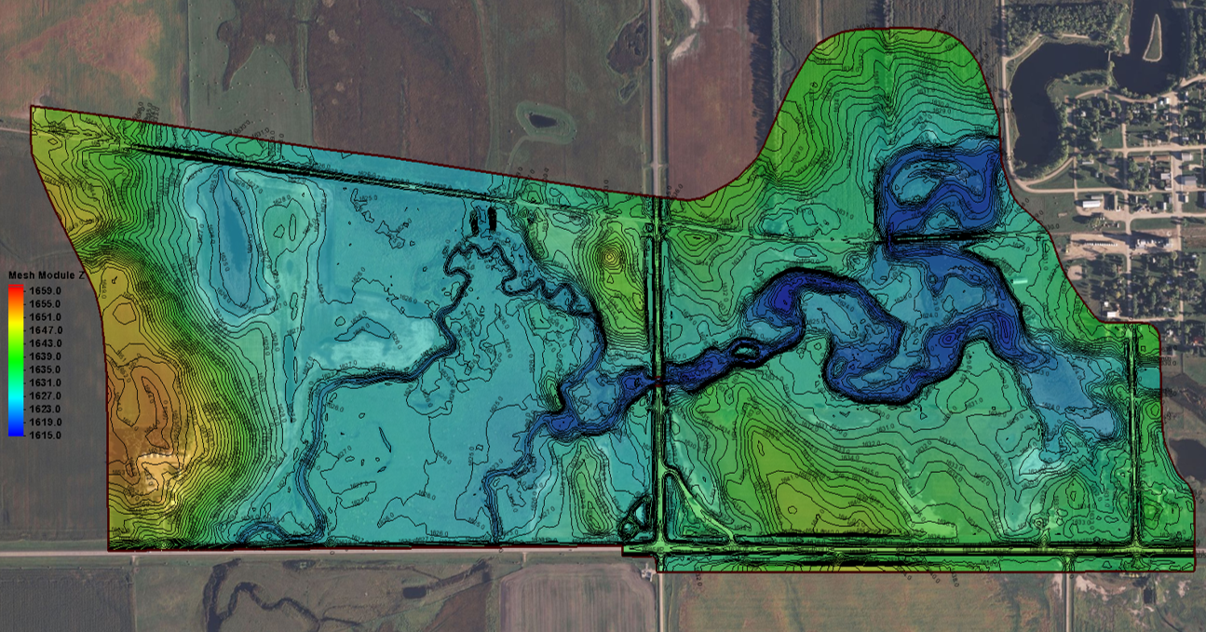
Outflow
Inflow
Inflow
Inflow
Abandoned RR Embankment
Structure 0030-088.503
30’x65’ Cont. Conc. Bridge

Figure _: SMS Model Domain Boundary

Peak flow discharges were entered as simulated inflows into the 2D model, with simulations evaluated for the existing structure(s) and the proposed structure alternatives across the (list flood events evaluated, e.g. the 10-year, 25-year, 50-year, 100-year, 200-year, and 500-year flood events). A _ second time step was used for the simulations and the simulations were analyzed using a total run time of _ to _ hours to reach steady state conditions. Results of these simulations are included in the appendices and include (add or remove the following items as applicable: graphical representation of the flooding extents at each recurrence interval, mesh terrain, mesh quality, contours, and materials/monitor coverage plots; water surface/velocity profiles, and model observation lines at critical locations within the model domain).
Provide brief description of hydraulic modeling software and version used. Specify simulation run times, time steps, mesh element size, number of mesh elements. Describe unique modeling circumstances and provide exhibit of model domain limits in Figure below. Briefly describe topographic/bathymetric survey conducted upstream and downstream of the structure crossing for modeling purposes.

Alternatives Considered
(Insert Number of Alternatives) proposed structure alternatives were modeled in consideration for replacement of the existing structure.
If applicable, list any proposed structure alternatives which were previously considered but were later discarded (e.g. bridge alternative would require grade raise and increase risk of flooding to an upstream building, inadequate cover for aluminum box culvert alternative, etc) and reasons for their exclusion from further hydraulic analysis here. If not applicable, this paragraph may be deleted.
List each modeled alternative and provide details on the alternative. Details may include: number of spans/barrels, length & width dimensions of structure, skew, inverts, Manning’s n values at the structure, culvert sinking requirements, wildlife crossings, girder depths, horizontal/vertical clearance provided (for bridges), grade raise/profile adjustments, guardrail requirements, etc.
The proposed structure alternatives were modeled and analyzed in accordance with the ND Stream Crossing Standards. Summarize the simulation results, including discussion on calculated headwater elevations, freeboard provided at the design and 100-year discharges (for bridges), design velocities at the structure, and overtopping discharges. Discuss whether the proposed structure alternative creates any increased risk of flooding of any upstream buildings/structures. A summary of the simulation data for the (insert flood events evaluated in model, e.g. 10-year, 50-year, 100-year, and 500-year flood events), which includes the observed discharge through the structure, upstream water surface elevations, and velocities through the structure, is provided below in Table _.
Table _ – Alternative 1 Simulation Results (include additional tables for multiple alternatives)
Event | Total Discharge (cfs) | Existing |  |  | Alternative 1
 |  | Discharge thru Structure (cfs) | Upstream WSE (ft) | Avg Vel thru Structure (cfs) | Discharge thru Structure (cfs) | Upstream WSE (ft) | Avg Vel thru Structure (cfs)
10-yr | - | - | - | - | - | - | -
50-yr | - | - | - | - | - | - | -
100-yr | - | - | - | - | - | - | -
500-yr | - | - | - | - | - | - | -

The estimated cost the proposed structure alternative(s) is shown below in Table _ – Cost Estimate. (Indicate whether the estimated costs includes any incidental items such as riprap, guardrail, embankment or if the proposed estimate is solely for the cost of the replacement structure)
Table _ – Cost Estimate
Alternative Number and Size | Estimated Structure Cost
Alternative #1 – 2-span, _’x_’ Steel Stringer Bridge | $###,###
Alternative #2 – Quad _’ x _’ x _’ RCB | $###,###
Alternative #3 – Dbl _’ x _’ x _’ Aluminum Box Culvert | $###,###

Summary of Recommendations
Based on the information above, it is recommended that Alternative _, a (enter structure description), be selected as the replacement alternative. A layout of the proposed structure and a water surface profile plot of the existing structure and the proposed alternative are shown below in Figures _ and _.
Document the selected alternative with supporting justification. Discuss requirements for the selected alternative (inverts, wingwall type, countersinking/end-slope requirements, wildlife crossings, etc). For proposed bridge alternatives, note the design velocity through the bridge (typically <5 ft/s) and freeboard provided at the design and 100-yr discharge events. For proposed culvert alternatives, note the design outlet velocity (typically <10 ft/s) and whether the box culvert satisfies allowable headwater requirements noted in the ND Stream Crossing Standards. Provide a layout view of the proposed alternative and a WSE plot comparing the existing structure and the chosen alternative.
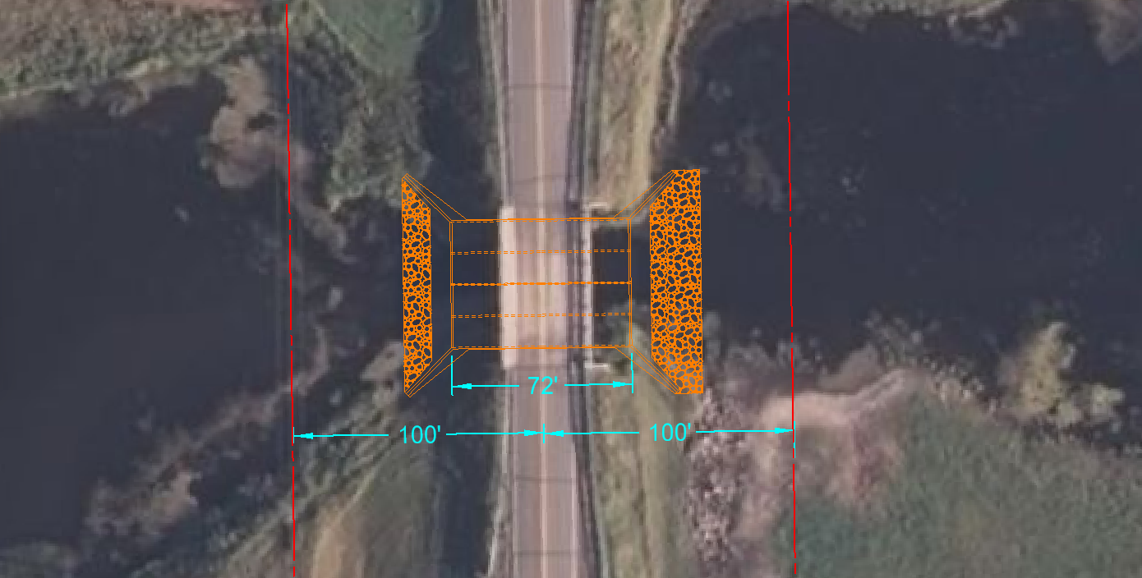
Quad 12’ x 12’ x 72’ RCB
Pipestem Creek
30
Figure _: Proposed Structure Layout (Box Culvert)

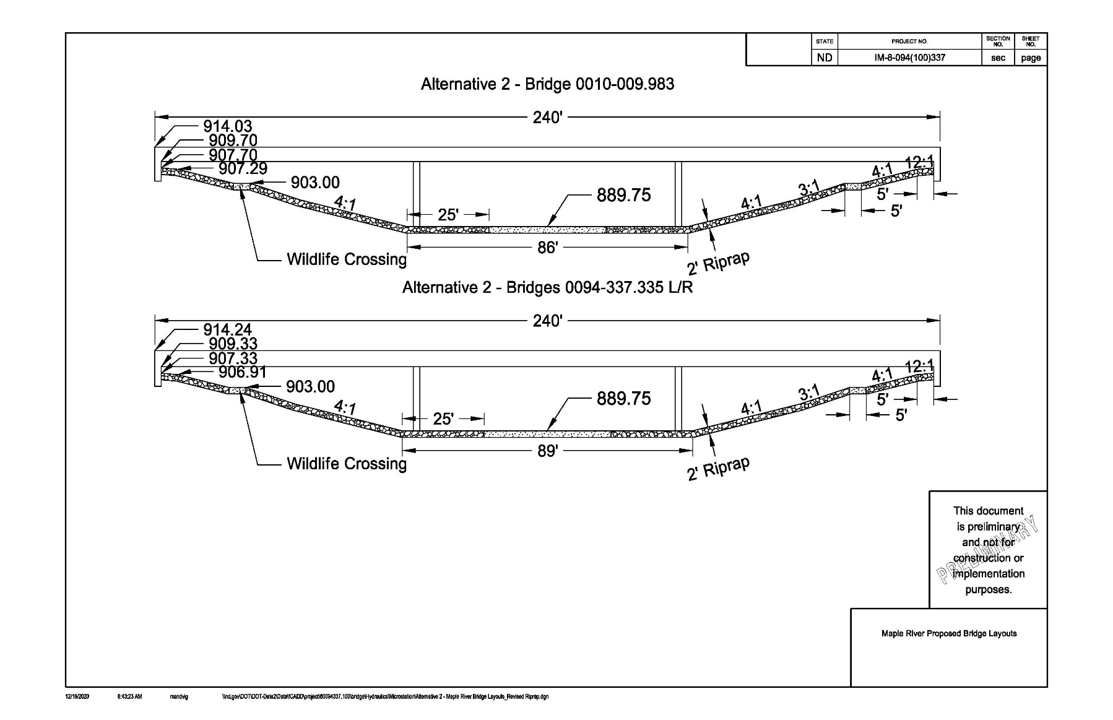
Figure _: Proposed Structure Layout (Bridge)

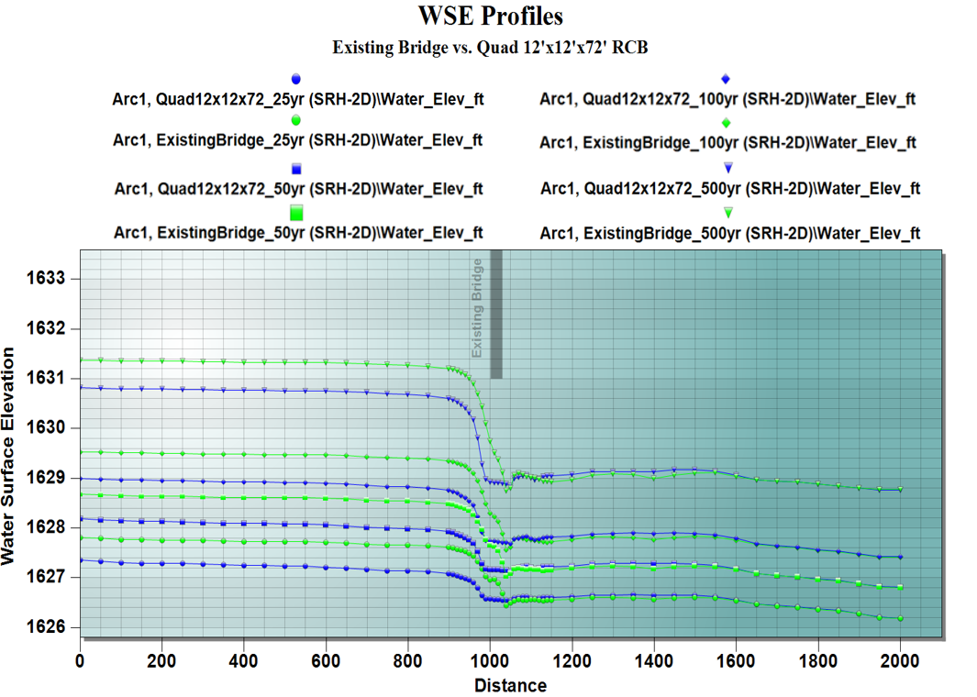
Figure _: Water Surface Elevation Comparison

Channel Excavation/Construction Impacts (if applicable)
The proposed structure opening is expected to be broader than the current channel bottom. Therefore, it is anticipated that there will be a need for channel excavation to transition from the existing channel bottom to the opening of the proposed structure. A layout is provided below in Figure _.
Describe necessary construction requirements and unique grading situations to accommodate the recommended structure alternative. Provide an exhibit of proposed structure layout with channel impacts as necessary. Ensure construction requirements described in Hydraulic Report are documented in the final design plans with clear instruction using plan notes, sheets, cross sections, etc.
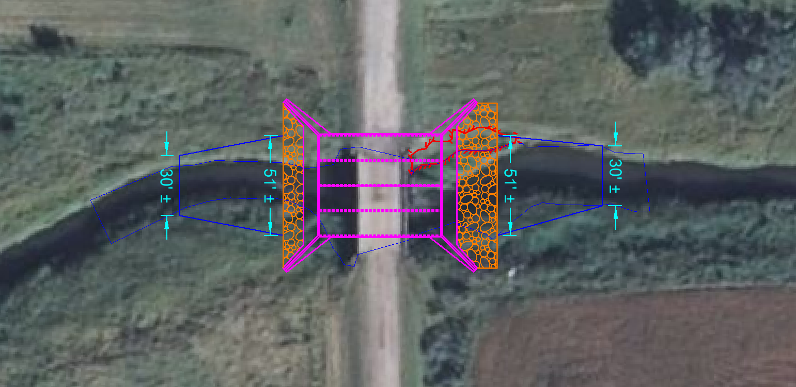
153rd Ave SE
Elm River
Figure _: Channel Excavation

Scour Analysis
For Proposed Bridges:
Scour calculations were computed using (FHWA’s Hydraulic Toolbox software, HEC-18 equations, etc) for each of the bridge alternatives. Calculations for the calculated scour (and if applicable, documentation of existing observed scour/existing channel cross sections) are shown in the appendices. A summary of the scour calculations is shown below in Table _. The scour calculations were performed under the assumption that no scour countermeasures are in place.
Table _ - Estimated Scour, Alternative _
Flood Frequency * | Discharge (cfs) | Contraction Scour (ft) | Pier Scour (ft) | Abutment Scour (ft)
 |  |  |  | Left | Right
50-yr | - | - | - | - | -
100-yr | - | - | - | - | -
200-yr | - | - | - | - | -
*Refer to HEC-18 – Table 2.1 for guidance on recommended minimum scour design frequencies.

Based on the scour analysis for Alternative _, it is recommended that the proposed bridge have NBI Item 113 for Scour Critical Bridges coded as 8 (indicating the bridge is stable under assessed or calculated scour conditions) and SNBI Item B.AP.03 Scour Vulnerability coded as A (indicating the bridge is determined to be stable for scour). {The engineer will need to determine scour ratings for the bridge. After review, if the bridge does not have an NBI rating of 8 or SNBI rating of A, please replace with the appropriate rating and explanation. Any state structure will be required to be stable for scour.}
It is recommended that a _” layer of riprap on geosynthetic material be placed at the bridge to protect the channel and structure from possible scour. As per guidance from HEC-23, the riprap should cover the abutment endslopes and extend into the channel _’ from the toe of the endslope. This riprap should extend _’ upstream and downstream of the bridge along the channel, measured from the edge of the bridge. This riprap meets the minimum requirements of the pier scour envelope. A layout of the proposed riprap protection for Alternative _ is shown in Figure _.
Discuss any history of scour at the current structure, if applicable, and provide supporting documents in the appendices. Perform scour calculations for bridge alternates in accordance with Chapter V-02 of the NDDOT Design Manual and document results for contraction, pier, and abutment scour at design/critical flood events. Indicate software/methods used to calculate scour and include applicable scour input/output data, assumptions, and envelope plot exhibits in the appendices. Indicate the NBI Item 113 Rating for Scour Critical Bridges/SNBI Item B.AP.03 Scour Vulnerability Code. Describe applicable scour countermeasures as necessary.
For Proposed Culverts:
Scour calculations were not performed for the box culvert alternatives, as specified in Chapter V-02.07 of the NDDOT Design Manual. Energy dissipators for Alternative _ were designed using methodology provided in HEC-14. It is recommended that a _” layer of riprap be placed in the channel at the ends of the box culvert aprons for a distance of 10 feet upstream and _ feet downstream to protect the channel and structure from possible scour. Calculations for the proposed energy dissipator are shown in the appendices. A layout showing the proposed riprap/energy dissipator is shown in Figure _.
Discuss any history of scour at the existing structure, if applicable, and provide supporting documents in the appendices. Perform calculations for energy dissipator design at the proposed culvert outlet. If a riprap apron is to be used, it is generally recommended that riprap be installed for a distance of 10’ upstream of the culvert, while HEC-14 equations should be used to calculate the riprap length downstream of the structure.

Miscellaneous
A Type, Size, and Location (TS&L) meeting (was held on _ OR will be held prior to plan completion) to discuss the following items:
- Structure Selection & Location
- Riprap Requirements
- Utilities
- Disposal of Existing Structures
- Construction Phasing
- ROW Impacts
- Temporary Bypass/Detours
Indicate items planned for discussion at the TS&L meeting, or if the meeting has already taken place, document the date of the meeting and include discussion on items discussed.

Appendix A: Hydraulic Calculation Data
Include water surface profile plots shown along stream channel (within bathymetry survey extents) for all flood frequency events. Include plots for existing conditions and all alternatives considered.
Include upstream/downstream cross section plots for existing structure and all alternatives considered. Display all flood frequency events in cross section plots.
Include tabular data/software report printouts comparing critical hydraulic information (e.g. water surface elevations, flow velocities, etc) of the modeled alternatives along stream channel near area where structure is being replaced.

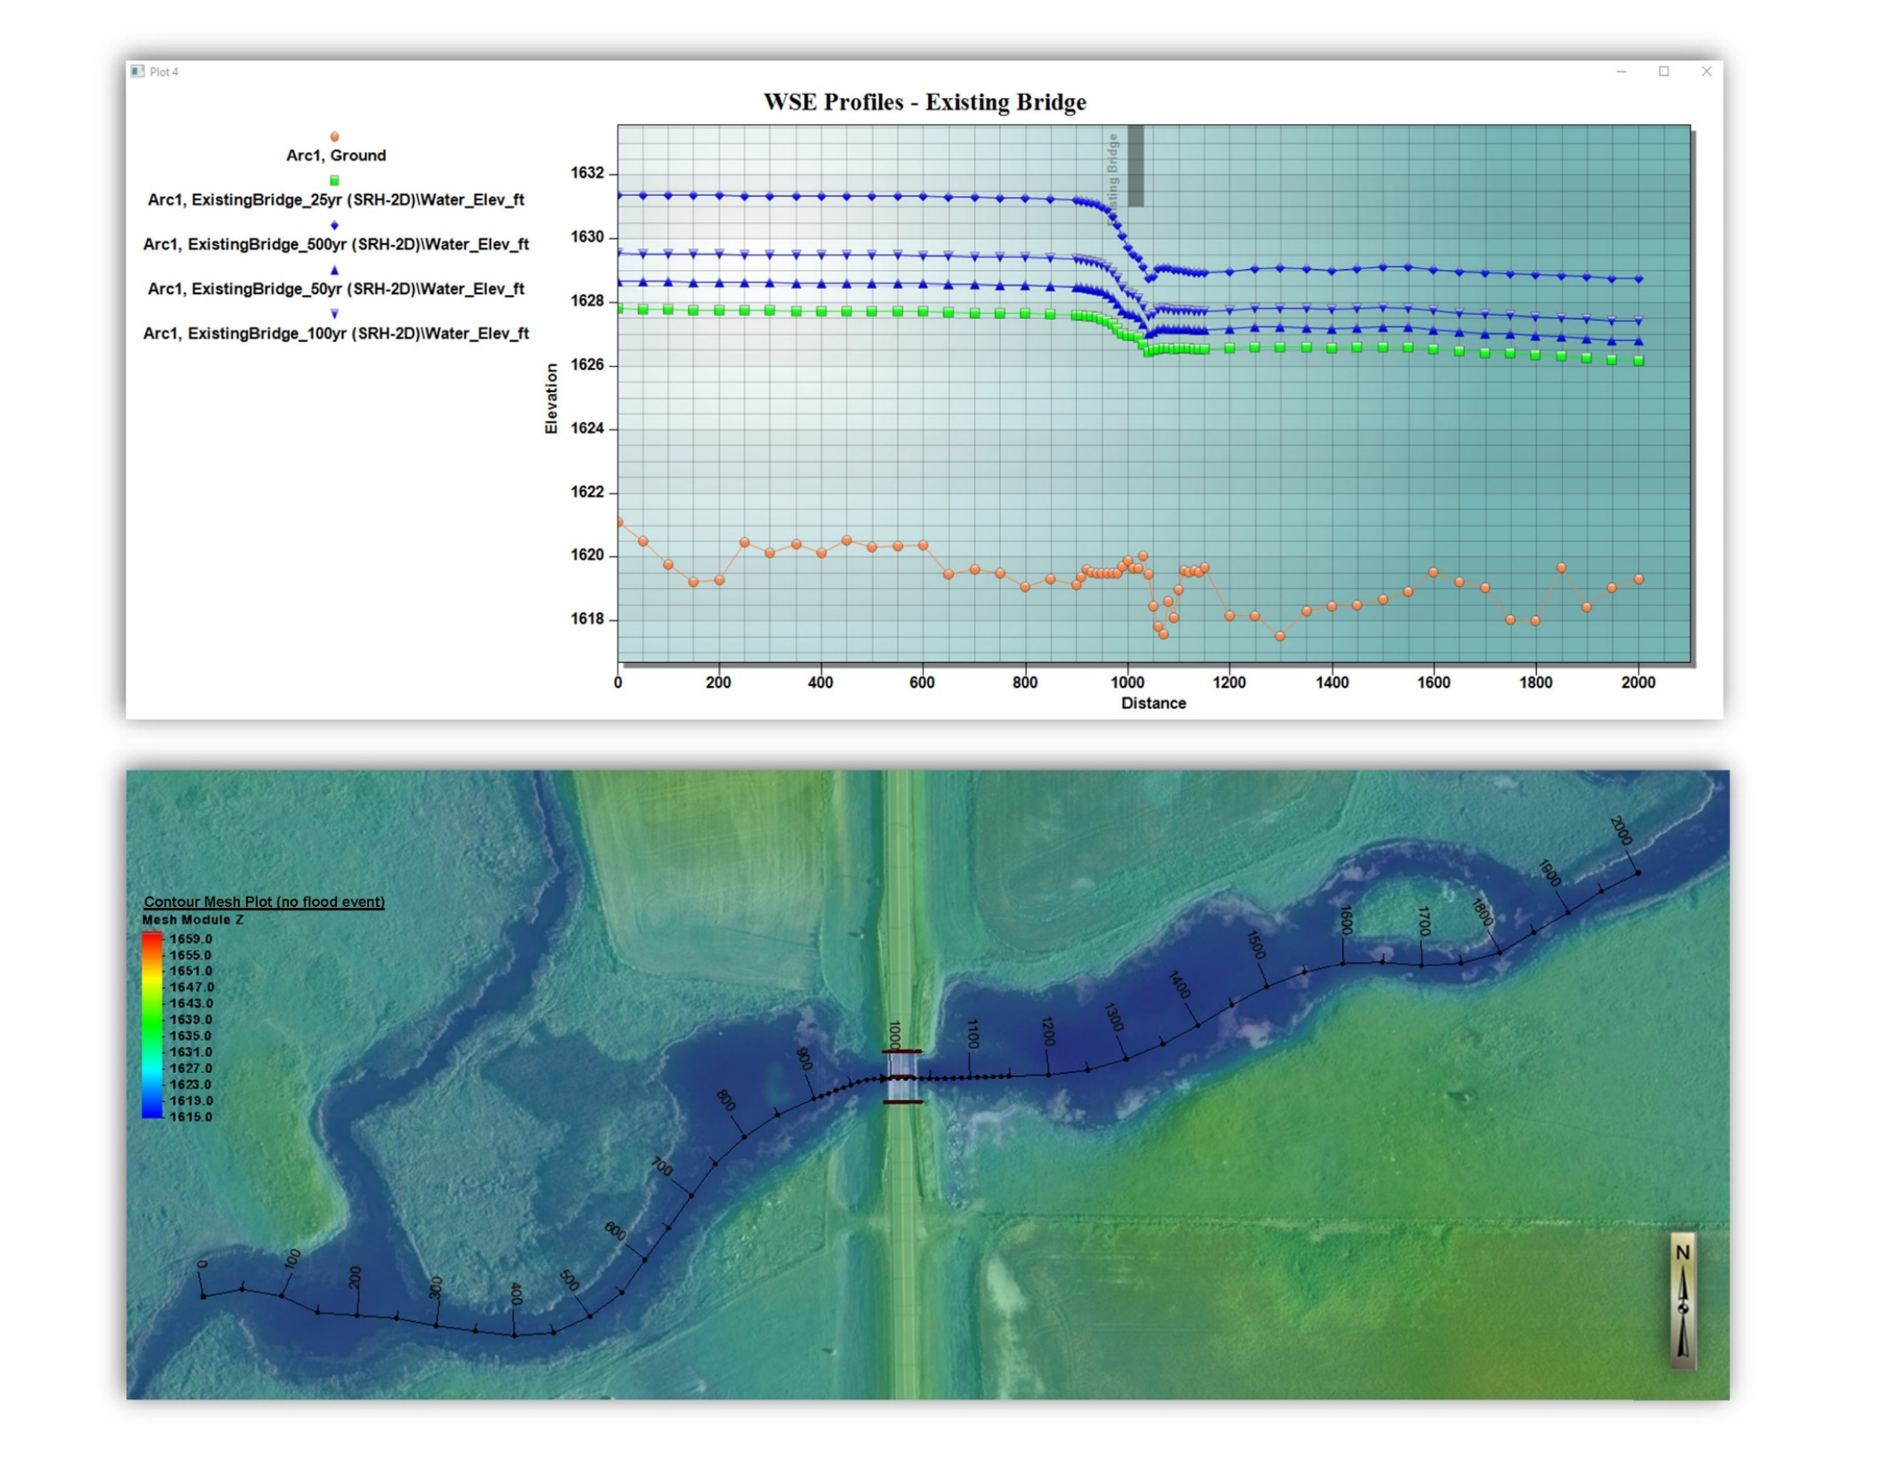
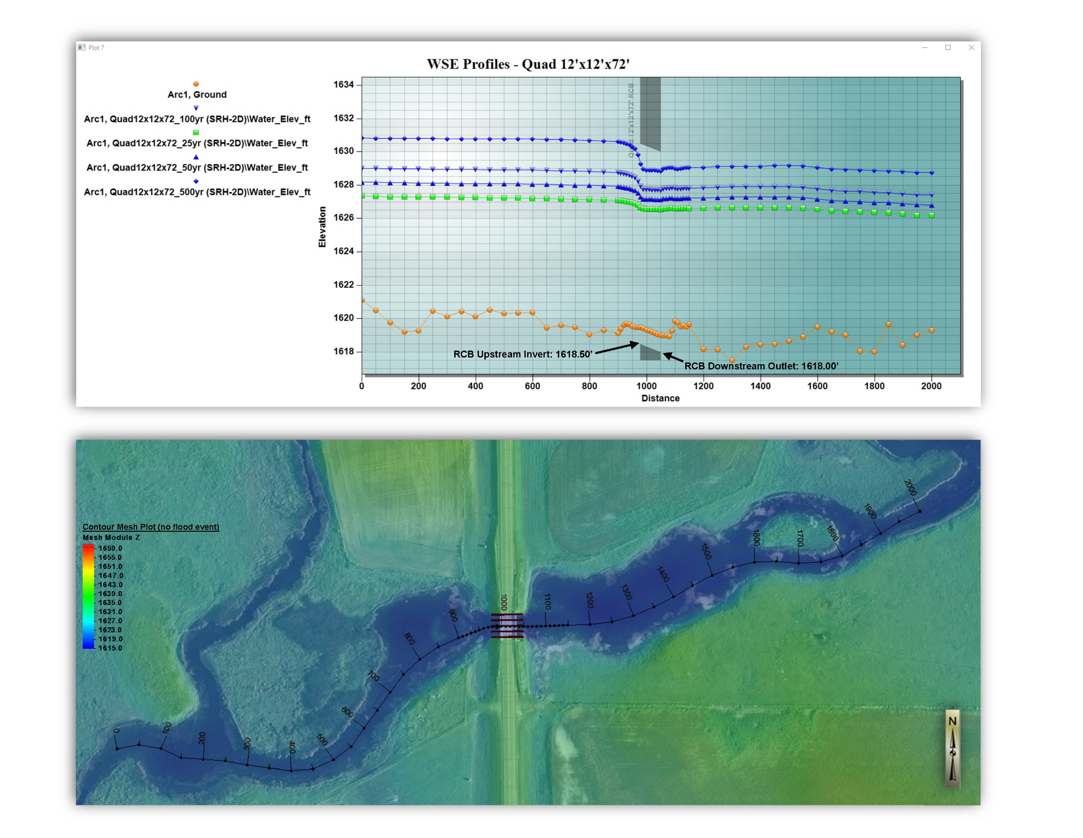
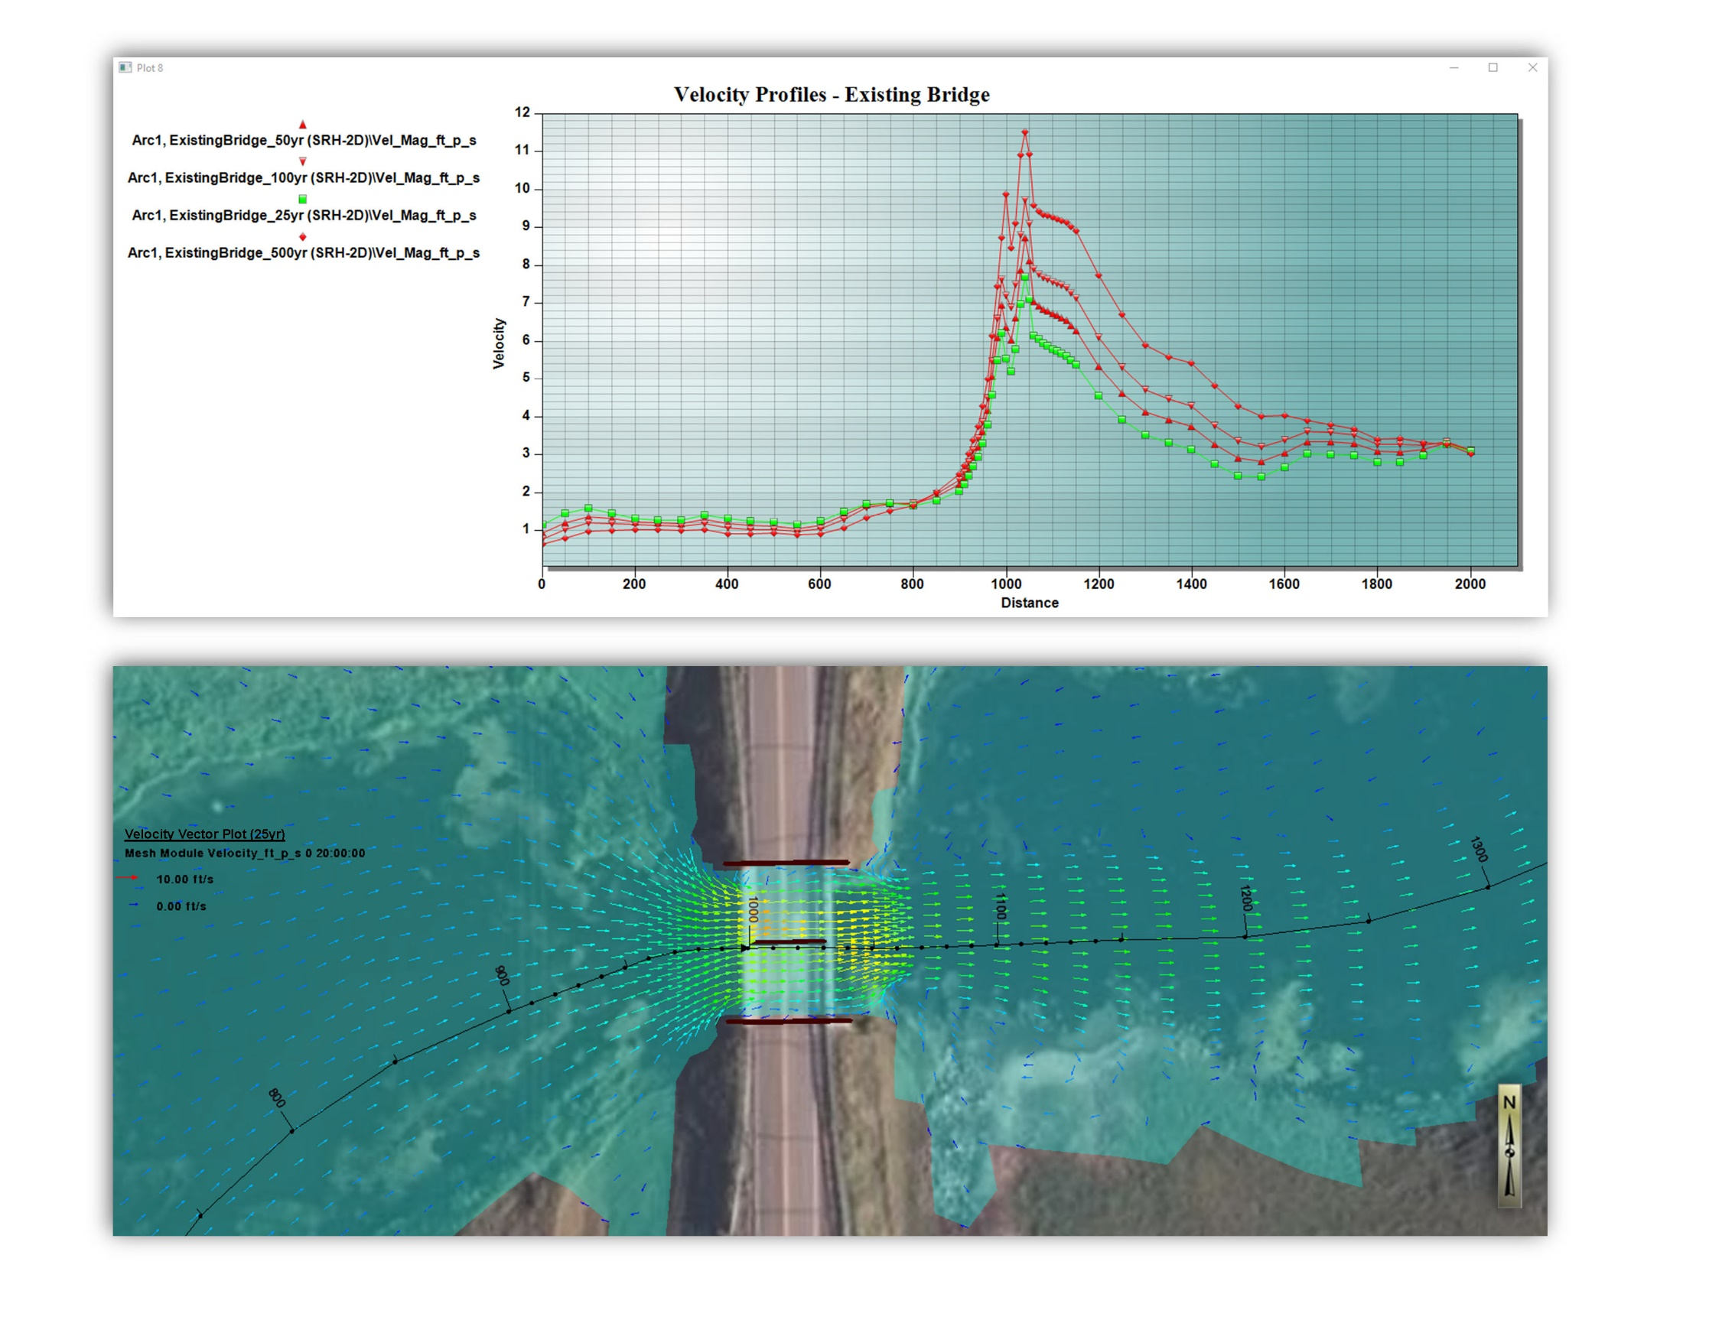
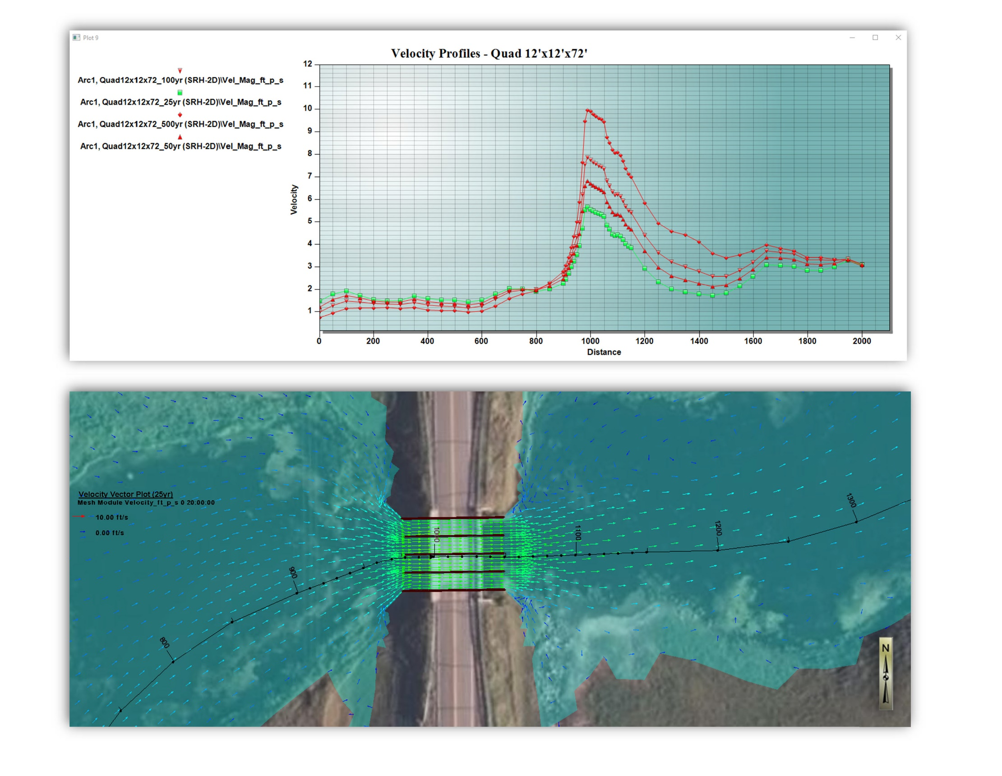

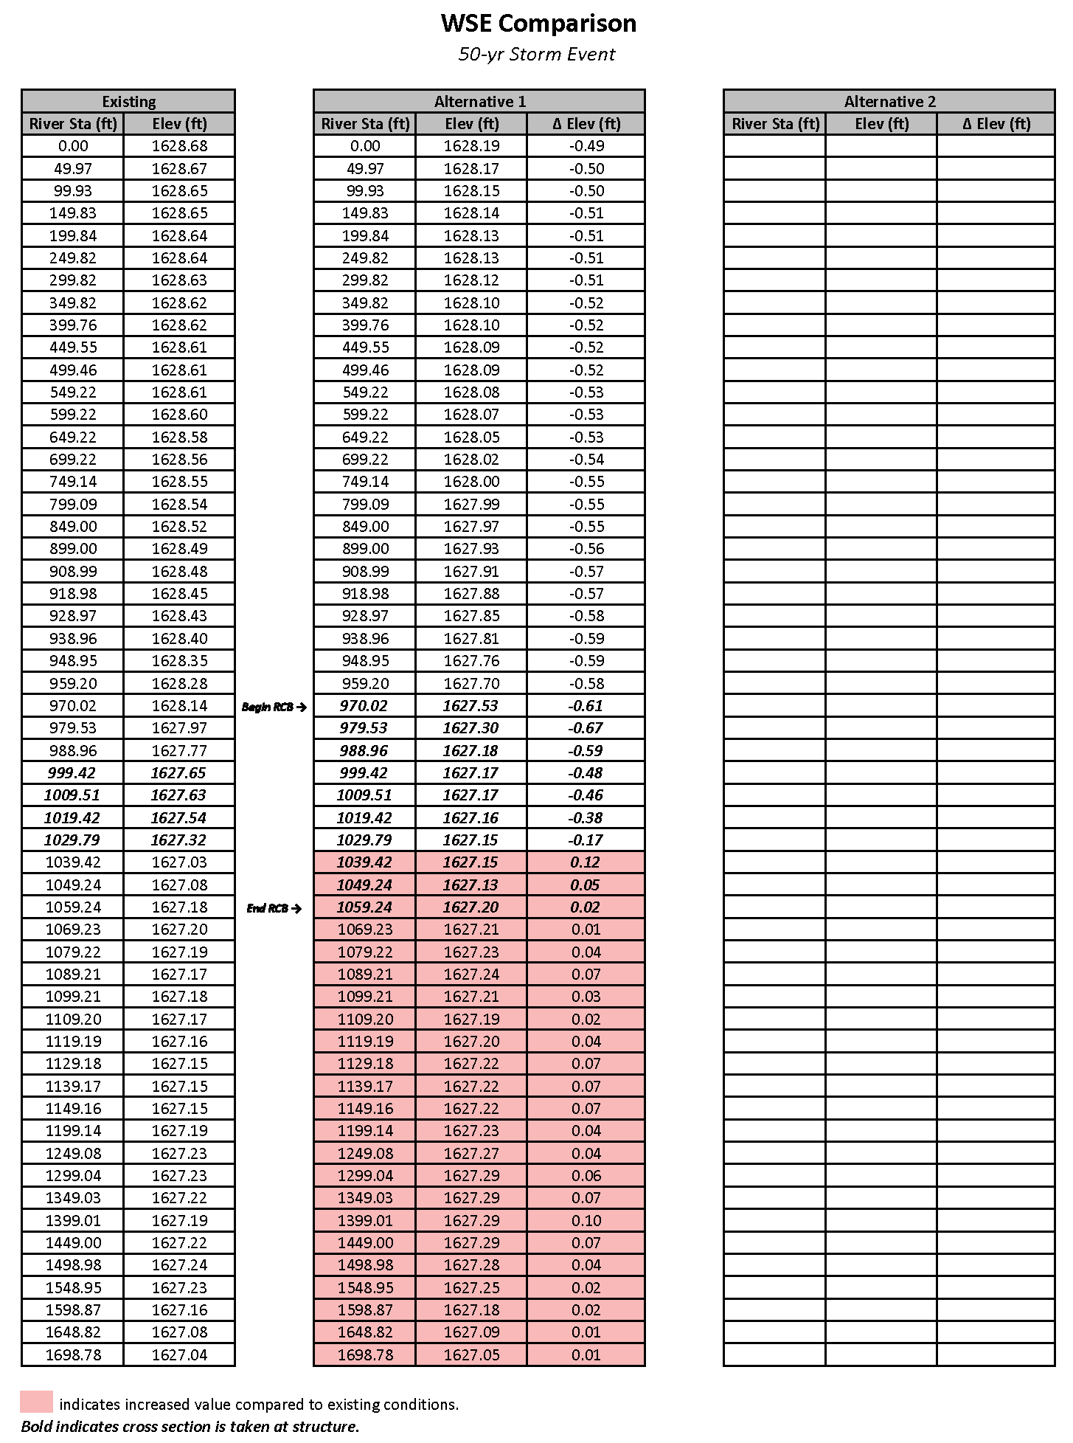
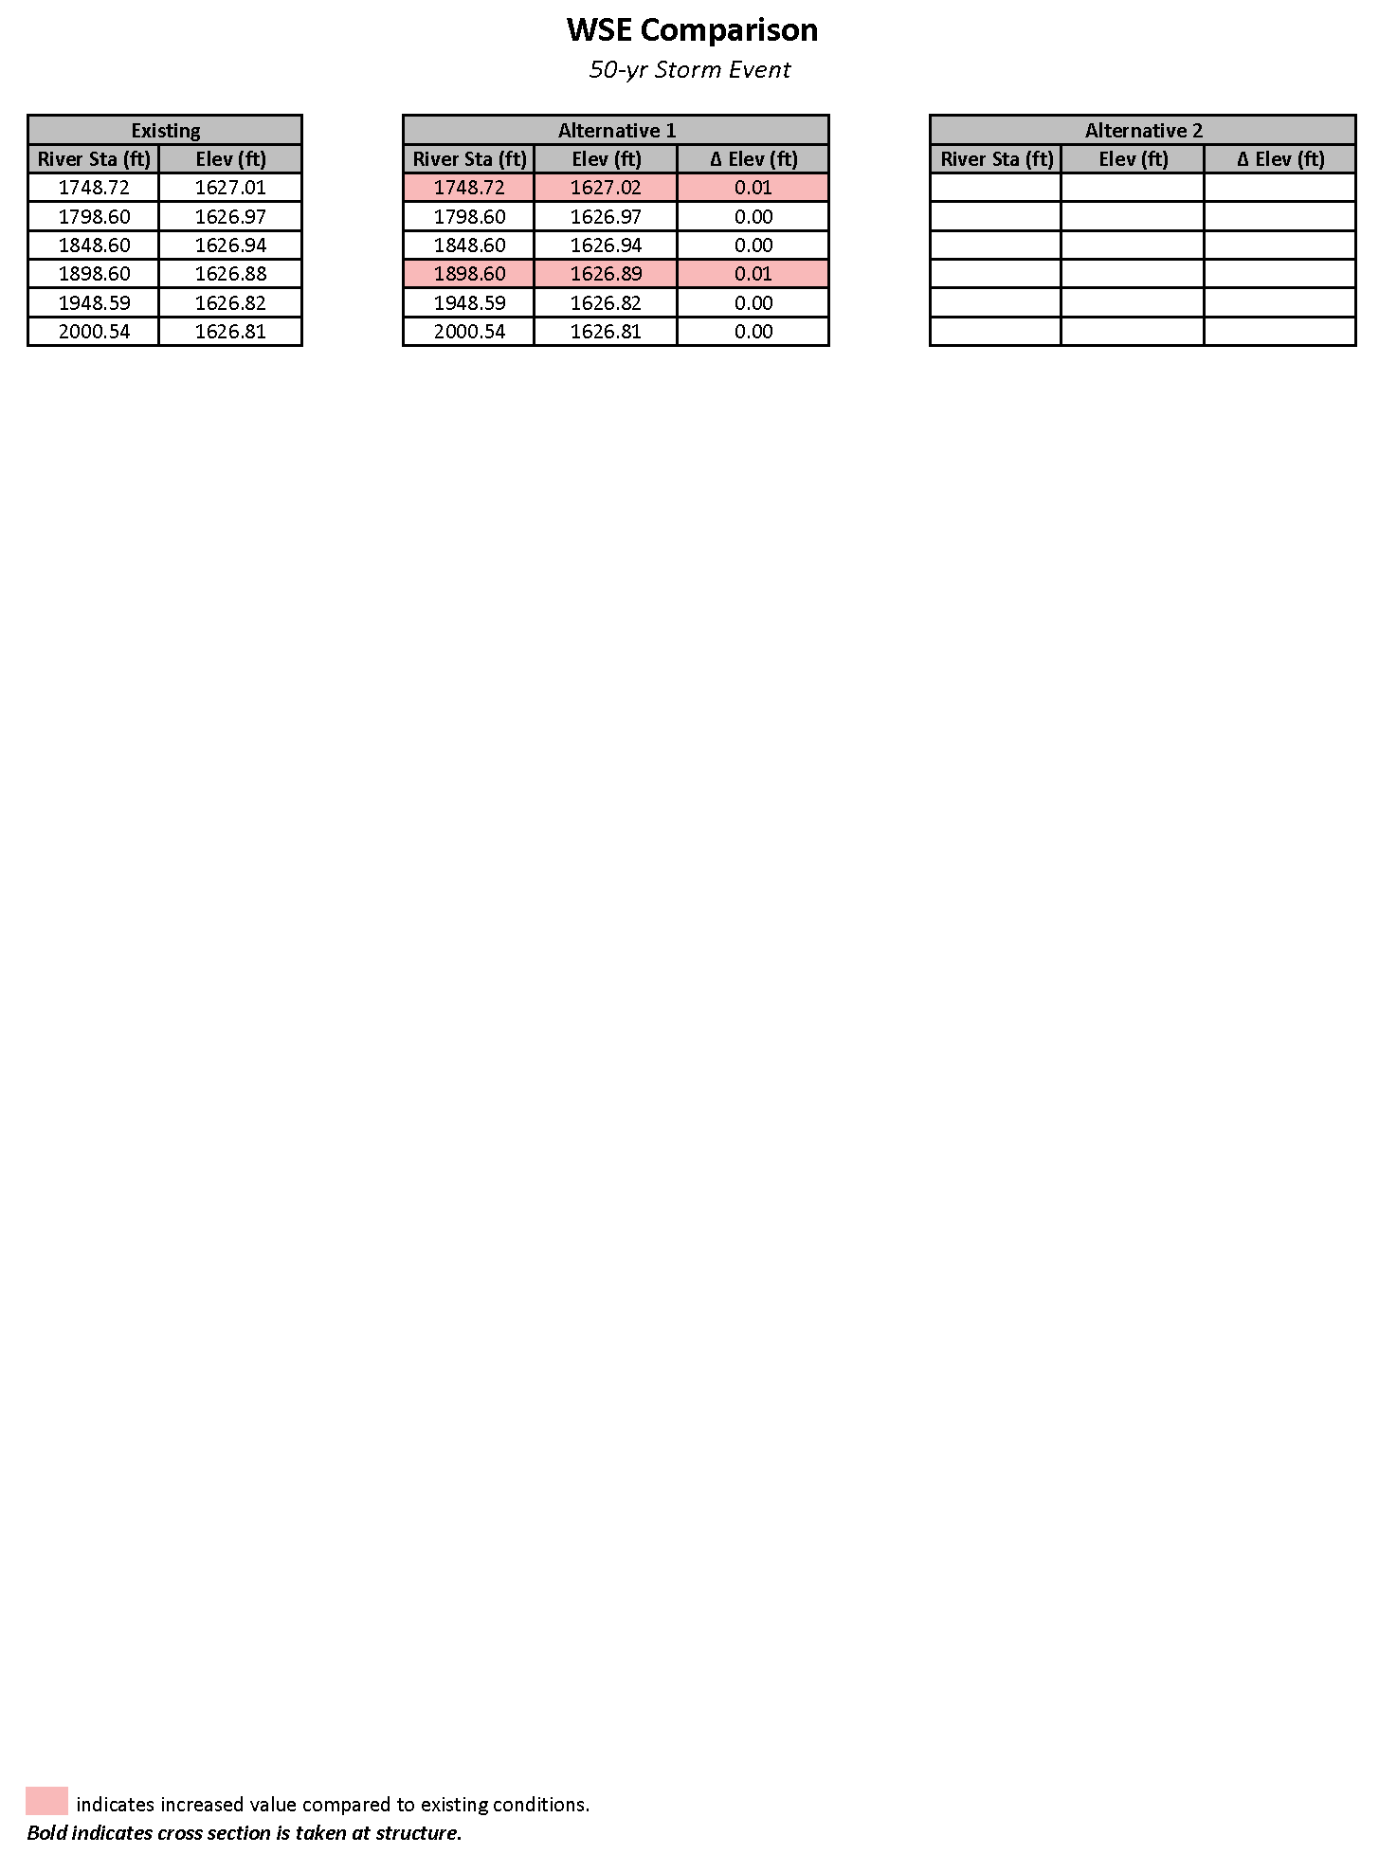
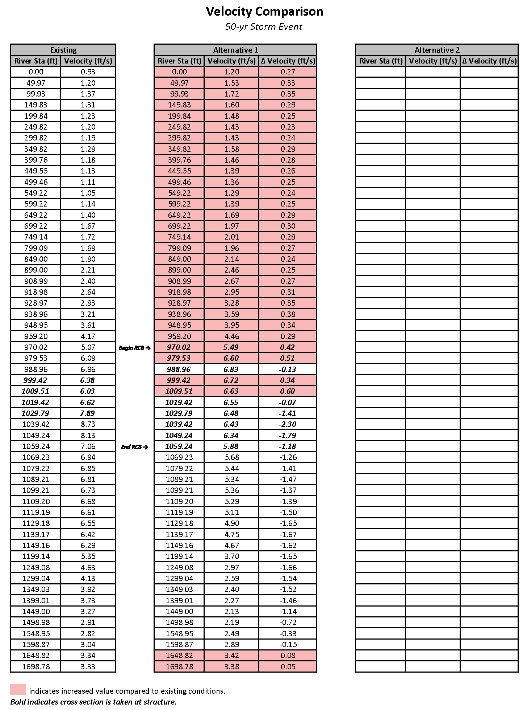


Appendix B: Estimated Flood Extents
Include plots/figures (as necessary) to display floodwater extents/comparisons between existing and proposed conditions for all modeled flood events. Indicate water surface elevation differences on exhibits at critical locations along stream channel/reach if necessary.
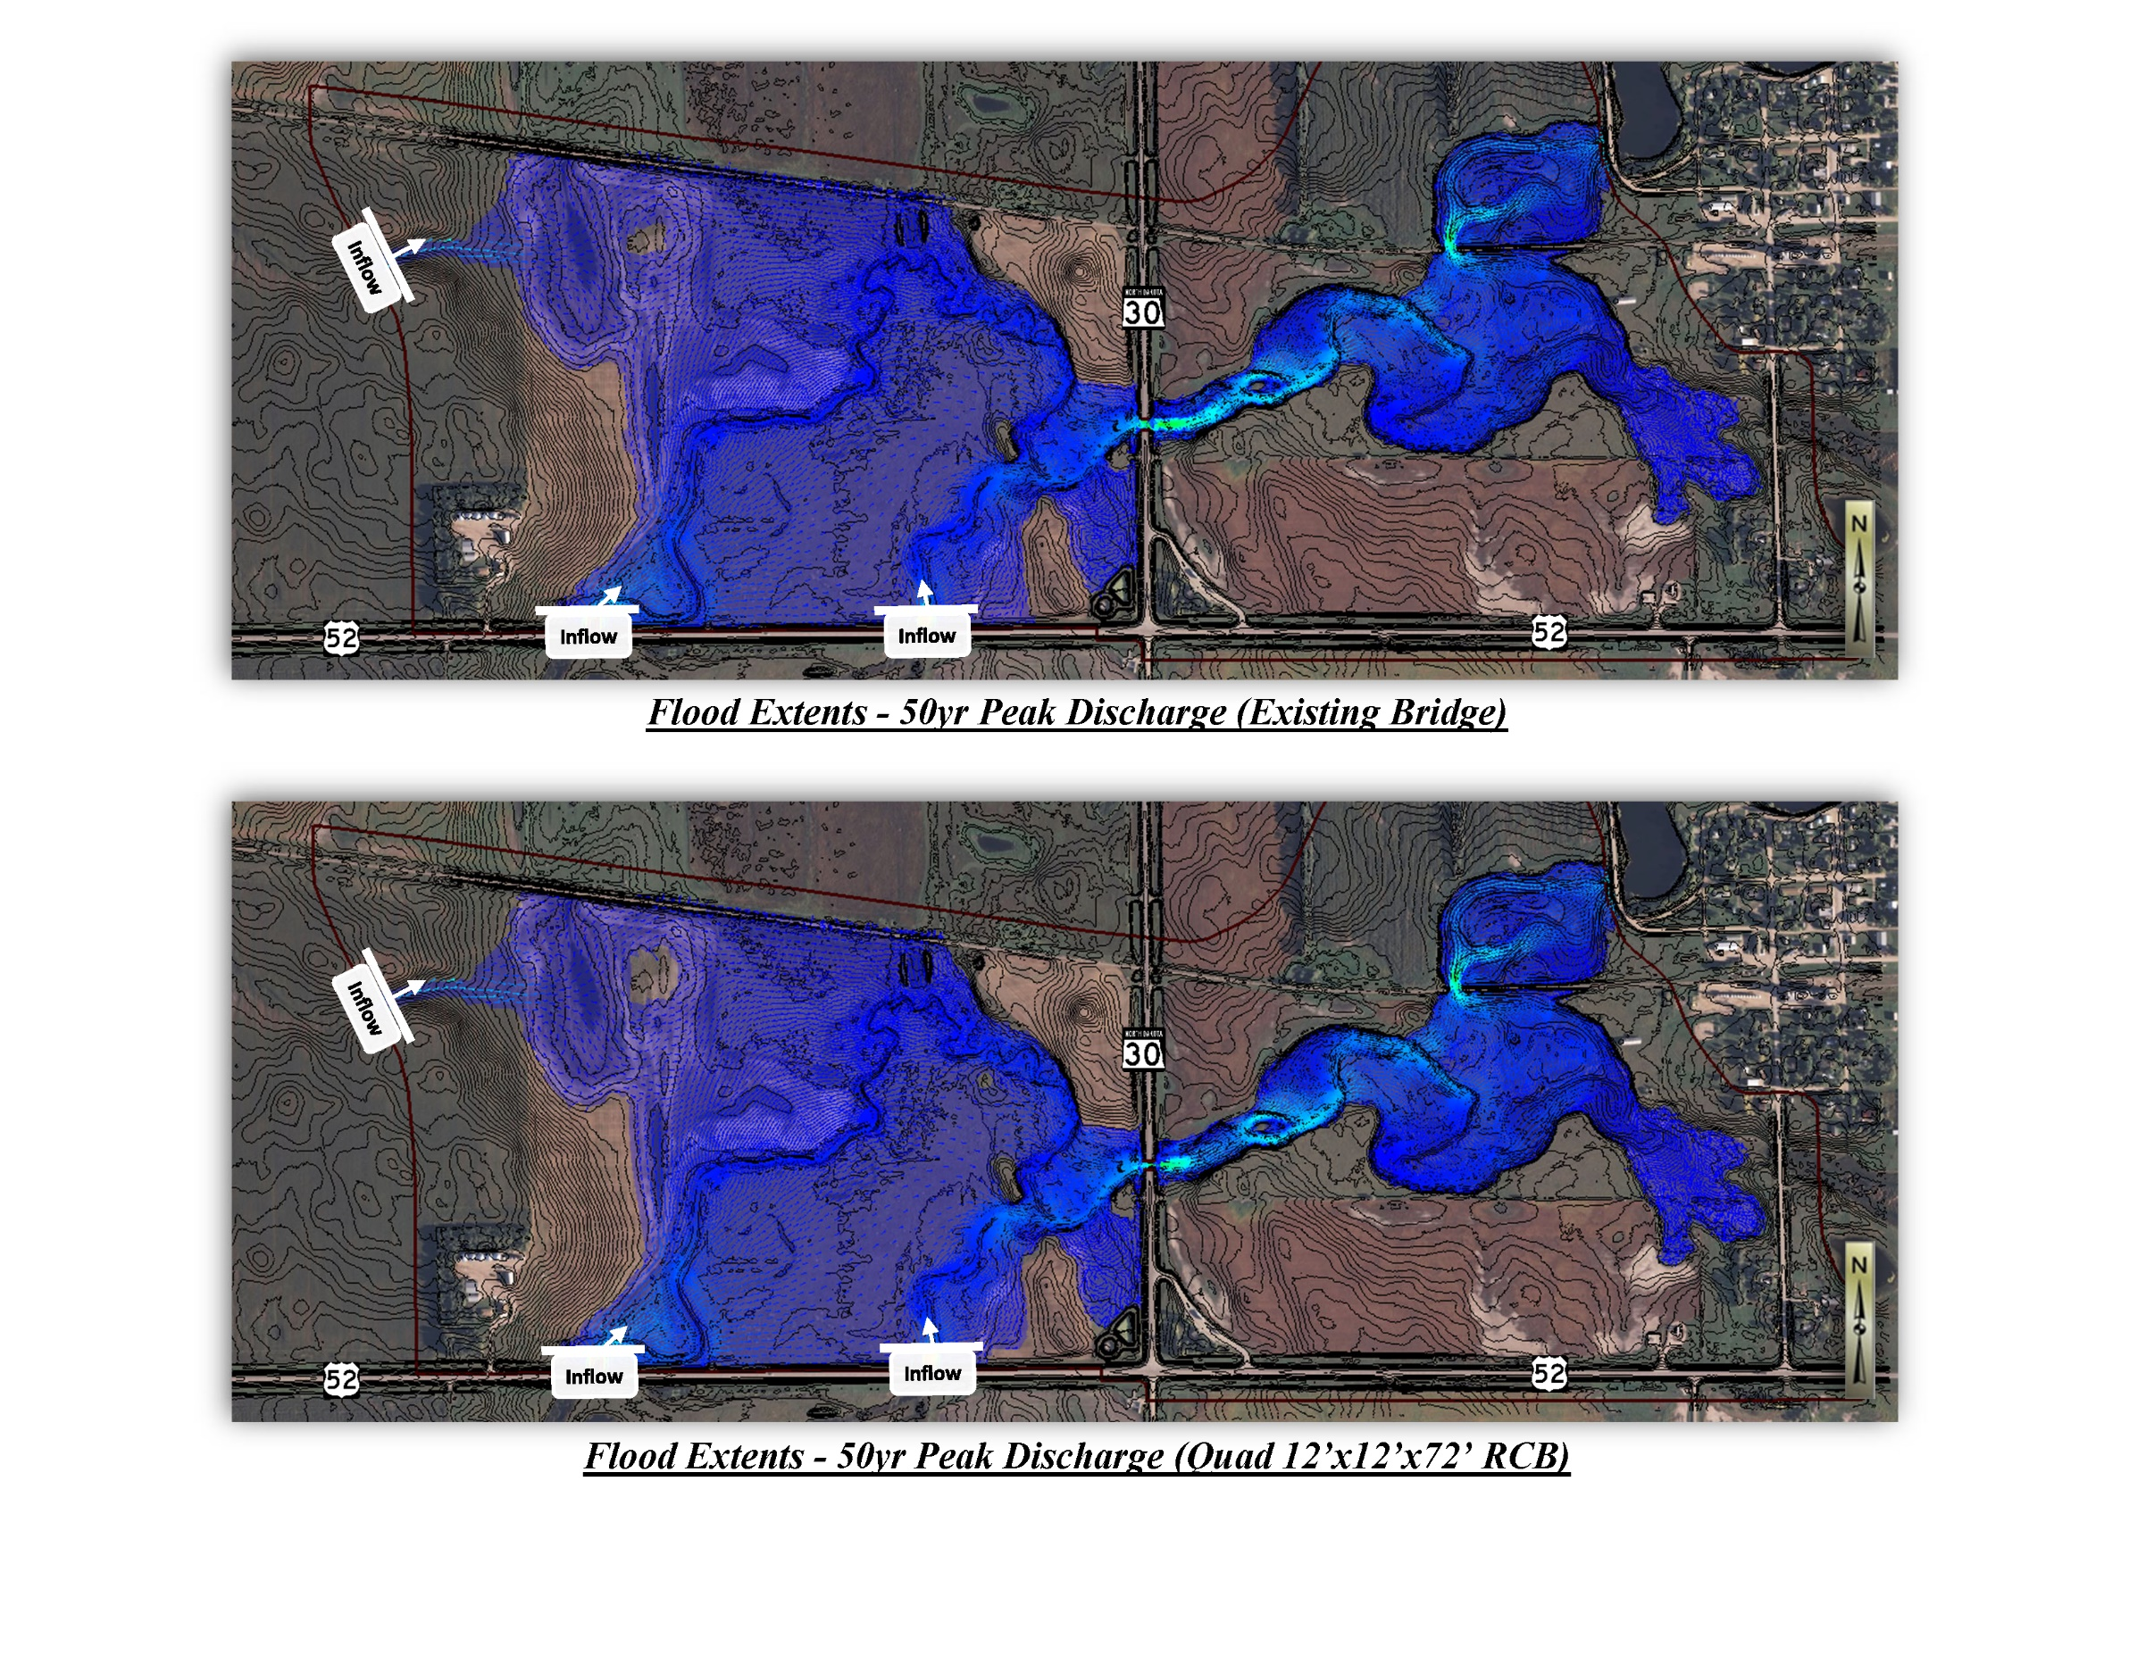

Appendix C: Miscellaneous Coverage Plots
Include miscellaneous coverage plots/exhibits as necessary for existing and selected alternatives (e.g. contour plot, mesh plot, mesh quality plot, materials coverage plot, monitor line profiles for WSE’s and net flow, etc).
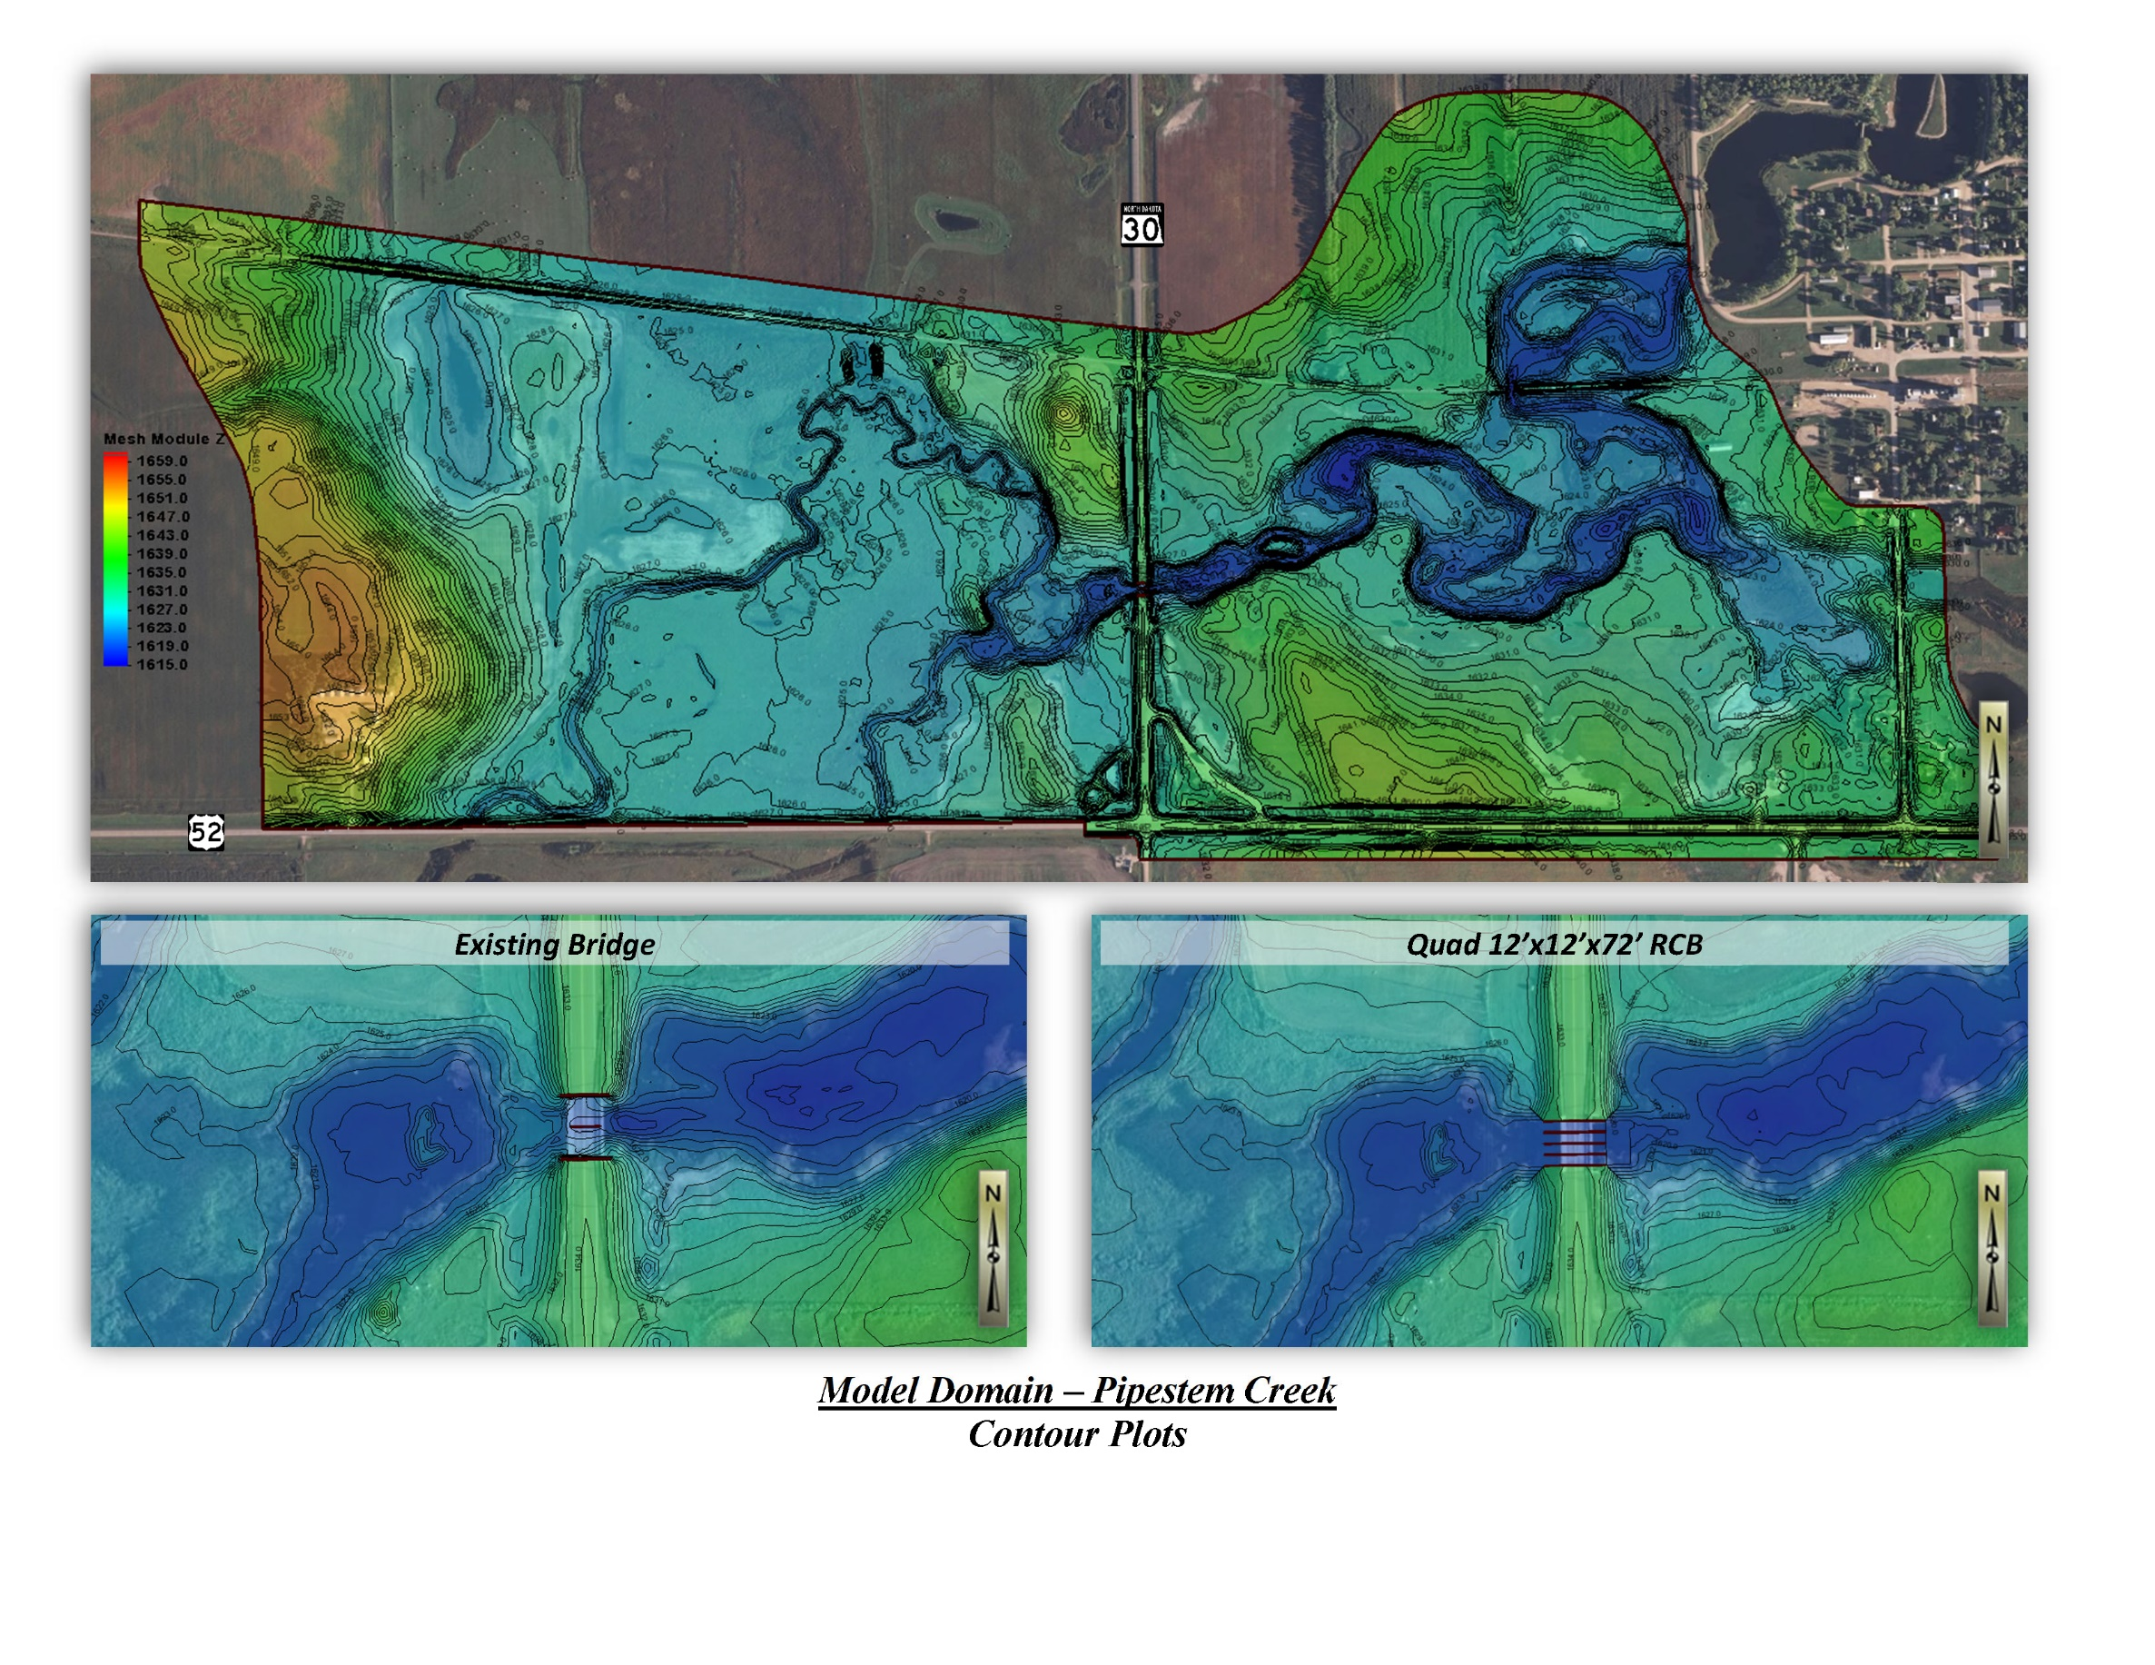

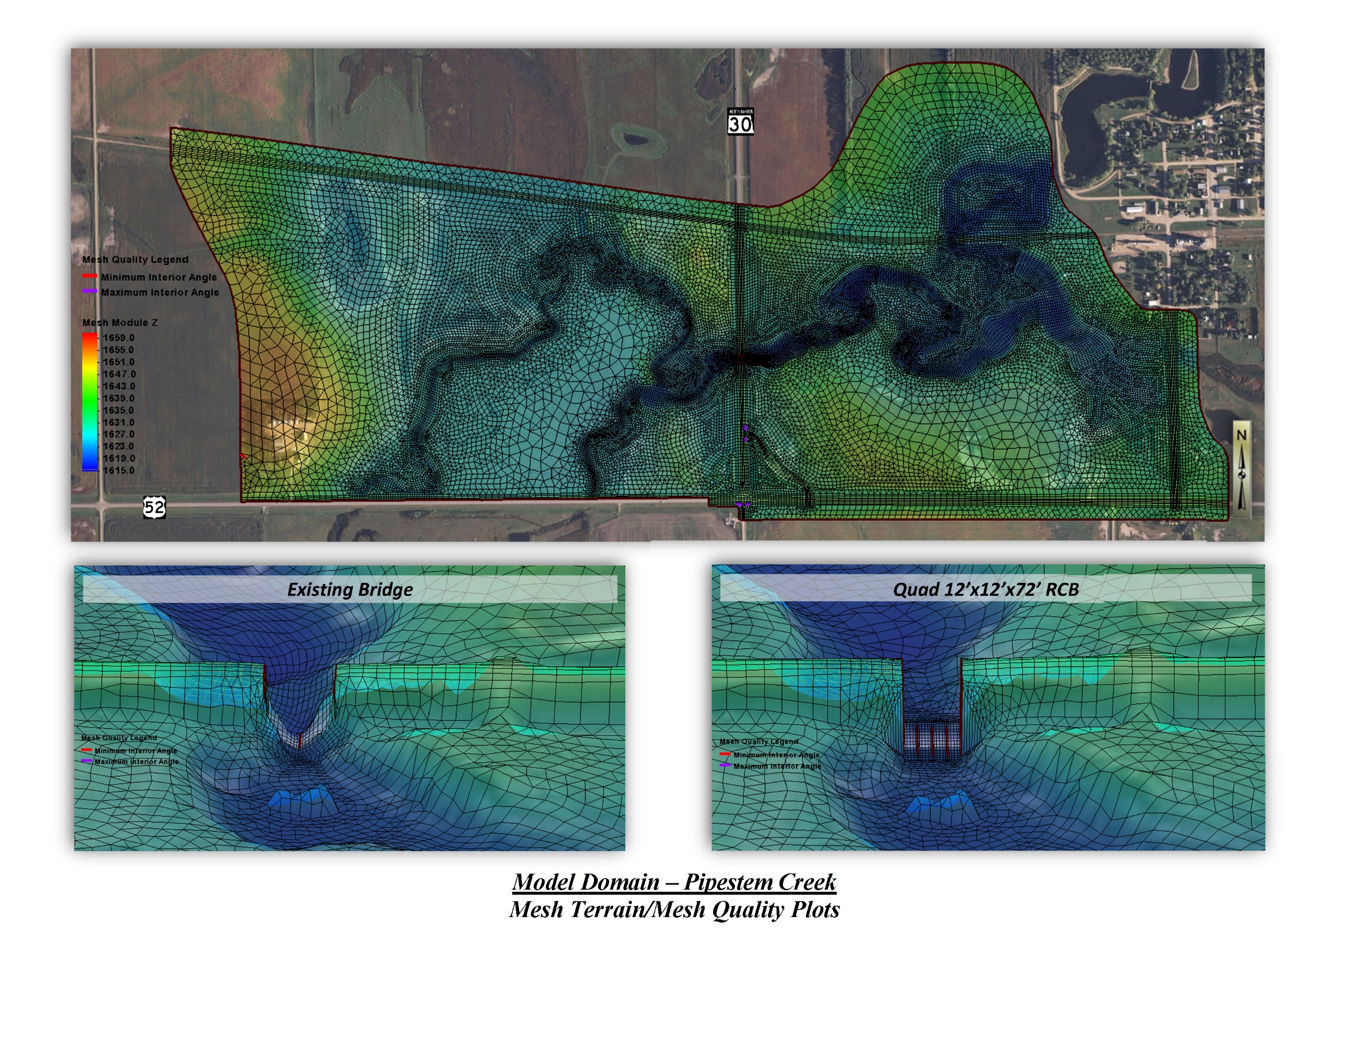
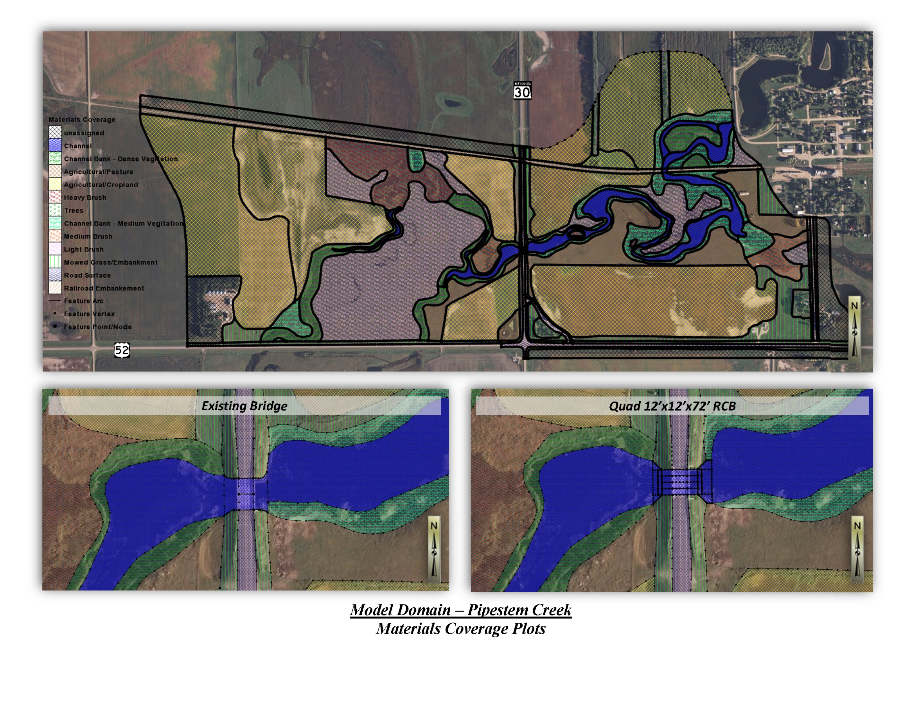
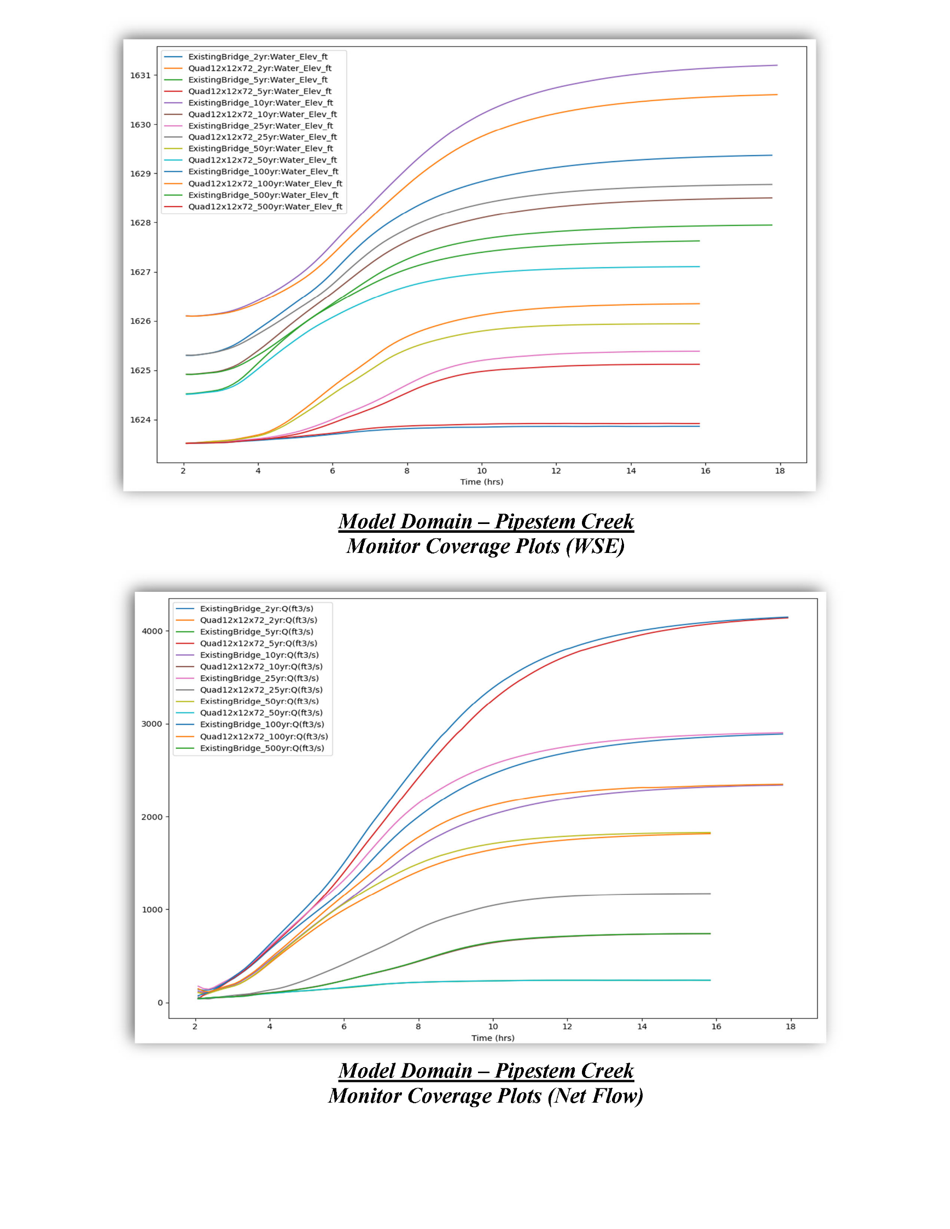

Appendix D: Structure Comparison Summary
Include SFN Form 18323 (Structure Comparison Summary)
STRUCTURE COMPARISON SUMMARY
North Dakota Department of Transportation, Bridge
SFN 18323 (Rev. 1-2000)
STRUCTURE DATA
ITEM |  | EXISTING | ALT. NUMBER 1 | ALT. NUMBER 1B | ALT. NUMBER 3
TYPE OR DESCRIPTION |  | Cont. Conc. Slab | Quad 12’x12’ RCB | - | -
NUMBER OF SPANS, BARRELS, ETC. |  | 2 | 4 | - | -
OVERALL LENGTH |  | 65 | 72 | - | -
TOTAL WATERWAY AREA (FT²) |  | 514 | 576 | - | -
CLEARANCE ELEVATION |  | 1631.0 | 1630.5 | - | -
ROADWAY OVERTOPPING ELEVATION |  | 1633.6 | 1634.5 | - | -
Hydraulic Comparison
25-Year Frequency |  | Q = 1835.9 CFS
ITEM |  | EXISTING | ALT. NUMBER 1 | ALT. NUMBER 1B | ALT. NUMBER 3
DISCHARGE THROUGH STRUCTURE (CFS) |  | 1835.9 | 1835.9 | - | -
DISCHARGE OVER ROADWAY (CFS) |  | 0 | 0 | - | -
UPSTREAM STAGE |  | 1627.6 | 1627.1 | - | -
DOWNSTREAM STAGE |  | 1626.6 | 1626.6 | - | -
AVG. VEL. THROUGH STRUCTURE (FT/SEC) |  | 7.7 | 5.7 | - | -
Hydraulic Comparison
100-Year Frequency |  | Q = 2925.4 CFS
ITEM |  | EXISTING | ALT. NUMBER 1 | ALT. NUMBER 1B | ALT. NUMBER 3
DISCHARGE THROUGH STRUCTURE (CFS) |  | 2925.4 | 2925.4 | - | -
DISCHARGE OVER ROADWAY (CFS) |  | 0 | 0 | - | -
UPSTREAM STAGE |  | 1629.4 | 1628.8 | - | -
DOWNSTREAM STAGE |  | 1627.8 | 1627.8 | - | -
AVG. VEL. THROUGH STRUCTURE (FT/SEC) |  | 9.7 | 7.9 | - | -
Hydraulic Comparison
200-Year Frequency |  | Q = 4257.7 CFS
ITEM |  | EXISTING | ALT. NUMBER 1 | ALT. NUMBER 1B | ALT. NUMBER 3
DISCHARGE THROUGH STRUCTURE (CFS) |  | 4257.7 | 4257.7 | - | -
DISCHARGE OVER ROADWAY (CFS) |  | 0 | 0 | - | -
UPSTREAM STAGE |  | 1631.2 | 1630.6 | - | -
DOWNSTREAM STAGE |  | 1629.0 | 1629.0 | - | -
AVG. VEL. THROUGH STRUCTURE (FT/SEC) |  | 11.5 | 9.9 | - | -
COMMENTS: | Structure 0030-088.503
Alternative 1 includes sinking the box culvert 1’ below the natural channel elevation.

Appendix E: Hydraulic Design Data for Bridges/Culverts
Include SFN Form 9634 (Hydraulic Design Data for Bridges) or SFN Form 9636 (Hydraulic Design Data for Culverts) for recommended structure alternatives.

HYDRAULIC DESIGN DATA FOR BRIDGES
North Dakota Department of Transportation, Bridge
SFN 9634 (Rev. 1-2000)

Project Number: IM-8-094(100)337 | Bridge Number: 0094-337.335 L/R
Drainage Area |  | 1,467.8 square miles
Design Frequency |  | 50-Year
Design Discharge |  | 11,443 cfs
Design Stage (upstream) |  | 908.27 ft
Stream Gradient (ft/ft) |  | 0.00068 ft/ft
Waterway Provided Below Design Stage |  | 2,717. sq ft
Waterway Provided Below Clearance Elevation |  | 3291.5 sq ft
Average Velocity of Flow in Natural Channel |  | 4.28 ft/sec
Depth of Flow |  | 18.36 ft
Velocity of Flow Under Bridge |  | 4.21 ft/sec
Freeboard Provided |  | 1.94 ft
100-year Frequency Discharge |  | 13,269 cfs
100-year Frequency Stage |  | 909.03 ft
Overtopping Stage |  | 914.24 ft
Overtopping Discharge |  | 45,093.6 cfs
Minimum Water Elevation |  | 889.75 ft
COMMENTS: Alternative 3
Bottom Elevation = 889.75 ft, 80' Channel Bottom Width
Bridge 0094‐337.335 L ‐ 48' Clear Roadway; Bridge 0094‐337.335 R ‐ 40' Clear Roadway

HYDRAULIC DESIGN DATA FOR CULVERTS
North Dakota Department of Transportation, Bridge
SFN 9636 (Rev. 1-2000)

Project Number: | SS-3-030(036)088 | Bridge Number: |  | 0030-088.503
Drainage Area |  |  | 190.661 Sq. Miles
Stream Gradient (ft/ft) |  |  | 0.001
Design Frequency |  |  | 25-Year
Design Discharge |  |  | 1835.9 cfs
Design Headwater Stage |  |  | 1627.1 ft
Design Tailwater Stage |  |  | 1626.6 ft
Velocity Through Culvert |  |  | 5.7 ft/sec
100-year Frequency Discharge |  |  | 2925.4 cfs
100-year Frequency Headwater |  |  | 1628.8 ft
Overtopping Stage |  |  | 1634.5 ft
Overtopping Discharge |  |  | 6126.5 cfs
Structure Selection |  |  | Quad 12'x12' RCB
COMMENTS:
Estimated Invert Elevations: Inlet = 1618.5 ft Outlet = 1618.0 ft RCB Skew Angle = 0°
(Inverts to be set one foot below the existing channel bottom to provide for aquatic organism passage.
The inverts above reflect the one foot sinking of the RCB.)

Appendix F: Watershed Area Map
Include drainage area map with all relevant hydrologic information (drainage area, stream lines, contour lines, basin relief, basin perimeter, stream length/density, Hydrologic Zone, etc).
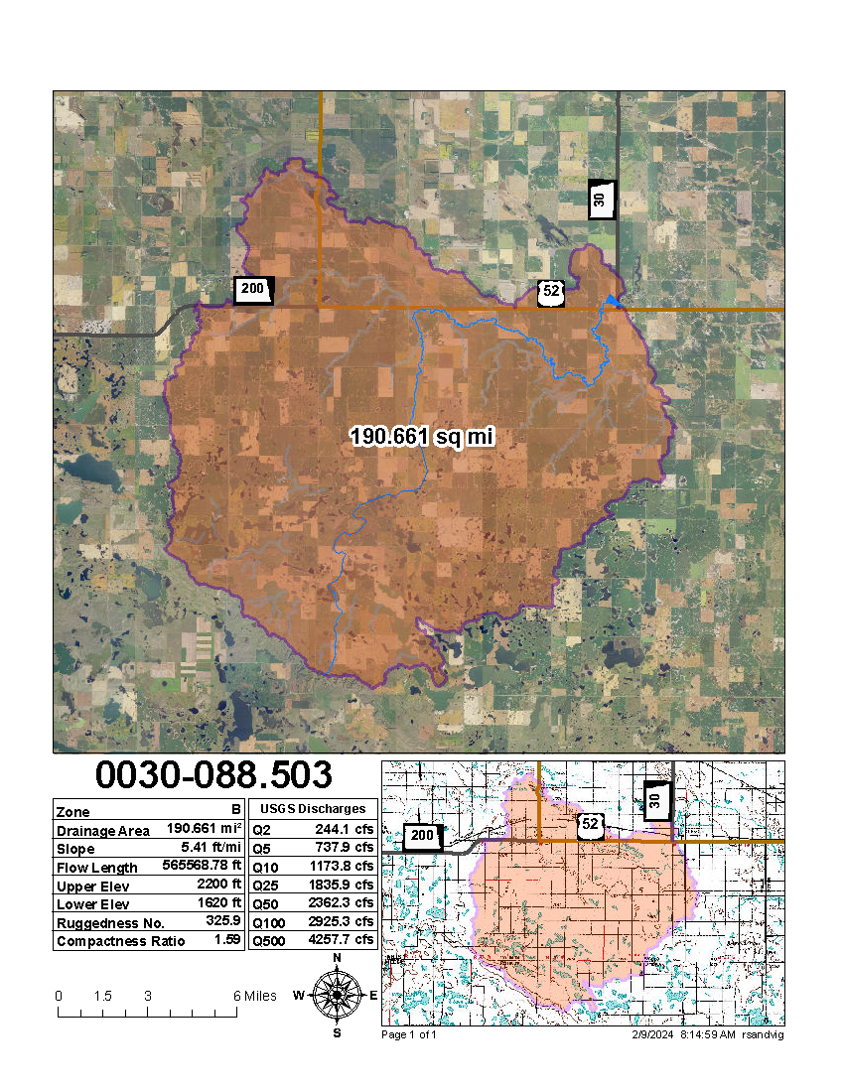

Appendix G: Structure Inspection Report
Include Structure Inspection Report summary sheet only.

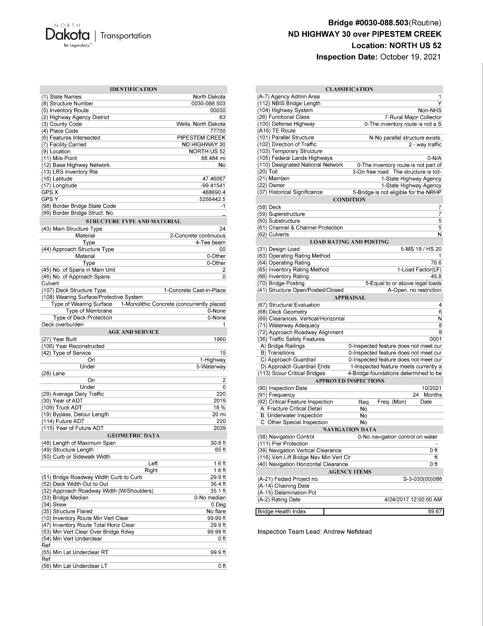

Appendix H: FEMA FIRM Maps
Include FEMA FIRM maps for crossings located within a floodway/floodplain.
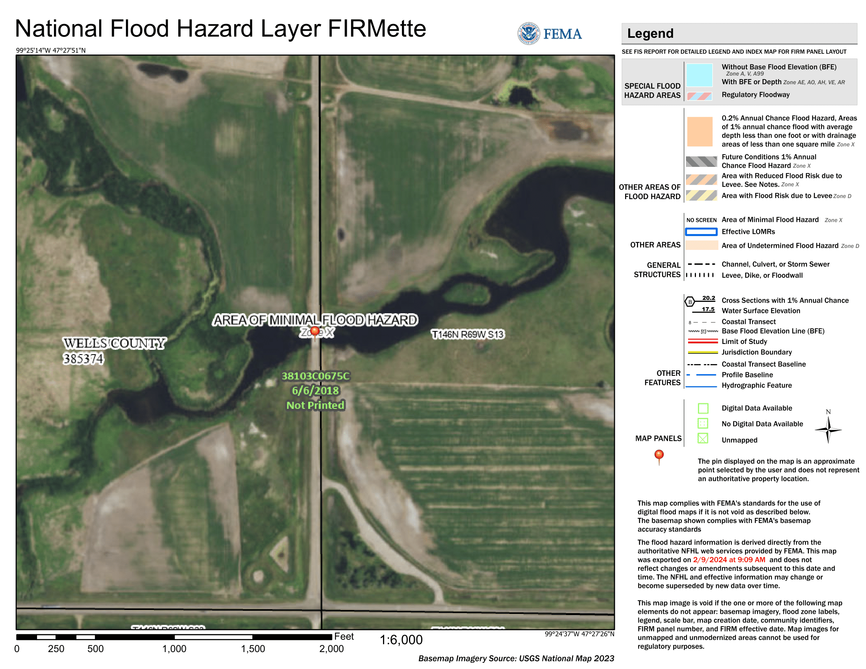

Appendix I: Miscellaneous
Include other applicable maps, scour calculation data, survey data, and correspondence as necessary (topographic survey exhibits of critical features such as buildings/drainage structures, scope change documents, email/SOV correspondence, etc).

