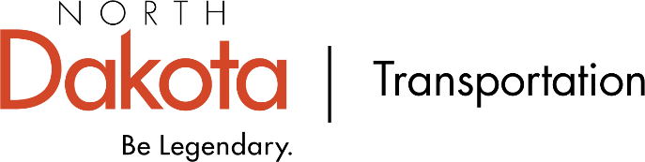

MEDIA RELEASE | FOR IMMEDIATE RELEASE | Jan. XX, XXXX

NDDOT hosts public input meeting for Highway # in/near City

BISMARCK, N.D. – The North Dakota Department of Transportation (NDDOT) will host a public input meeting Day of week, Month Date, from Time to Time p.m. time zone if needed to discuss (state the purpose of the meeting – example “proposed improvements to Highway 22 from Ninth Street West to West Broadway Street in Dickinson.” )

The meeting will be held at the Location, Address, in City. There will be an open house format with a formal presentation at Time.

The project includes (state details of the project here – example “replacement of the signals at Second Street and Ninth Street and the removal of the signals at West Broadway Street, Third Street, and Fourth Street.”)

Representatives from the NDDOT and consultant firm/city will be on hand to answer questions and discuss concerns.

A pre-recorded presentation and other materials are/will be available on the NDDOT website at www.dot.nd.gov/public-input.

If unable to attend the meeting, written comments must be postmarked or emailed by Month Date with “Public Input Meeting - PCN 01234” in the letter heading or e-mail subject. Send all comments to Name address or email address.

The NDDOT will consider every request for reasonable accommodation to provide an accessible meeting facility or other accommodation for people with disabilities. Language interpretation and translation services will be available upon request for this meeting.

To request accommodations, contact Heather Christianson, Civil Rights Division, NDDOT, at 701-328-2978 or civilrights@nd.gov. TTY users may use Relay North Dakota at 711 or 1-800-366-6888.

- ### -

CONTACT:

David Finley | North Dakota Department of Transportation
drfinley@nd.gov
701-328-4444

Sarah Arntson | North Dakota Department of Transportation
sararntson@nd.gov
701-328-6965

Nicole Peske | North Dakota Department of Transportation
nipeske@nd.gov
701-328-4322

