NORTH DAKOTA DEPARTMENT OF TRANSPORTATION
DESIGN EXCEPTION REQUEST

I. Project Description:

Project # PCN

Work Type/Investment Strategy System FHWA Involvement

Highway Classification Cross Section

Speed:
Posted Design
Speed

Traffic Volumes:
Current Forecast
Year
Passenger ADT
Truck ADT
Total ADT
Note: Current traffic volumes are used for design on Preventative Maintenance and Minor Rehabilitation projects. Forecast volumes are used for design on all other projects.

Location:

Description of Work:

II. Design Exception for the following element (identify location(s) below).

₁ ₁
₁ ₁
₁ ^{1,2}
³ ₁
³ ₁
^{1,4} ³
³ ^{1,4}
₁

¹ Indicates an item from the FHWA 10 Controlling Criteria.

²Per FHWA Memorandum titled “Vertical Clearance, Interstate System Coordination of Design Exceptions” dated August 15, 1997, Military Defense approval is required for vertical clearance on STRAHNET designated highways or connectors. STRAHNET designated highways in North Dakota are; I-29 and I-94. STRAHNET connectors are; US-83 connecting Minot AFB to I-94 and US-2 connecting Grand Forks AFB to I-29.

³ For NDDOT use only – FHWA approval not required

⁴For all projects on the Interstates that are not New or Reconstruction. If these items met the standards at the time of original construction then the Design Exception is for NDDOT use only – FHWA approval is not required.

Location(s) & existing features’ dimension and design value (locations shall be identified by station and reference point). Identify which feature(s) do not meet, (NDDOT Guidance, AASHTO Guidance, etc.).

III. Proposed design values for the exception element (identify what speed and appropriate dimensions this treatment meets if applicable):

IV. All Design Exceptions must have a crash analysis. Describe Crash Analysis performed, (include length of analysis period) and discuss crash history relationship to the proposed design exception feature.

V. Impacts other than costs of bringing the features up to minimum design values (e.g., impacts to other design features, ROW, environmental effects, preservation of historical feature, construction issues, social concerns, reduction of design life, compatibility with adjacent roadway features, engineering discretion).

VI. Estimate of construction cost of project:

VII. Estimated increased cost to meet minimum design value for requested design exception:

VIII. Proposed mitigation to address exception feature if applicable. List any recommendations from Crash Analysis and/or Safety Review and/or Traffic Operations Report. Some possible countermeasures may include advisory signs, lighting, inslope flattening, guardrail, signing, traversable end sections, rumble strips (shoulder, centerline, or advanced for stop signs), future work to address design exception, incremental improvement, etc.

IX. Additional Comments:

Basis for Recommendation:

NDDOT Recommend Approval

_
Director, Office of Project Development Date

NDDOT Approval
I hereby certify that this Design Exception was prepared by me or under my direct supervision and that I am a duly registered professional engineer under the laws of the State of North Dakota.
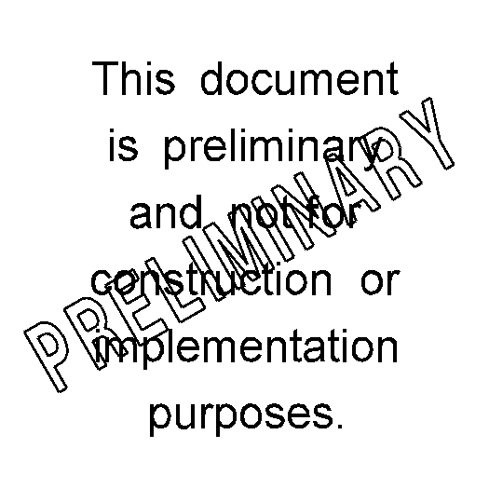

_
Deputy Director for Engineering Date

Design exceptions will only be submitted to FHWA for approval if required by a PODI Plan.

FHWA Approval (If unapproved, document will be returned, unsigned with a letter of explanation.)

_
Federal Highway Administration Date

Contingency Yes ______ No ______

Contingencies of FHWA Approval (If applicable):

