DRAFT PUBLIC INVOLVEMENT REPORT | HOT BITUMINOUS OVERLAY  Project No. PCN  SS-5-085(030)124 12345  From point A to point B    85  Prepared by  NORTH DAKOTA DEPARTMENT OF TRANSPORTATION  BISMARCK, NORTH DAKOTA  http://www.dot.nd.gov/  DIRECTOR  Ronald J. Henke, P.E.  PROJECT DEVELOPMENT DIRECTOR  Jon Ketterling, P.E.  Principal Author: (Consulting Firm OR name, NDDOT Division name)  Environmental Reviewer: (name, NDDOT Division name)  May 2023

23 USC § 407
NDDOT Reserves All Objections

TABLE OF CONTENTS

Description Page
Table of Contents i
List of Tables ii
List of Figures ii
- Public Meeting Summary 1
- Project Information 1
- Meeting Details 1
- Attendees 1
- Comments Received 1
- Public Concerns 1

Appendices (delete non-applicable items below)
Appendix A Notifications
Appendix B Handouts
Appendix C Exhibits Presented
Appendix D Presentation Slides
Appendix E Roster
Appendix F Comments and Responses
Appendix G Transcript/Video Script

LIST OF TABLES
Table 1: Summary of Comments/Responses 1

LIST OF FIGURES
Figure 1: Project Location Map 1

LIST OF EXHIBITS

- Public Meeting Summary

  - Project Information

Highway:

District:

Limits:

Associated Project PCN(s) and Description(s):

Figure 1 – Project Location Map

  - Meeting Details

City, State:

Facility:

Date and Time:

Meeting Format Used:

Briefly explain why the meeting was held.

  - Attendees

Number of Attendees:

Briefly explain who was there that is working on the project (NDDOT/Consultants/Local Government/FHWA). How many from the public and if there were any special interest groups in attendance.

  - Comments Received

State the number of comments received during the meeting and on comment cards that night as well as after the meeting via email or mailed comment cards.

Table 1 – Summary of Comments/Responses

Topic | Comments | Responses

* If no comments are received delete the table and Appendix F – Comment and Responses. If no duplicate comments are received, delete this table and refer the reader to Appendix F – Comment and Responses.

  - Public Concerns

Discuss if there were any controversial issues regarding the project. If there were no controversial issues this section can be deleted.

APPENDICES

Appendix A
Notifications
(Affidavit of Publication, Press Release with email distribution from Communications Division, and Legal Display Advertisement)

*If SOV #8 was sent out, the distribution email should be included as well with the email distribution list from Communications Division.

*If letters were mailed out to notify homeowners or businesses of the meeting, please include a copy of the letter with any of the attachments mailed out and the SOV list.
Appendix B
Handouts

(After the Storm, Information for Highway and Street Projects, Comment Cards)

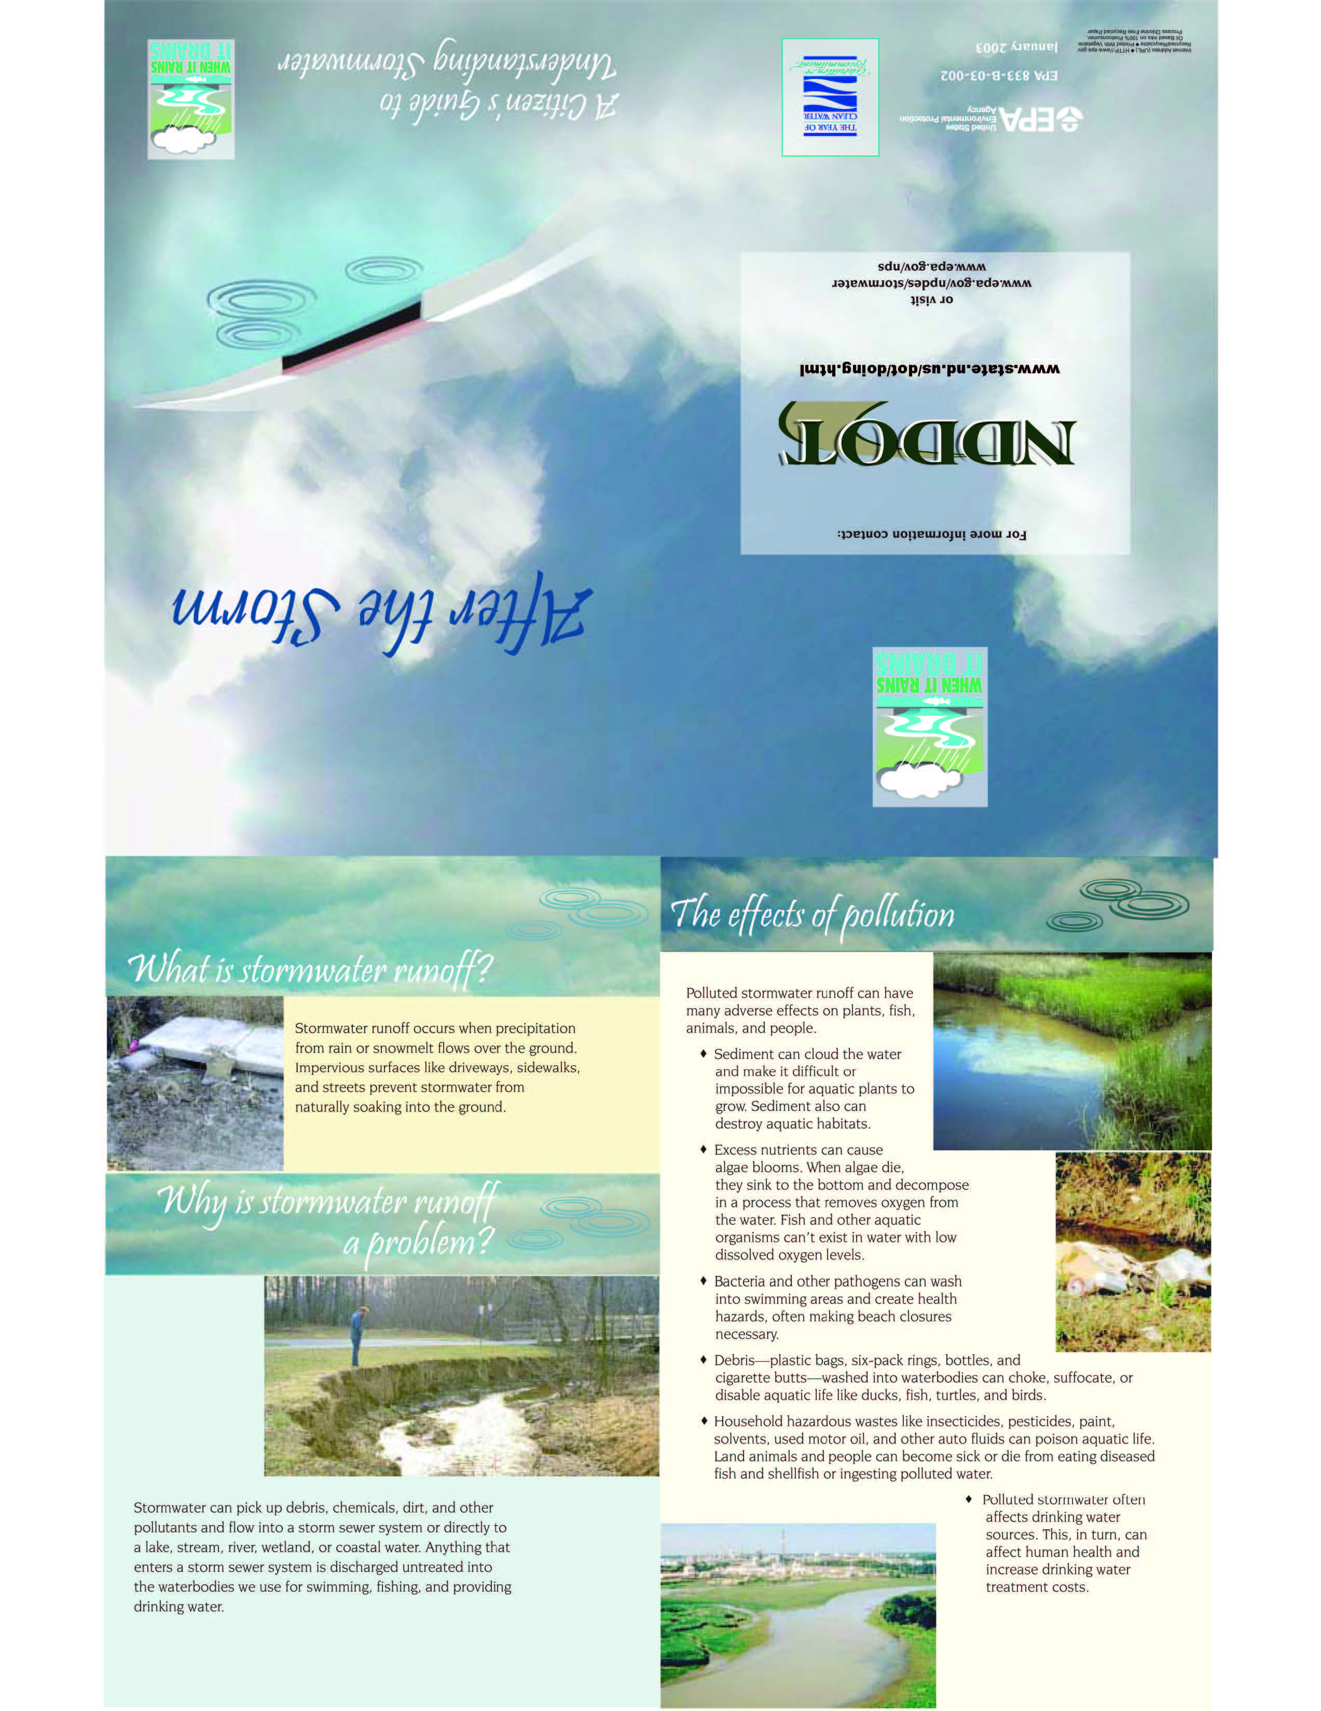

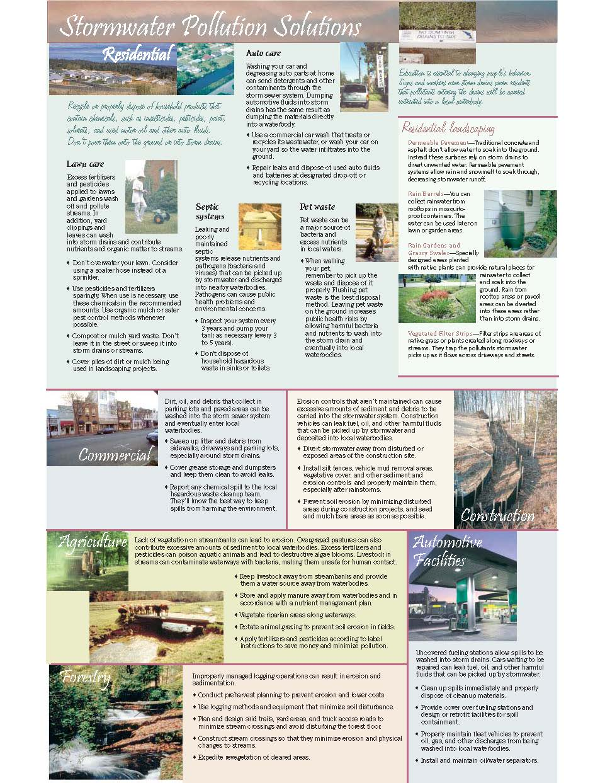

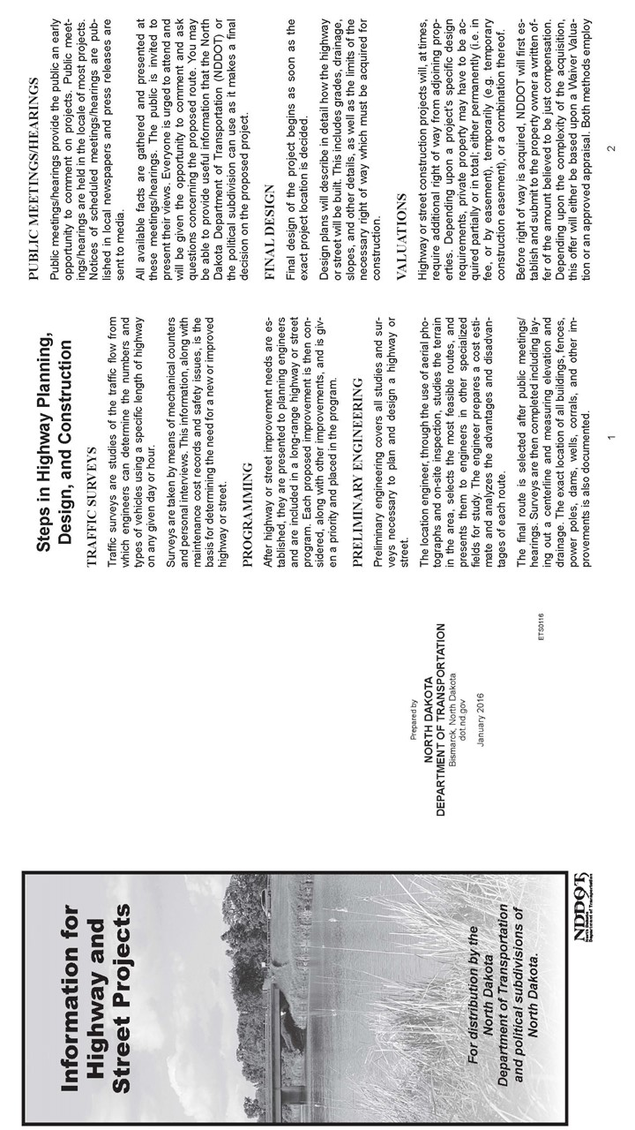
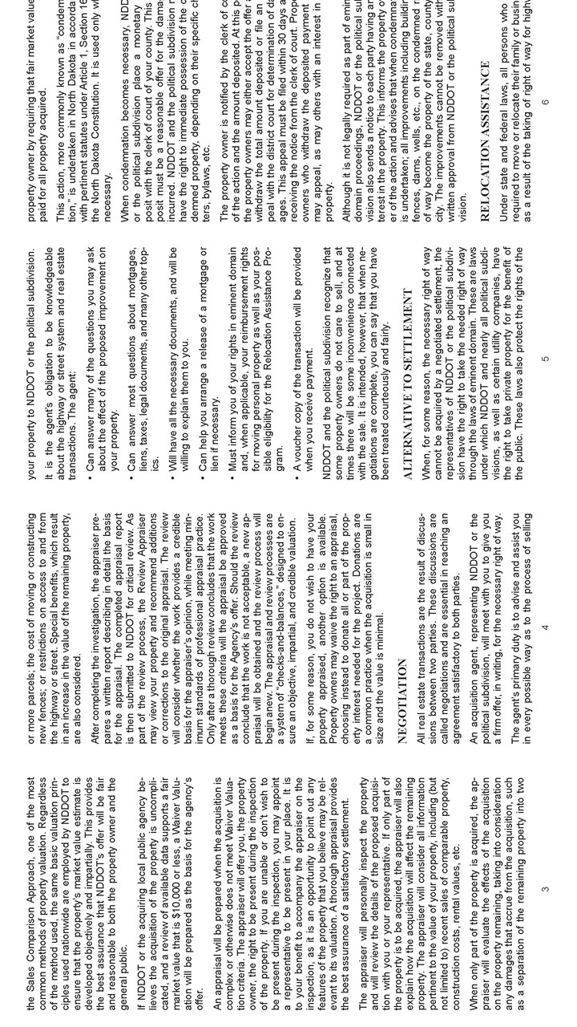
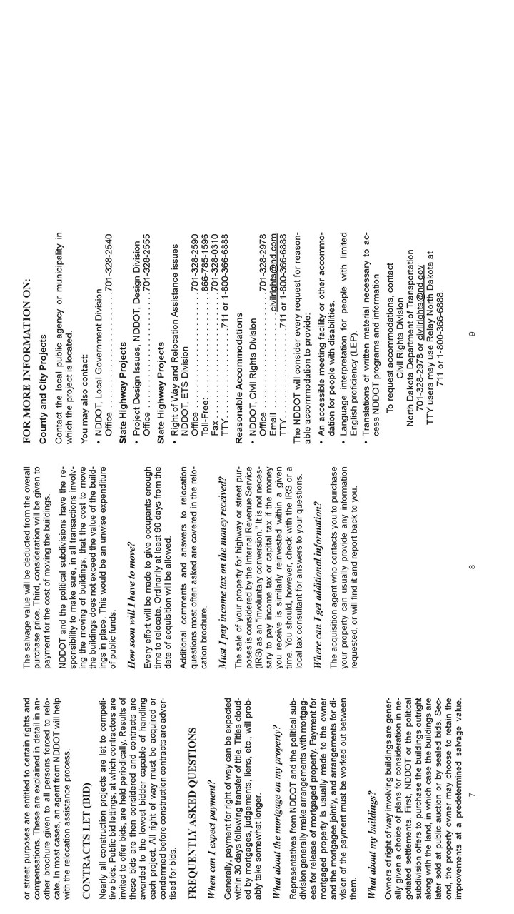
Appendix C
Exhibits Presented

(Stormwater and the Construction Industry)
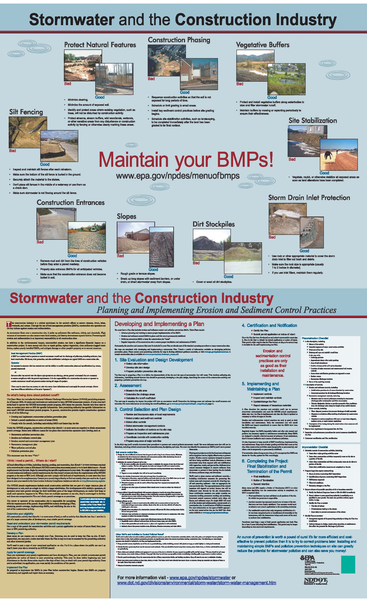
Appendix D
Presentation Slides
Appendix E
Roster

(SFN 60149 NDDOT Title VI Public Participation Survey is not to be included in the Public Involvement Report)

Appendix F
Comments and Responses
(Also include in the final document the original comment cards that were received as well as any emails. If figures or attachments were included with the cards or emails those also need to be included.)

Location of Comment in Public Hearing Transcript/Topic
Response
Comment
Date of Comment
Entity
(Name, Relation to Project)
Comment Number
Appendix G
Transcript/Video Script

