Compensatory Wetland Mitigation Plan; Hwy 52 near Pingree;
February 2, 2017

- OBJECTIVE:
The objective is to create a shallow, seasonal palustrine emergent (PEMx) wetland consisting of a prevalence of herbaceous hydrophytic vegetation. The mitigation area of Site 1 is 0.14 acre which expands wetland 1d(d) to mitigate for losses to wetland 1d(c) of which 0.10 acre is required to function for the USACE. The created wetland will be constructed within the NDDOT right of way along US 52 / 281 near Pingree. Ditch bottoms will be widened and deepened in one area to pond water in the ditch to an appropriate elevation. The mitigation area is proposed to be adjacent to the impacted wetlands. The created wetlands will offset the unavoidable loss of aquatic resource functions and values.

- SITE SELECTION:
The site was selected due to the location adjacent to existing wetlands, the contributing watershed, suitable soils, the proximity to the project, the ease of construction, and because it is within existing DOT right of way. Excavated material from the created wetland will may be utilized in the roadway embankment. The created wetland area will be sustained through storm water runoff and spring snow melt. All impacts and mitigation are within the Missouri River Basin Southern Zone Regional Service Area.

Hydrology
Site 1 is adjacent to wetland 1d(d) which receive hydrology from stormwater and snow melt from the 42.8 acres of contributing watershed.

Soils
The existing NRCS Web Soil Survey generally indicates soil characteristics at the site near wetland 1d(d) and 1d(c) consist of soils having a high infiltration rate with a 0-3 percent slope with fine sandy loam soils with a 36 - 60” water table.

- SITE PROTECTION:
The mitigation site is located within the NDDOT's permanent ROW. The mitigation site will be protected in perpetuity. In the event of highway abandonment, the terms of the permit and mitigation will be transferred to the receiving property owner.

- BASELINE INFORMATION:
A field delineation was conducted on November 24, 2015 and June 16, 2016. The mitigation site vegetation is above the existing adjacent wetland and dominated by upland vegetation typical on NDDOT ROW. The area does not have a cropping history. The upland area will be converted to wetland with hydrology driven by spring snowmelt and storm water runoff. The proposal is to expand wetland 1d(d) to compensate for the permanent impacts to wetland 1d(c).

- Hydrology
This drainage area of the James Headwaters hydrologic unit HUC10160001 should support the proposed mitigation plan stormwater runoff and from spring snowmelt. Average annual precipitation at Jamestown, 20 miles to the south, is 18.8 inches.

- Soils
From the NRCS Web Soil Survey, the area primarily consists of G732A – Swnoda-Barnes fine sandy loams with 0 – 3 percent slopes. The depth to restrictive feature is more than 80 inches, and the hydric rating is 2, which is 1 – 32 percent hydric components.

- Vegetation
From the closest sampling point Pit # 1 of the Wetland delineation report, the existing Herb Stratum is 80 % smooth brome (Bromus inermis) and 20% Kentucky bluegrass (Poa pratensis).

- DETERMINATION OF CREDITS:
Credit ratios were determined using the Wetland Mitigation Banking in North Dakota – Interagency Guidance for Mitigation Bank document, utilizing guidance that creation adjacent to the wetland impacted receives a 1:1 and mitigation nonadjacent to the wetland impacted receives a 2:1. The breakdown of impacts, ratios, and resulting mitigation required is below. NDODT proposed no mitigation for the artificial portion of the resource with permanent impacts greater than 0.10 acre.

Table 1: Wetland Credit Ratios and Credit Calculation
Mitigation Site # | Wetland Number | Wetland Feature | Mitigation Type | Perm. Wetland Impact (acre) | Acre-Credit Ratio (location) | Mitigation after ratios for USACE Impacts (acres) | Total Constructed Onsite Mitigation (acres)
Site 1 | 1d(c) | Natural | Creation Adjacent | 0.10 | 1:1 | 0.10¹ | 0.14
 |  |  | Totals | 0.10 |  | 0.10 | 0.14
¹ Mitigation for the natural portion where cumulative permanent impact to the resource was greater than 0.10 acre.

- MITIGATION WORK PLAN:
Site 1 will be constructed by excavating and grading upland to a variable depth up to 2 feet maximum depth depressional area adjacent to the existing wetlands 6 and totaling 1.61 acres (1.59 acre required for the USACE). The site will be over excavated by 6 inches to a final elevation of 1449.70 feet and will be graded with a 4:1 transition, not included in the mitigation acreage, from the final 2 foot depth to the existing grade and contours of the adjacent uplands surrounding the mitigation site. The work will be started in the summer of 2017 and anticipated to be completed by the end of November. Hydrology will be obtained from the adjacent wetlands, road ditches, and water table. The wetland mitigation site will be seeded with the following wetland seed mix.

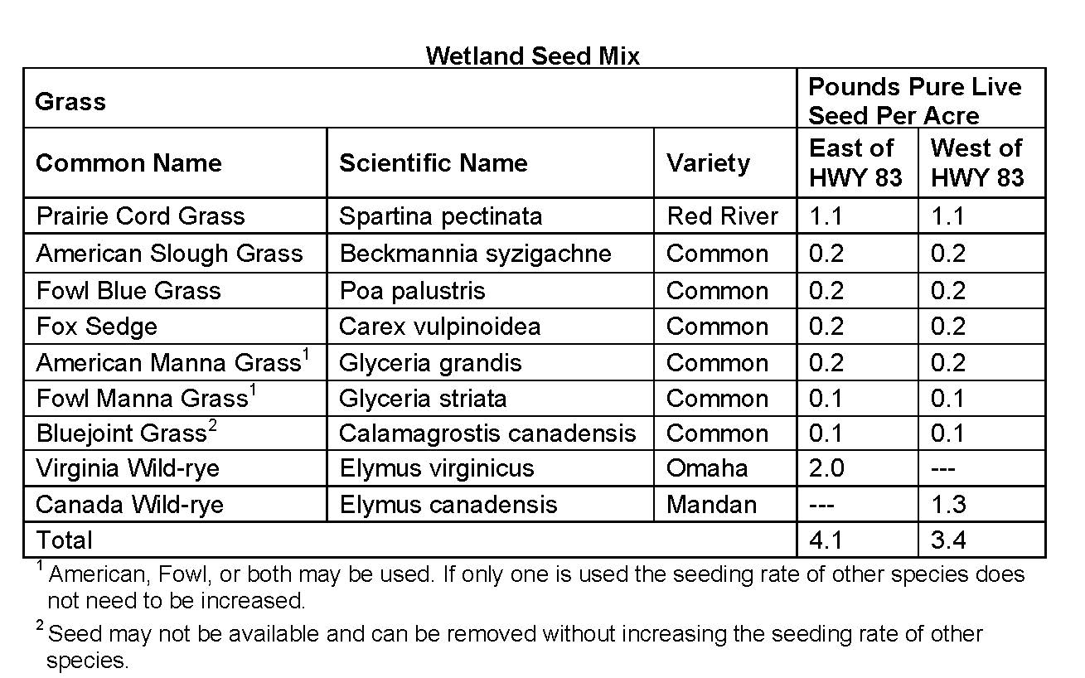

BMPs will be installed to prevent erosion and sedimentation within the site. All BMPs will be removed from the mitigation site upon the establishment of vegetative cover. After completion of the mitigation site designated photo points will be developed. Monitoring reports will be provided yearly until success criteria are met. As-built plans will be submitted to the USACE only if changes in the design plan occur.

- MAINTENANCE PLAN:
The site will be maintained along with the adjacent road right of way. This section of highway is mowed periodically from the edge of pavement to the toe slope of the road grade by NDDOT maintenance staff. The balance of the right of way may be hayed by the adjacent landowner. No haying restrictions will be placed on this site. Noxious weeds will be controlled by NDDOT staff or a certified applicator. The site will be maintained to meet the success criteria outlined in the performance standards.

- PERFORMANCE STANDARDS:
Wetland – Success criteria will be met when hydrology exists at the site for sufficient time periods to support a prevalence of vegetation typically adapted for life in saturated soil conditions. Performance standards are met when the mitigation meets wetland criteria for hydrology and hydrophytic vegetation as defined in the 1987 Corps of Engineers Wetland Delineation Manual and Great Plains Regional Supplement (Version 2.0). Once hydrology and hydrophytic vegetation performance standards are met, this serves to confirm that the soil is forming under conditions of saturation, flooding, or ponding long enough during the growing season to develop anaerobic conditions in the upper part.

Buffer – No buffer credits are proposed due to ROW restrictions at this location; however, all disturbed terrestrial areas will be reestablished with permanent native grass cover, as described in the mitigation work plan above. No buffer performance standards are necessary.

- MONITORING REQUIREMENTS:

- Performance standard: The 0.10 acre mitigation area must successfully meet performance standards, as defined in component 8. Performance Standards

- Monitoring Requirements:

The NDDOT shall submit mitigation monitoring reports as stated below:

      - First growing season: A mitigation monitoring report will be submitted to the North Dakota Regulatory Office. The report will discuss and document that the site was constructed as detailed in the mitigation plan, identify any problem areas, and a map will be included with established photo points. The photographic narrative will be included. The NDDOT onsite mitigation certification form will be included.

The map will include:
        - Most current aerial background
        - Previously delineated existing wetlands (if present, supplied by NDDOT)
        - Design mitigation boundary
        - Photo points
        - Remedial action areas

      - Second growing season: A mitigation monitoring report will be submitted to the North Dakota Regulatory Office. The report will discuss and document how the site is progressing toward meeting performance standards up to the design boundary, identify any problem areas, and a map will be included with previously established photo points. The photographic narrative will be included.

The map will include:
- Most current aerial background
- Previously delineated existing wetlands (if present, supplied by NDDOT)
- Design mitigation boundary
- Photo points
- Remedial action areas

      - Third growing season and/or until performance criteria are met: A monitoring report shall be submitted to the North Dakota Regulatory Office. The report will include the identification of existing vegetation and documentation of hydrology indicators within the mitigation site. A mitigation site boundary where performance standards are being met will be collected and shown on a map. The photographic narrative will be included.

The map will include:
        - Most current aerial background
        - Previously delineated existing wetlands (if present, supplied by NDDOT)
        - Design mitigation boundary
        - Mitigation boundary where performance standards are met (can go beyond mitigation design boundary but not within previously delineated wetlands)
        - Photo points
        - Remedial action areas

      - If remedial actions are needed, the reporting may start over as the first growing season requirements after remediation activities are complete.

Onsite monitoring shall be conducted from June 15th to the end of the growing season. The monitoring reports shall include the following:

- Corps of Engineers Permit Number NWO-2016-1395-BIS, NDDOT project number HEN-2-052(040)244, PCN 21040.
- Name and contact information of permittee, point of contact and consultant (if one is used), as well as the dates the inspection(s) was conducted.
- Directions to the mitigation/project site.
- Log or timeline reflecting the construction and development of the compensatory wetland mitigation, including the completion date for construction of all mitigation, remedial actions (if any), plantings, monitoring dates, etc., as well as the date the site meets full success criteria (meeting all performance standards).
- Photographic and narrative summary of the mitigation site’s development, specifically including the following:
- Photographs of the mitigation site prior to construction, encompassing the entire mitigation area using the NDDOT photo template.
- Photographs and narrative summary of the mitigation site’s progress and development into meeting wetland criteria.
- Photographs taken from a minimum of one fixed point and directions for each wetland mitigation Site. Photo location and points must be sufficiently spaced to provide visual depiction of the entire site’s development.
- Additional photograph(s) and description(s) of problem areas, if any are identified.
- Recommendations for any additional corrective or remedial actions (if needed).
- Monitoring requirements may be waived by the North Dakota Regulatory Office once performance standards are met or a determination is made that the site adequately offsets the authorized impacts.

III. Reports shall be sent to: North Dakota Regulatory Office, 1513 South 12th Street, Bismarck, North Dakota, 58504

10. LONG-TERM MANAGEMENT PLAN:
The NDDOT will continue to manage the site with noxious weed control, periodic mowing, and litter removal along with the adjacent road right of way. Repairs will be to the original construction specification. The NDDOT will inform the USACE if any corrective measures are needed.

- ADAPTIVE MANAGEMENT PLAN:
The NDDOT will continue to manage the site with noxious weed control, periodic mowing to reduce litter accumulation, and repair of any structures to original construction specification. The NDDOT will inform the USACE of any adaptive management needs.

- FINANCIAL ASSURANCES:
Sufficient funds will be available to pay for monitoring and maintenance in the future. The Department receives an allocation from the North Dakota Legislature on biennium basis for road development and maintenance. Historically the NDDOT has allocated $0.5 million annually for wetland mitigation development, management and monitoring.

