REQUEST FOR PROPOSAL
SEPTEMBER 17, 2026

TO PERFORM
PRELIMINARY ENGINEERING SERVICES
FOR Project

8-011(055)118 PCN 25259
STRUCTURAL PLATE PIPE REPLACEMENT ON ND 11

8-011(064)141 PCN 25662
BRIDGE REPLACEMENT ON ND 11

ronald J. henke, pe
DIRECTOR
NORTH DAKOTA DEPARTMENT OF TRANSPORTATION

PROPOSALS MUST BE DELIVERED TO
CHAD TAYLOR
ENVIRONMENTAL AND TRANSPORTATION SERVICES DIVISION
By
12:00 PM Central Time OCTOBER 8, 2026

REQUEST FOR PROPOSAL (RFP)

PROJECT OVERVIEW
The North Dakota Department of Transportation (NDDOT) is requesting one qualified engineering consultant(s) to perform preliminary engineering, environmental documentation, hydraulic engineering, structure design, Right Of Way (ROW), and affiliated services to complete the following projects:

8-011(055)118 PCN 25259
Work Type: Structure Replacement - Replacing a structural plate pipe, it is anticipated to be replaced with a box culvert
Location: RP 118.863 approximately 2 miles west of Cogswell, North Dakota
Project Completion Date: December 01, 2027

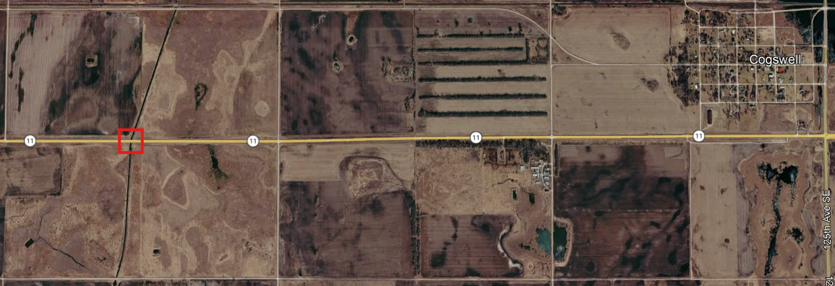
Figure 1 – Structural Plate Pipe Structure Number 11-118.863

8-011(064)141 PCN 25662
Work Type: Structure Replacement - Replacing a bridge with a box culvert
Location: RP 141.391 approximately a quarter mile west of Cayuga, North Dakota
Project Completion Date: December 01, 2027

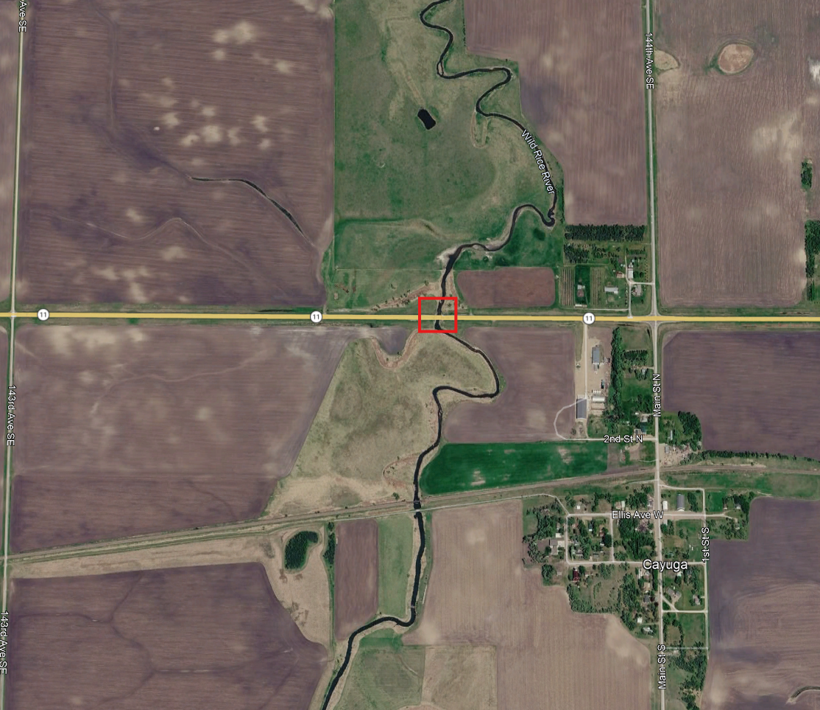
Figure 2 - Bridge Number 11-141.391

The Wetland Delineation Report and Cultural Resource Class III survey has been contracted through the NDDOT IDIQ process. All deliverables for wetland and 106 items are contracted to be completed according to the Milestone delivery dates and will be provided to the awarded consultant for incorporation into the project design as necessary.

For each project, the consultant will be responsible for developing all structural design and associated roadway design necessary to complete all phases of work including environmental document, survey, preliminary engineering, final design and construction plans, specifications, estimates, utility conflict plans for adjustments and relocations, right of way plats and acquisition, final mitigation plans and environmental permitting, associated roadway design including all work for grading, construction phasing traffic control plans, signing, and erosion control.

Note: it is currently anticipated that the projects will be tied and only one plan set will be required.

SCOPE OF SERVICES
The NDDOT intends to execute one cost plus fixed fee contract requiring monthly billings per project with the selected consultant. The NDDOT reserves the right to assign work in phases and have the selected consultant perform any additional work not initially assigned. Project work items may be added or removed from the contract by work authorization or supplement agreement.

Consultants will allow 14 days for the review and/or approval of project deliverables by the NDDOT. The schedule will indicate which project phase the deliverable will begin. All deliverables must be submitted to allow time for approval from the NDDOT and all permitting agencies prior to the bid ready date. The NDDOT is not responsible for added cost or lost time for the rework of the project deliverables.

Interviews will be conducted tentatively 14 days from the due date of this proposal.

Attached with the RFP are the Milestones, Inspection Reports, a Progress Report example spreadsheet, and the Risk Management Appendix.

PROJECT PHASING
Phase I, Scoping
Phase I will include conducting a scoping meeting, field review, preliminary survey, and developing an approved scope of work and hours for Phase II. The scoping/field review will include a discussion of the planning study and work completed to date.
The consultant will have 30 days, from the date that the Phase I contract is executed, to conduct the scoping meeting and field review and to secure an approved scope of work and hours. A preliminary scope of work and hours shall be provided by the consultant within 21 days of signing the contract. Pending NDDOT approval of the scope of work and hours completed in Phase I, the NDDOT may authorize the consultant to perform Phase II and any additional work not currently assigned or completed in Phase I.
Phase II, Environmental Document and Preliminary Design
Phase II consists of all activities necessary to complete the environmental document (including FHWA concurrence and approval), perform preliminary design, analyze right of way impacts, and coordinate utility location and conflict plans. Environmental studies may be initiated in Phase I. Coordinate the environmental study and environmental checklist requirements with ETS Division. Phase II will be considered complete upon receiving environmental approval from FHWA and NDDOT approval of all other deliverables. Phase III may be negotiated and authorized based on the outcome of Phase II, consultant’s proposal, consultant’s performance, and available funding.

Phase III, Final Design
Phase III will consist of design activities following preliminary design and preparation of final construction plans, specifications, and estimates, final utility conflict plans for adjustments and relocations, final right of way acquisition, and final mitigation plans and permitting. Phase III will be considered complete upon delivery and approval of final construction plans, specifications, estimates, certifications, and NDDOT approval of all other deliverables. Phase IV may be negotiated and authorized based on the outcome of Phase III, consultant’s proposal, consultant’s performance, and available funding.

Phase IV, Engineer of Record
Phase IV, if necessary, will consist of engineering services associated with Engineer of Record activities including, but not limited to, consultation and questions, pre-job meetings, plan revisions & change orders, and shop/work drawings. Phase IV does not include construction engineering.

PROJECT SCHEDULE
Submit a schedule that follows Appendix A. If the consultant’s proposed schedule differs from the Milestone (attached), the proposed schedule will be submitted by the consultant to the NDDOT Technical Representative who will then submit it to the NDDOT Milestone Committee for review. If approved, the project schedule will be revised in the Milestone Program.

PROJECT PROGRESS REPORTS
Bi-weekly progress reports are required. The report must state the project number, PCN, the reporting period dates, and be numbered in sequential order. The report will identify the percentage of progress on the contract, describe in detail the work performed by each task, and identify the remaining tasks. The report will identify any activity that is not completed or anticipated not to be completed on time. The report will include the reasons why any date was missed and what actions will be taken to get the project back on schedule.

The report must contain a spreadsheet breakdown of activities. For each milestone activity and/or deliverable detail the following:
- Project status according to the NDDOT Project Status Report (PSR) reporting Section I-04.02 of the Design Manual
- Percent complete at the start of reporting period, end of reporting period, and for the next reporting period
- Projected start date
- NDDOT milestone date
- Adjusted milestone date (if applicable)
- Actual completion date
- Explanation of delays for the given activity
- Plan to correct issues and get activity back on track

PROJECT SUBMITTALS
All design and project data will become the property of the NDDOT upon completion of the final submittal. Generate all project information in the following formats and standards:
• MS Word and MS Excel
• MicroStation 24.00.02.62
• OpenRoads Designer 24.00.02.025
• NDDOT CADD Manual
• Microsoft “Project”
• NDDOT Preliminary Surveys Manual requirements
• NDDOT Design Manual and Plan Preparation Guide Website
• NDDOT Right of Way Manual
• Adobe Acrobat (standard or compatible)

All project submittals must follow WCAG 2.1, Level AA compliance according to the Americans with Disabilities Act (ADA) Title II.

DRONES
The American Security Drone Act of 2023 (ASDA) and OMB Memorandum M-26-02ll prohibits the use of drones manufactured by foreign companies on Federal Aid projects. Drone platforms, payloads, ground control systems, communications equipment, and related technologies used must be compliant with NDAA Section 889 restrictions. Documentation of compliance may be requested by the Department.

EVALUATION AND SELECTION PROCESS
Consultants interested in performing the work must submit one electronic copy in PDF format prior to the date and time listed on the cover of this RFP. Late proposals will not be considered.

Submit proposals by email to Chad Taylor cataylor@nd.gov with copies to Joy Glasoe jglasoe@nd.gov and Adam Cahlin acahlin@nd.gov.

Each proposal must contain a cover letter signed by an authorized officer who can sign contracts for the consultant. Include the email addresses of these individuals. The pages of the cover letter will not be counted as a part of the pages.

The proposal pages shall be numbered and must be limited to five pages in length. Proposals that exceed the page length requirement will not be considered. This section should contain your approach and project specific plan.

The consultant’s proposal shall include an appendix. The appendix may include updated Federal form 330 if you do not have one on file with CAS. The pages in the appendix will not be counted as a part of the pages. The appendix shall include the following in this order:

Appendix A
Include a proposed work plan and project schedule with milestone of activities through project completion. The approved schedule will be included as part of the contract.

Appendix B
A staffing plan identifying the key project personnel (including titles, education, and work experience) and the respective roles and responsibilities for the project.

Appendix C
Project Specific QC/QA Plan including check lists, persons, responsibilities, proposed submittals and reviews, and DOT response timelines. The QC/QA Plan will be reviewed by the NDDOT and become part of the project after the contract has been signed.

Appendix D
Subconsultants and associated activities to be completed by the subconsultants. Attach proposed sublet form SFN 60232 for each sub at the end of this section.

Each proposal will be evaluated by a selection committee consisting of NDDOT staff members and/or representatives. The NDDOT reserves the right to limit the interviews to a minimum of three consultants whose proposals most clearly meet the RFP requirements. Consultants not selected to be interviewed will be notified in writing.

Selection will be based on the following weighted criteria:
10% | i. Past performance
15% | ii. Ability of professional personnel
10% | iii. Willingness to meet time and budget requirements
05% | iv. Location
10% | v. Recent, current, and projected workloads of the persons/consultants
15% | vi. Related experience on similar projects
10% | vii. Recent and current work for the agency
25% | viii. Project understanding, issues, and approach

Weights for each criterion are assigned independently for each specific project by CAS and the
Project Technical Representative. Maximum total weight is 100 points.

Shortlisting
Depending on the amount of interest for this solicitation, proposals may be subject to shortlisting. Following a review and evaluation of submitted proposals, the top three aggregate scorers will automatically have an interview, and additional firms may be invited to interview depending on point separation or natural breaks in aggregate scoring. Scoring categories match those stated previously. All firms that responded to the advertisement will be notified of the shortlisting determination and the reasons of the committee for selecting those to be interviewed. Shortlist scoring is independent of the interview scoring.

REQUEST TO SUBLET
Subconsultants that have been contacted and agree to be listed on the prime consultant’s project proposal must submit one copy of SFN 60232, Proposed Subconsultant Request to be attached to the proposal. This form is used for informational purposes only.

Prime consultants shall include a SFN 60233, Prime Consultant Request to Sublet form for each subconsultant prior to execution of the contract. The form assures that the contract between the prime consultant and all subconsultants contains all the pertinent provisions and requirements of the prime contract with the NDDOT.

RIGHT OF WAY
Project Coordination
Prior to commencing valuation work, a preliminary meeting will be held with the consultant and the NDDOT Review Appraiser. A Preliminary Valuation Review form must be completed for every project requiring an Appraisal, Waiver Valuation, Short Form Report and/or Basic Data Book. http://www.dot.nd.gov/forms/sfn61346.pdf

Prior to commencing initial right of way work, a preliminary meeting will be held with the consultant, subconsultant (negotiator), NDDOT ROW tech support, NDDOT Design tech support, NDDOT Designer, and any additional participants as needed. This will include reviewing forms, package submission, process review and reporting requirements.

Prior to commencing right of way relocations, a preliminary meeting will be held with the consultant, sub consultant (relocation officer), NDDOT ROW tech support, NDDOT Design tech support, NDDOT Designer and any additional participants as needed. This will include reviewing education, experience, and process to conduct relocations.

It is preferred that key personal performing right of way work are certified through a professional ROW service – IRWA or similar – or have a real estate license. At a minimum, the consultant shall indicate in Appendix B (staffing plan) not only who will perform the ROW tasks but who is responsible for the Quality Control of all ROW work. ROW quality should also be addressed directly in the QCQA plan (Appendix C).

*CIVIL RIGHTS
The North Dakota Department of Transportation, in accordance with the provisions of Title VI of the Civil Rights Act of 1964 (78 Stat. 252, 42 U.S.C. §§ 2000d to 2000d-4) and the regulations, hereby notifies all bidders that it will affirmatively ensure that any contract entered into pursuant to this advertisement, disadvantaged business enterprises will be afforded full and fair opportunity to submit bids in response to this invitation and will not be discriminated against on the grounds of race, color, or national origin in consideration for an award.

*Title VI/Nondiscrimination and ADA
Title VI assures that no person or group of persons may, on the grounds of race, color, national origin, sex, age, or disability, be excluded from participation in, be denied the benefits of, or be otherwise subjected to discrimination under any and all programs or activities administered by the Department. For information regarding Title VI, see the Title VI/Nondiscrimination and ADA Program at 2025-Title_VI_Nondiscrimination_and_ADA_Program_Implementation-Plan.pdf

*These requirements apply to every consultant on the project including every tier of subconsultant. It is the consultant’s or subconsultant’s responsibility to include these two paragraphs in every subcontract.

AUDIT
Consultants proposing to do work for the NDDOT must have an approved audited rate that is within 12 months of the close of the consultant’s fiscal year. Consultants that do not meet this requirement will not qualify to propose or contract for NDDOT projects until the requirement is met. Consultants that have submitted all the necessary information to the NDDOT and are waiting for the completion of the audit will be qualified to submit proposals for work. Information submitted by a consultant that is incomplete will not qualify. Out of state consultants can submit a current accepted Federal Audit Regulation (FAR) audit rate from a cognizant agency. Under certain conditions NDDOT may offer a Safe Harbor Rate of 110% to consultants that do not have a compliant rate.

PROMPT PAYMENT
Consultants will be required to make prompt payment to subconsultants as required by 49 CFR 26.29. The consultant must make payment to all subconsultants within thirty (30) calendar days from receipt of payment from the State. Such payment must be certified by the Consultant by submittal of the subsequent Consultant Contract Billing Form to the State. The State may withhold subsequent payment(s) to the Consultant if any subconsultants have not been paid for work satisfactorily completed.

RIGHT OF REJECTION
The North Dakota Department of Transportation reserves the right to reject any or all proposals.

DISCLOSURE OF PROPOSAL
At the conclusion of the selection process, the contents of the shortlisted proposals will be subject to North Dakota's Open Records Law and may be open to inspection by interested parties. Any information included in the proposal that the proposing party believes to be a trade secret or proprietary information must be clearly identified in the proposal. Any identified information recognized as such and protected by law may be exempt from disclosure.

RISK MANAGEMENT FOR PROFESSIONAL SERVICES
The Risk Management Appendix/Addendum will be incorporated into the agreement between NDDOT and the consultant.

Consultants must provide a proper Certificate of Insurance within 15 days of notification of selection.

CONSULTANT EMAIL CONTACTS
If necessary, please update contact information for receiving emails and phone calls.

