REQUEST FOR PROPOSAL
JUNE 5, 2026

TO PERFORM
engineering SERVICES
FOR Project

7-085(141)127 PCN 25067
HWY 85 – RP 128 SCENIC OVERLOOK LANDSLIDE

ronald J. henke, pe
DIRECTOR
NORTH DAKOTA DEPARTMENT OF TRANSPORTATION

PROPOSALS MUST BE DELIVERED TO
CHAD TAYLOR
ENVIRONMENTAL AND TRANSPORTATION SERVICES DIVISION
By
12:00 PM Central Time June 26, 2026

REQUEST FOR PROPOSAL (RFP)

PROJECT OVERVIEW
The North Dakota Department of Transportation (NDDOT) is requesting a qualified consultant to perform geotechnical engineering services. To assist the Department in developing a Landslide Mitigation Alternatives Report, the consultant shall complete change detection analysis, instrumentation installation, management/maintenance of instrumentation and data, and peer review of geotechnical reporting.

7-085(141)127 PCN 25067
Work Type: Landslide Report Development
Location: Hwy 85 – RP 128 Scenic Overlook Landslide
Project Completion Date: June 1, 2027

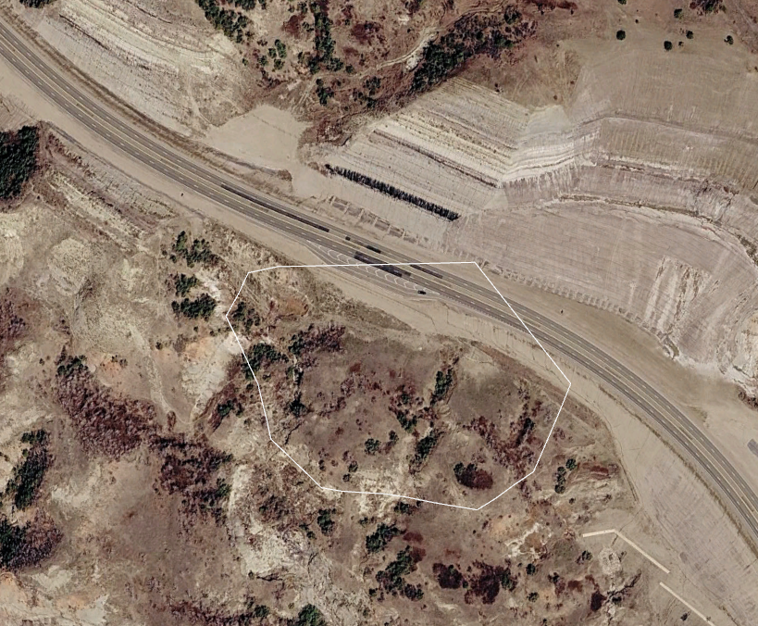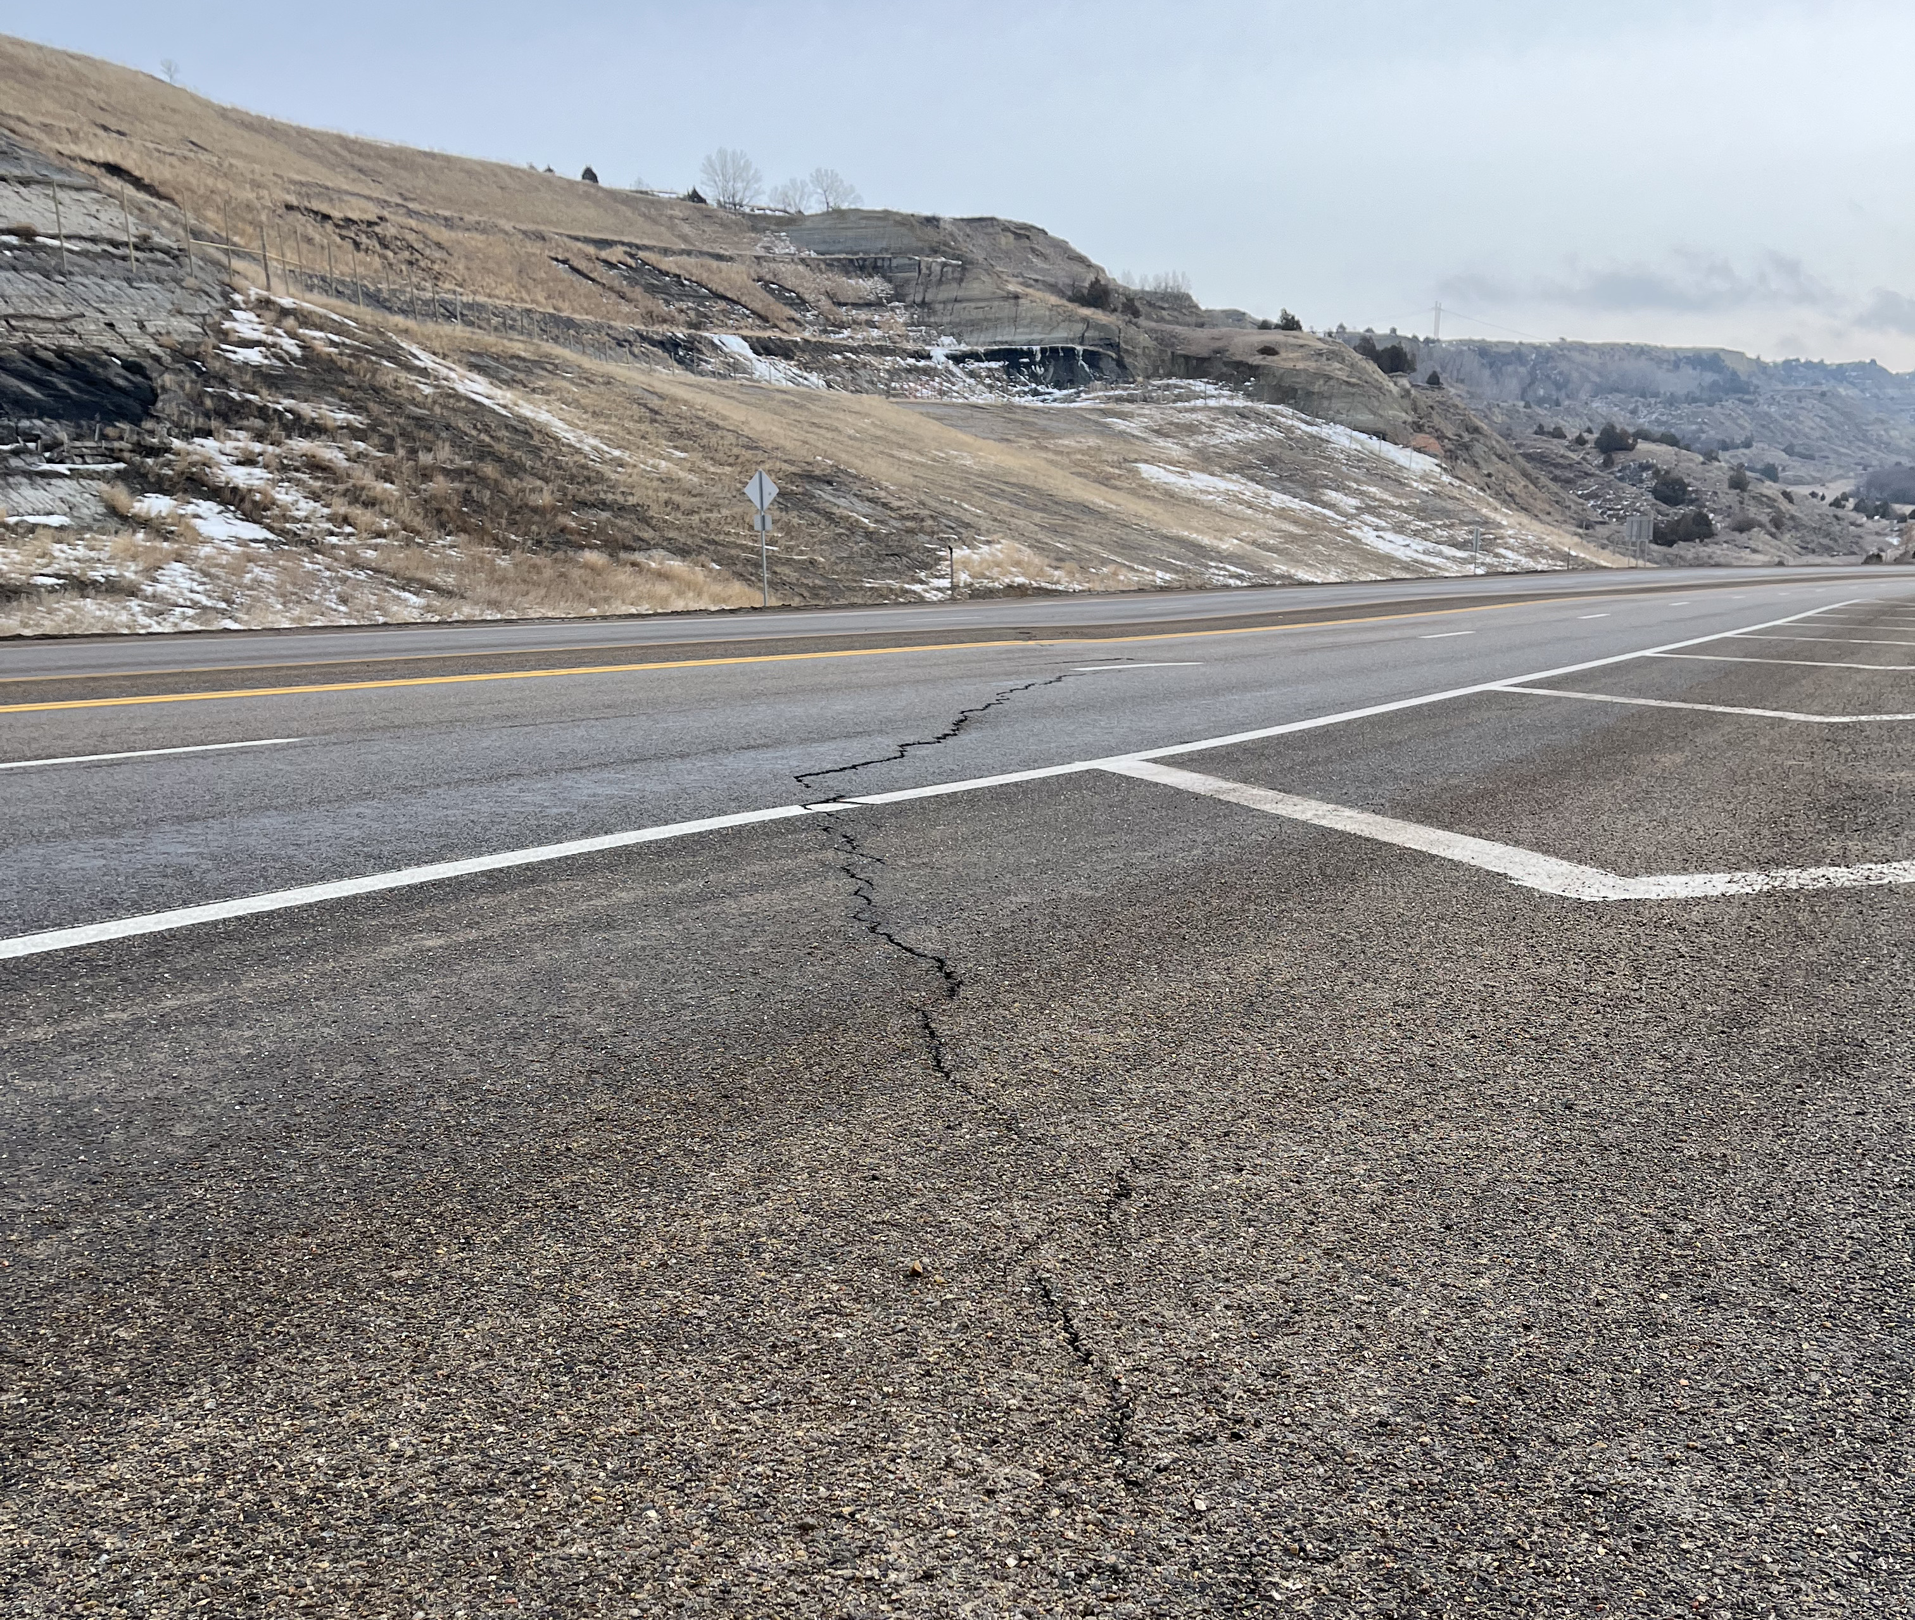

This project is to evaluate mitigation alternatives for a landslide on Highway 85 at roughly RP 128 adjacent to the existing scenic overlook. The consultant will install and manage instrumentation data, perform a change detection study, and assist the NDDOT Geotechnical Section in development of the Mitigation Alternatives Report.

The Department will complete the geotechnical drilling and any permitting, permissions, or coordination required to gain access for borings off the right of way. The consultant will coordinate with the Department and be available to install instrumentation as borings are completed.

SCOPE OF SERVICES
The NDDOT intends to execute one cost plus fixed fee contract requiring monthly billings with the selected consultant. The NDDOT reserves the right to assign work in phases and have the selected consultant perform any additional work not initially assigned. Project work items may be added or removed from the contract by work authorization or supplement agreement.

Consultants will allow 14 days for the review and/or approval of project deliverables by the NDDOT. The schedule will indicate which project phase the deliverable will begin. All deliverables must be submitted to allow time for approval from the NDDOT and all permitting agencies prior to the bid ready date. The NDDOT is not responsible for added cost or lost time for the rework of the project deliverables.

Interviews will be conducted tentatively 14 days from the due date of this proposal.

Attached with the RFP are the Milestone, an example report, and the Risk Management Appendix

PROJECT PHASING
Phase I, Scoping
Phase I will include conducting a field review and developing an approved scope of work and hours for Phase II. The scoping/field review will include a discussion of the work completed to date.

The consultant will have 30 days, from the date that the Phase I contract is executed, to conduct the scoping meeting and field review and to secure an approved scope of work and hours. A preliminary scope of work and hours shall be provided by the consultant within 21 days of signing the contract. Pending NDDOT approval of the scope of work and hours completed in Phase I, the NDDOT may authorize the consultant to perform Phase II and any additional work not currently assigned or completed in Phase I.

Phase II, Change detection analysis, Instrumentation installation, Report Development
Phase II consists of all activities necessary to complete the change detection analysis, instrumentation installation, management/maintenance of instrumentation and data, and Landslide Mitigation Alternatives Report. Phase II will be considered complete upon finalization of the Landslide Mitigation Alternatives Report.

PROJECT SUBMITTALS
All design and project data will become the property of the NDDOT upon completion of the final submittal. Generate all project information in the following formats and standards:
• MS Word and MS Excel
• MicroStation 24.00
• OpenRoads Designer 24.00
• NDDOT CADD Manual
• Microsoft “Project”
• NDDOT Preliminary Surveys Manual requirements
• NDDOT Design Manual and Plan Preparation Guide Website
• NDDOT Right of Way Manual
• Adobe Acrobat (standard or compatible)

All project submittals must follow WCAG 2.1, Level AA compliance according to the Americans with Disabilities Act (ADA) Title II.

DRONES
The American Security Drone Act of 2023 (ASDA) and OMB Memorandum M-26-02ll prohibits the use of drones manufactured by foreign companies on Federal Aid projects. Drone platforms, payloads, ground control systems, communications equipment, and related technologies used must be compliant with NDAA Section 889 restrictions. Documentation of compliance may be requested by the Department.

EVALUATION AND SELECTION PROCESS
Consultants interested in performing the work must submit one electronic copy in PDF format prior to the date and time listed on the cover of this RFP. Late proposals will not be considered.

Submit proposals by email to Chad Taylor cataylor@nd.gov with copies to Joy Glasoe jglasoe@nd.gov and Adam Cahlin acahlin@nd.gov.

Each proposal must contain a cover letter signed by an authorized officer who can sign contracts for the consultant. Include the email addresses of these individuals. The pages of the cover letter will not be counted as a part of the pages.

The proposal pages shall be numbered and must be limited to five pages in length. Proposals that exceed the page length requirement will not be considered. This section should contain your approach and project specific plan.

Include an updated Federal Standard Form 330 if you do not have one on file with CAS.

The consultant’s proposal shall include an appendix. The pages in the appendix will not be counted as a part of the pages. The appendix shall include the following in this order:

Appendix A
Include a proposed work plan with milestone activities through project completion.

Appendix B
A staffing plan identifying the key project personnel (including titles, education, and work experience) and the respective roles and responsibilities for the project.

Appendix C
Project Specific QC/QA Plan including check lists, persons, responsibilities, proposed submittals and reviews, and DOT response timelines. The QC/QA Plan will be reviewed by the NDDOT and become part of the project after the contract has been signed.

Appendix D
Subconsultants and associated activities to be completed by the subconsultants. Attach proposed sublet form SFN 60232 for each sub at the end of this section.

Each proposal will be evaluated by a selection committee consisting of NDDOT staff members and/or representatives. The NDDOT reserves the right to limit the interviews to a minimum of three consultants whose proposals most clearly meet the RFP requirements. Consultants not selected to be interviewed will be notified in writing.

Selection will be based on the following weighted criteria:
10% | i. Past performance
15% | ii. Ability of professional personnel
10% | iii. Willingness to meet time and budget requirements
05% | iv. Location
10% | v. Recent, current, and projected workloads of the persons/consultants
15% | vi. Related experience on similar projects
10% | vii. Recent and current work for the agency
25% | viii. Project understanding, issues, and approach

Weights for each criterion are assigned independently for each specific project by CAS and the
Project Technical Representative. Maximum total weight is 100 points.

Shortlisting
Depending on the amount of interest for this solicitation, proposals may be subject to shortlisting. Following a review and evaluation of submitted proposals, the top three aggregate scorers will automatically have an interview, and additional firms may be invited to interview depending on point separation or natural breaks in aggregate scoring. Scoring categories match those stated previously. All firms that responded to the advertisement will be notified of the shortlisting determination and the reasons of the committee for selecting those to be interviewed. Shortlist scoring is independent of the interview scoring.

REQUEST TO SUBLET
Subconsultants that have been contacted and agree to be listed on the prime consultant’s project proposal must submit one copy of SFN 60232, Proposed Subconsultant Request to be attached to the proposal. This form is used for informational purposes only.

Prime consultants shall include a SFN 60233, Prime Consultant Request to Sublet form for each subconsultant prior to execution of the contract. The form assures that the contract between the prime consultant and all subconsultants contains all the pertinent provisions and requirements of the prime contract with the NDDOT.

*CIVIL RIGHTS
The North Dakota Department of Transportation, in accordance with the provisions of Title VI of the Civil Rights Act of 1964 (78 Stat. 252, 42 U.S.C. §§ 2000d to 2000d-4) and the regulations, hereby notifies all bidders that it will affirmatively ensure that any contract entered into pursuant to this advertisement, disadvantaged business enterprises will be afforded full and fair opportunity to submit bids in response to this invitation and will not be discriminated against on the grounds of race, color, or national origin in consideration for an award.

*Title VI/Nondiscrimination and ADA
Title VI assures that no person or group of persons may, on the grounds of race, color, national origin, sex, age, or disability, be excluded from participation in, be denied the benefits of, or be otherwise subjected to discrimination under any and all programs or activities administered by the Department. For information regarding Title VI, see the Title VI/Nondiscrimination and ADA Program at 2025-Title_VI_Nondiscrimination_and_ADA_Program_Implementation-Plan.pdf

*These requirements apply to every consultant on the project including every tier of subconsultant. It is the consultant’s or subconsultant’s responsibility to include these two paragraphs in every subcontract.

PROMPT PAYMENT
Consultants will be required to make prompt payment to subconsultants as required by 49 CFR 26.29. The consultant must make payment to all subconsultants within thirty (30) calendar days from receipt of payment from the State. Such payment must be certified by the Consultant by submittal of the subsequent Consultant Contract Billing Form to the State. The State may withhold subsequent payment(s) to the Consultant if any subconsultants have not been paid for work satisfactorily completed.

RIGHT OF REJECTION
The North Dakota Department of Transportation reserves the right to reject any or all proposals.

DISCLOSURE OF PROPOSAL
At the conclusion of the selection process, the contents of the shortlisted proposals will be subject to North Dakota's Open Records Law and may be open to inspection by interested parties. Any information included in the proposal that the proposing party believes to be a trade secret or proprietary information must be clearly identified in the proposal. Any identified information recognized as such and protected by law may be exempt from disclosure.

AUDIT
Consultants proposing to do work for the NDDOT must have an approved audited rate that is within 12 months of the close of the consultant’s fiscal year. Consultants that do not meet this requirement will not qualify to propose or contract for NDDOT projects until the requirement is met. Consultants that have submitted all the necessary information to the NDDOT and are waiting for the completion of the audit will be qualified to submit proposals for work. Information submitted by a consultant that is incomplete will not qualify. Out of state consultants can submit a current accepted Federal Audit Regulation (FAR) audit rate from a cognizant agency. Under certain conditions NDDOT may offer a Safe Harbor Rate of 110% to consultants that do not have a compliant rate.

RISK MANAGEMENT FOR PROFESSIONAL SERVICES
The Risk Management Appendix/Addendum will be incorporated into the agreement between NDDOT and the consultant.

Consultants must provide a proper Certificate of Insurance within 15 days of notification of selection.

CONSULTANT EMAIL CONTACTS
If necessary, please update contact information for receiving emails and phone calls.

