REQUEST FOR PROPOSALS
FOR TRANSPORTATION PLANNING SERVICES

The Bismarck-Mandan Metropolitan Planning Organization (MPO) request proposals from qualified consultants for the following project:
2026 Transit Development Plan

Qualifications based selection criteria will be used to analyze technical proposals and interviews from responding consultants. The MPO reserves the right to reject any or all proposals. This project has a not to exceed budget of $180,000.
Interested firms should contact, Paulette Jacobsen, Transit Planner, at the Bismarck-Mandan MPO, 221 N 5th Street P.O. Box 5503, Bismarck ND 58506. Contact can also be made via phone 701.355.1473 or by email: pjacobsen@bismarcknd.gov

All proposals received by 5:00 PM (Central Time) on Monday, March 16, 2026, will be given consideration for an interview. The Bismarck-Mandan MPO reserves the right to limit the interviews to a maximum of five (5) firms whose proposals most clearly meet the RFP requirements. Firms will be notified in writing or by phone of shortlist results. Successful candidates will receive date, time and location information for the interviews.
It is the responsibility of the consultant to ensure all required elements of the proposal are submitted. Proposals missing required elements will be rejected and consultants will be denied interviews.

Respondents must submit one (1) electronic copy of the proposal. The full length of the proposal shall be no more than eight (8) pages. Appendix material is not counted toward the eight (8) page limit. Submittals must be received no later than 5:00 PM (Central Time) Monday, March 16, 2026, and may be emailed to:

pjacobsen@bismarcknd.gov

Once submitted, the proposals become the property of the MPO. Proprietary information must be clearly noted in the proposal, or it will be subject to open records laws.

REQUEST FOR PROPOSAL
TO PERFORM PLANNING SERVICES FOR:

Transit Development Plan

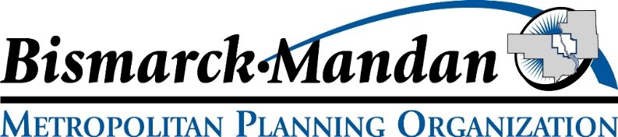


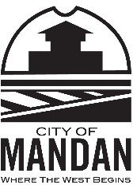


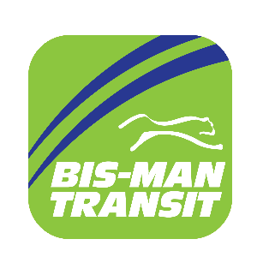

BISMARCK-MANDAN METROPOLITAN PLANNING ORGANIZATION

Paulette Jacobsen Transit Planner

PROPOSALS MUST BE DELIVERED TO BISMARCK-MANDAN MPO
BY 5:00 P.M. Central Time, Monday, March 16, 2026

Contents
I: PURPOSE OF THE REQUEST 4
II: GENERAL INSTRUCTIONS 4
III: CONTENT OF PROPOSALS 6
IV: ADDITIONAL REQUIREMENTS AND MISCELLANEOUS INFORMATION 7
V: EVALUATION CRITERIA AND PROCESS 8
VI: REGIONAL CONTEXT AND EXISTING CONDITIONS 8
VII: OBJECTIVE 10
VIII: STUDY AREA 11
IX: SCOPE OF WORK 12
X: REVIEW AND COMPLETION PROCESS 14
XI: PUBLIC INVOLVEMENT PLAN 15
XII: INFORMATION AVAILABLE TO THE CONSULTANT 16
Appendix A: Proposed Sub-Consultant Request Form
Appendix B: Consultant Self Certification of Government-Wide Debarment and Suspension (Nonprocurement) Form Appendix C: Certification and Restriction on Lobbying Form
Appendix D: Federal, State and Local Clauses

PURPOSE OF THE REQUEST
The purpose of this Request for Proposals (RFP) is to provide interested consulting firms with enough information about the professional services desired by the Bismarck-Mandan Metropolitan Planning Organization (MPO) for the following project:
2026 Transit Development Plan
The MPO is requesting services to complete an evaluation and operational analysis of the transit system managed by Bis-Man Transit, which serves Bismarck, Lincoln and Mandan, ND. This study will be in cooperation with the cities of Bismarck, Lincoln and Mandan; the Bis-Man Transit Board, the North Dakota Department of Transportation (NDDOT), the Federal Highway Administration (FHWA), and the Federal Transit Administration (FTA).

GENERAL INSTRUCTIONS

A. Any questions or comments regarding this proposal should be submitted to:

Paulette Jacobsen Bismarck-Mandan MPO 221 N 5th Street
P.O. Box 5503
Bismarck, ND 58506-5503
Phone: 701-355-1473
pjacobsen@bismarcknd.gov
B. Proposals shall be submitted to:
Paulette Jacobsen pjacobsen@bismarcknd.gov
C. All Proposals must be clearly identified and marked as follows:

NAME OF SUBMITTING FIRM
Proposal for:
2026 Transit Development Plan Bismarck-Mandan MPO
D. The MPO will only consider proposals received prior to 5:00 PM (Central Time) on Monday, March 16, 2026. One (1) electronic copy must be received by the deadline. Electronic copies may be emailed to: pjacobsen@bismarcknd.gov. Proposals received after the 5:00 PM deadline will be considered unresponsive and will not be considered for an interview. The MPO reserves the right to reject any or all proposals.
E. Proposal Cut Down:
The Selection Committee intends to interview between three (3) and five (5) consultants, depending on the number and quality of proposals received. Strength of the written proposals will be the basis for awarding an interview. Consultants who are awarded an interview will be notified by phone or email between March 24-26, 2026. Consultants not selected for an interview will be notified in writing.

F. Selection Committee:
The Selection Committee will consist of a five (5) person panel; four (4) voters and one (1) moderator. Committee members represent the following entities: City of Bismarck, City of Lincoln, City of Mandan, Bis-Man Transit. The MPO Project Manager will moderate the interviews. In the case of a first ranked tie, the moderator’s ranking will provide the tie-breaking score.
G. Interviews:
Consultants will be evaluated on both the written proposal and interviews, which may be conducted either in-person or remotely (TBD). Ranking is based on the criteria listed in Section V: Evaluation Criteria and Process. Interviews are planned to be held April 13 – 16, 2026. Consultants will be given forty-five (45) minutes for their proposal and Q&A. Consultants manage their own time and are encouraged to leave space at the conclusion of their presentation for questions and answers. If remote, the MPO project manager will provide a TEAMs link for the interview.
H. Selection and Approvals:
Selection will be based on the interview committee’s recommendation. All interviewees will be notified of the selection results in writing. Approval of the top ranked consultant will be requested of the MPO’s TAC and Policy Board on April 20 & 21, 2026, respectively.
- Contract Negotiations:
Contract development will begin immediately after Policy Board approval of the top-ranked consultant. The MPO has a template contract which will be used for the study. Consultant will be required to prepare a scope of work and final fee schedule, which will be included in the contract. The draft contract is reviewed by MPO Staff, its partners, and legal counsel(s). After negotiations, the MPO intends to execute the contract upon staff authority. (Disclaimer: This contract will be subject to a financial assistance contract between the state of North Dakota and the USDOT).

Final negotiations will include submission of:
  - Prime Consultant scope of work and final fee schedule not exceeding $180,000 (programed in 2026 to spend up to $99,338 & programed in 2027 to spend remaining balance of the not to exceed $180,000 total study budget)
  - Scope of work and fee schedule for ALL Subconsultants
  - Prime Consultant Certificate of Liability Insurance
  - Prime Consultant Indirect Cost Form (blank form will be provided by MPO)
  - SFN 60233: Prime Consultant Request to Sublet Form (blank form will be provided by MPO)
  - Up-to-date SF330 Form for NDDOT (See Section III: Content of Proposals).

CONTENT OF PROPOSALS

Length of Proposals:
The length of the main body of the proposal shall be limited to eight (8) pages and these pages shall be numbered. The cover page, the table of contents, and the appendix material are not counted in the (8) page limit. These may be numbered distinct from the main body or not numbered all, and consultants may use as many pages as needed for these elements.

Required Elements for Proposal:
The consultants are requested to be as brief and concise as possible. The main body of the proposal shall address the following major sections:
  - Description of firm
  - Organizational chart showing project team and general activities
  - Table of key individuals’ time-available for project/study
  - Understanding of project and proposed work approach
  - Brief examples of past, pertinent work projects

Required Elements for Appendix:
The consultant’s appendix must include the following items unless noted as ‘optional’. The following items will not count toward the eight (8) page limit and may take as many pages as needed.
- Proposed Project Schedule: Proposed schedules may begin as soon as May 15, 2026, and should detail all activities necessary to complete the study. Activities may include but are not limited to:
  - Contract Negotiations
  - Monthly Updates (via telephone or in person) to MPO TAC and Policy Boards
  - Updates (as needed) to the Bis-Man Transit Board.
  - Data Acquisition (provided, as available, by MPO, NDDOT, City of Bismarck, City of Lincoln, City of Mandan, and Bis- Man Transit)
  - Stakeholder Interviews/ Bis-Man Transit Board
  - Steering Committee Meetings/ Activities
  - Public Outreach Activities (webpage, meetings, social media, news releases, etc.)
  - Public Input Meetings
  - Documents/Tech Memos for Study Milestones
  - Draft Report Development
  - Draft Report Review by Steering Committee, MPO, NDDOT, FHWA, and FTA (required before presentation to the Bis-Man Transit Board, City Commissions, and MPO Boards)
  - Final Presentations to the Bis-Man Transit Board, Bismarck City Commission, Lincoln City Council, Mandan City Commission, MPO TAC and Policy Board.

- Quality Control/Quality Assurance (QC/QA) program: Detail the program that will be used on the project. This (QC/QA) program must identify the team members, their responsibilities, and stages of development at which each is to be responsible.
- Required Qualification Based Selection (QBS) Documents:
  - Signed Proposed Sub-Consultant Request Form (Appendix A)
  - Signed Consultant Self Certification of Government-Wide Debarment and Suspension (Nonprocurement) Form (Appendix B)
  - Signed and Notarized Certification and Restriction on Lobbying Form (Appendix C)

- Resumes or list of Personnel: Detail who will be assigned to work on the project (including titles, education, and/or work experience).

- Optional: Consultants are encouraged to update or complete a Federal Standard Form 330 (Architect-Engineer Qualifications). The SF 330 is an NDDOT requirement, and proves the consultant is pre-qualified to provide architectural, engineering and/or planning services for NDDOT. Consultants will not be penalized if the SF 330 is omitted in their proposal, but the consultant selected for contract negotiations must provide an active SF-330 before the contract can be signed.

See https://www.gsa.gov/system/files/2024-08/SF330-21a.pdf for link to the SF 330. All SF 330 forms will be kept on file by the MPO and forwarded to NDDOT.

Disclosure of Proposal Ownership:
At the conclusion of the selection process, the contents of all proposals will be subject to the City of Bismarck’s Open Records Law and may be open to inspection by interested parties. Any information included in the proposal that the proposing party believes to be a trade secret or proprietary information must be clearly identified in the proposal. Any identified information documented as such and protected by law may be exempt from disclosure.

IV: ADDITIONAL REQUIRMENTS AND MISCELLANEOUS INFORMATION

State, Federal and Local Contract Requirements:
The City of Bismarck as the MPO’s Host Agency, the NDDOT, and FHWA require that specific clauses accompany federally funded projects executed by the MPO. Consultants should be prepared to abide by the necessary clauses which are included verbatim and unaltered in all potential MPO contracts. The clauses can be reviewed in Appendix D: State, Federal and Local Clauses.

Ownership of Work Product:
One additional clause not included in Appendix D, but required due to the use of Federal Funds, is the ‘Ownership of Work Product Clause’. Consultants and subconsultants should be prepared to abide by the following:
Ownership of Work Product: All work products and copyrights of the contract, which result from the contract, are the exclusive property of Bismarck-Mandan Metropolitan Planning Organization (BMMPO) and North Dakota Department of Transportation (NDDOT), with an unlimited license for use by the federal government and its assignees without charge.

General Information:
Bismarck-Mandan MPO reserves the right to enter into a supplementary agreement to have the selected firm perform any additional work not currently assigned.
If the contract is terminated prior to completion of the final report, all work completed, which has been compensated for, shall become the property of the Bismarck-Mandan MPO and NDDOT, as per the ‘Ownership of Work Product’ Clause.
The final report will be submitted using the following formats and standards, if applicable:
- MS Word/ MS Excel
- Adobe Acrobat (Standard or Compatible)
- NDDOT Data Collection Codes and Procedures
- NDDOT and/or City, as applicable, Drafting Standards
- NDDOT Design Manual
- ArcGIS Online
- GIS Shapefiles

EVALUATION CRITERIA AND PROCESS

The selection process will be completed in accordance with Bismarck-Mandan MPO policies. Written proposals shall address the firm’s ability to perform the necessary services in the allotted time with qualified personnel. Selection will be based on an array of measures chosen from the following criteria:
  - Recent, current, and projected workloads
  - Ability of professional personnel (staff experience and technical capabilities)
  - Related experience on similar projects
  - Location
  - Project understanding, issues and approach
  - Past Performance
  - Willingness to meet time and budget
  - Recent and current work for the agency
  - Project Schedule
The final selection will be based on written proposals along with in-person interviews. All firms not selected will be notified in writing.
A final scope of work will be developed, and cost will be negotiated with the successful firm. An agreement will be executed with a single firm. If unable to arrive at a mutual agreement with the top ranked firm, the MPO retains the right to move on to negotiations with the second (then third, etc.) ranked firm. Approved sub-agreements for minor portions of the work will be permitted.

REGIONAL CONTEXT AND EXISTING CONDITIONS

Bismarck-Mandan MPO Region:
The Bismarck-Mandan MPO consists of the cities of Mandan, Bismarck, and Lincoln, and the metropolitan portions of Burleigh and Morton County. The MPO has a performance-based planning process that supports metropolitan community development and federal, state and local transportation goals. These plans and programs are intended to lead to the development of an integrated, multi-modal metropolitan transportation system that facilitates the safe, efficient and economic movement of people and goods.

The MPO planning area is roughly 394 square miles and is bisected from north to south by the Missouri River and is generally comprised of rolling topography throughout. The MPO area has a population of approximately 123,000 and 50,000 households (Source: US Census Bureau 2020 Decennial Census). One of the more noteworthy challenges facing the MPO planning area is the heightened level of growth, experienced largely due to energy development in western North Dakota from 2011-2015. Historic growth trends in the MPO area have traditionally hovered within a 1% to 1.5% annual rate of population growth. The currently adopted growth projection is a “Continuation of Past Trends”, or a 1.1% annual growth rate for the period between 2025 and 2050.
While the population growth is generally perceived as positive, there are some noteworthy concerns, specifically: the impact of recent growth on public service costs, the continued ability of the MPO region to grow in an efficient manner, and the ability to maintain the high quality of life enjoyed by residents of the communities. Heightened rates of growth strain many aspects of the region’s transportation infrastructure and create increased demands on area municipal services, schools, and transportation. Topography, man-made barriers, and historical development patterns have contributed to challenges regarding roadway connectivity. The MPO’s local jurisdictions have worked diligently to meet these needs and now must develop a balance to accommodate the expanding systems but also maintain current, aging infrastructure.
The MPO has a planning process that supports metropolitan community development and social goals. These plans and programs are intended to lead to the development of an integrated, multi-modal metropolitan transportation system that facilitates the safe, efficient and economic movement of people and goods.

Bis-Man Transit:
The Bis-Man Transit system was originally developed in 1989-1990. It was designed as a coordinated transportation system to replace several smaller individual programs.
Transit services are run out of the Bis-Man Transit offices, located at 3750 East Rosser Avenue. This location also serves as the regular stop and depot for the Jefferson Lines inter-state bus service.

The City of Bismarck is designated as the grantee for Federal Transit funds and owns the building, vehicles and equipment of the Bis-Man Transit service. The City passes federal funds to the Bis-Man Transit Board, who is the broker for public transportation in the community. Numerous City departments, as well as the MPO, provide monitoring and oversight of Bis-Man Transit’s administrative processes to ensure federal requirements are met and maintained.

The Bis-Man Transit Board is comprised of nine members. Board members serve voluntarily and have three-year terms. Placement onto the board is achieved through individual application followed by popular vote of the current board’s contingency. The Board provides members to an Executive Committee, a Finance Committee, and an Administrative Committee which confer on committee-specific items. The Board also considers recommendations provided through a citizen-led advisory committee known as CTIC (Community Transportation Input Committee). The Bis-Man Transit Board employs three staff persons to manage the administrative duties of the Transit offices: a Transit Executive Director, a Marketing and Mobility Specialist, and a Transit Accountant.

The Bis-Man Transit Board contracts with We Drive U (formerly National Express), to operate the area’s public transportation service. We Drive U provides all drivers, dispatchers, and maintenance personnel, as well as the management to employ these persons. We Drive U also staffs the Jefferson Lines bus depot.

Bis-Man Transit, as a public transportation service, has two operational components. The paratransit service, which was the community’s original service, is called Bis-Man Transit. The fixed-route service, which began in 2003, is known as Capital Area Transit (CAT). Weekly paratransit services run 18.5 hours on Monday thru Saturday (5:30am -12am) and seven hours on Sunday (7:30am - 2:30pm). Weekly CAT service runs 12 hours on Monday thru Friday (7:00am – 7pm), six hours on Saturday (8:00am – 7:00pm), and zero hours on Sunday.

The Bis-Man Transit Board, their staff, and We Drive U have looked into alternative modes of public transportation. This includes a premium demand-response option which can be made available to the entire community (and not only paratransit eligible individuals) or other micro-transit opportunities. They would like to continue this investigation in the current study.

The paratransit service logged approximately 489,458 miles within the Bismarck-Mandan service area and the City of Lincoln in 2025. The CAT fixed-route service logged 343,370 miles in the same period but does not extend to Lincoln.
The paratransit service made 92,760 trips in 2025, and the CAT fixed-route service made 138,073 trips in the same period.
In 2017, the Bis-Man Transit Board, with approval from the Bismarck City Commission, implemented service changes that reduced the hours of service and eligibility for paratransit ridership. These changes were an attempt to ‘right-size’ the operations and become more financially sustainable. These changes did decrease paratransit ridership somewhat and produced a very small shift to fixed-route ridership. Further, the last fixed-route re-design occurred in 2021. The Bis-Man Transit Board and staff are relatively pleased with these service changes.

Monthly CAT ridership listed in the table below:

CAT Bus | 2021 | 2022 | 2023 | 2024 | 2025
January | 3,878 | 5,131 | 6,950 | 8,537 | 11,938
February | 4,065 | 5,209 | 6,433 | 9,571 | 11,065
March | 4,488 | 5,802 | 6,911 | 9,142 | 12,193
April | 4,087 | 5,056 | 7,598 | 8,956 | 13,005
May | 4,559 | 5,765 | 9,145 | 9,399 | 12,637
June | 4,694 | 5,784 | 9,090 | 9,083 | 11,400
July | 4,096 | 7,154 | 8,626 | 8,788 | 10,462
August | 4,770 | 7,635 | 8,816 | 11,576 | 10,877
September | 5,298 | 6,954 | 8,900 | 11,157 | 10,633
October | 6,147 | 7,822 | 10,756 | 13,348 | 12,186
November | 5,604 | 7,139 | 9,609 | 11,421 | 10,801
December | 5,058 | 5,145 | 7,702 | 10,560 | 10,876
 | 56,744 | 74,596 | 100,536 | 121,538 | 138,073

Monthly paratransit ridership listed in the table below:

Paratransit | 2021 | 2022 | 2023 | 2024 | 2025
January | 6,066 | 7,439 | 7,962 | 7,333 | 8,107
February | 6,194 | 7,197 | 7,506 | 7,300 | 7,270
March | 7,495 | 8,720 | 8,006 | 7,721 | 7,955
April | 6,825 | 6,559 | 7,067 | 7,706 | 8,108
May | 6,834 | 8,074 | 7,832 | 7,622 | 7,840
June | 7,437 | 8,217 | 7,925 | 6,768 | 7,496
July | 7,324 | 7,521 | 6,846 | 7,288 | 7,989
August | 7,903 | 8,424 | 7,067 | 7,598 | 7,812
September | 7,526 | 7,695 | 6,686 | 7,287 | 7,853
October | 7,825 | 7,809 | 7,616 | 8,388 | 8,267
November | 7,372 | 6,763 | 6,914 | 7,498 | 6,649
December | 7,402 | 6,012 | 6,324 | 7,698 | 7,414
 | 86,203 | 90,430 | 87,751 | 90,207 | 92,760

OBJECTIVE
The purpose of this study is to provide the Bismarck-Mandan MPO and Bis-Man Transit with a quality and usable guide to improve operations in a financially constrained manner. The study should evaluate and build upon the previous TDPs but provide additional guidance where improvement is needed.

The study should be comprehensive in its discussion of recommendations and potential outcomes. Recommendations should be achievable in a strategic manner and backed by a clear, logical rationale that is useful for decision-makers, staff, and community members. Exceedingly clear and thorough communication is required for this study.

VIII: STUDY AREA
The study area encompasses transits current service area, which includes the corporate limits of Bismarck and Mandan AND ¾ of a mile from an existing route. Routes may be viewed on the Bis-Man Transit website: www.bismantransit.com/

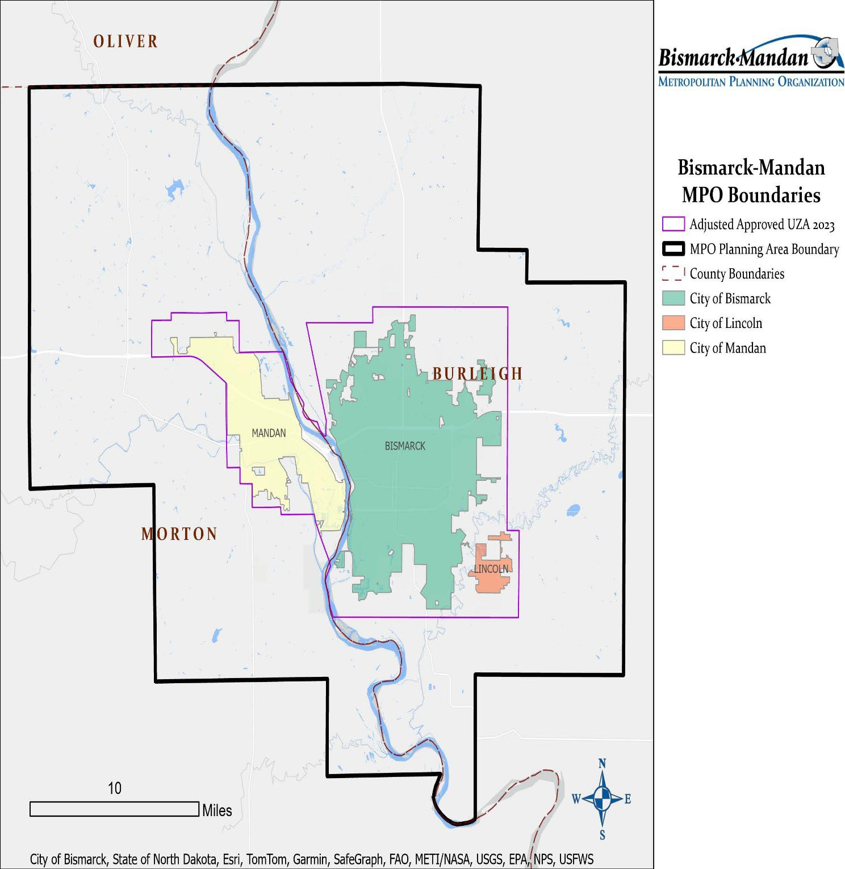

SCOPE OF WORK
Project Management:
This task involves activities required to manage the project including staff, equipment, and documentation. It also includes the preparation of progress reports, documenting travel and expense receipts, and preparing and submitting invoices in a timely manner (monthly). This task includes monthly progress reports to the MPO, Bis-Man Transit Board and Transit Staff, the Technical Advisory Committee, and to the Policy Board.
Steering Committee:
The MPO project manager will assist the consultant in developing a Steering Committee(s) for the study. The Committee(s) may contain but are not limited to the following members:
  - City Engineers/ City Traffic Engineers
  - City Planners
  - Staff of Bis-Man Transit
  - Staff member(s) of the MPO
  - Human Service Providers representing seniors and/or individuals with disabilities
  - Members of the CTIC
  - City representative staff for the interests of Bismarck, Mandan and a Lincoln city official familiar with transit operations in their community.
  - Transit Board Members (preferably not to exceed a quorum)
  - NDDOT Local Government Division
  - FHWA
  - FTA
The consultant shall meet with the Steering Committee periodically, and as necessary, during the study process to review data and recommendations.
The consultant shall provide progress/technical memorandums at key points throughout the study process. Sufficient copies shall be provided for the distribution to the Steering Committee.
Involvement with the Transit Board:
Consultant is expected to regularly meet with the Transit Board and consider their input in identifying the future vision for Transit and recommendations for the Transit Development Plan. Study updates should be given to the Transit Board every 2-4 months, or as needed. These presentations are intended as general updates, not opportunities to steer the study. For this effort, the Transit Board has been asked to designate members to sit on the steering committee and/or participate in Full-Board design charrettes to provide guiding input.

- Objective
  - Identify the long-term vision for transit in our community. Consider the needs and wishes of Users, Citizens, Commissions, and Transit Board and Transit Staff.
  - Involve the public in further discussion on funding challenges for Transit. How can transit involve the community so they better understand the ‘why’ behind service changes so that Transit’s reputation remains favorable in the communities.

- Facility/Service Analysis and Peer Comparisons
  - Evaluate the effectiveness of the current fixed-route system
    - Headway and Frequency
    - Routes
    - Flag System versus Designated Stop
  - Limited comparison of the facility/services versus peer communities (to exclude 2026 service changes)
  - Limited comparison of cost of services to peer communities (to exclude 2026 service changes)
- Facility/ Service Recommendations
  - Review current fixed route system. Identify potential changes/ additions to fixed routes.
  - Evaluate alternative types of Transit services
    - Community Circulator Routes
    - Micro-Transit
    - Mobility Hubs
    - Flex Routing
  - Develop recommended location for additional fixed bus stops and outline entities/avenues for funding new stops.
  - Evaluate community need for a new central Transit Hub.
  - Tie services recommendations back to public comments and financial forecast.
  - Identify potential impact to brokerage contract resulting from recommended service changes.
  - Identify how transit service could provide expanded transportation options and enhance connectivity as a compliment to restored passenger rail service.
Policy Guidance & Federal Requirements:
Consultant should review local, state and federal policies and requirements that impact the operations and performance of Bis-Man Transit in providing public transportation services. These may include but not be limited to:
- Safety and Security Performance Measures/Targets
- Transit Asset Management (TAM) Plan
- Address capital and operational needs to inform fiscally constrained and long-term phases in the next Metropolitan Transportation Plan (MTP).

Monthly TAC and Policy Board Meetings:
The consultant will provide monthly updates (i.e. progress reports) to the MPO TAC and Policy Boards. Updates will be conducted verbally and with written memorandums, briefly updating board members on the status of the project. A minimum of one (1) personal appearance is also required before the TAC and Policy Board during the development or completion of the study.
Public Involvement:
See Section XI: Public Involvement Plan for detailed information.

REVIEW AND CO MPLETION PROCESS

Draft Development and Review:
A draft report shall be produced after all recommendations have been developed and approved by the Steering Committee(s). Electronic and paper copies of the draft report shall be provided for the Steering Committee(s), the MPO project manager, the Bis-Man Staff, Bis-Man Transit Board or designees, NDDOT, FHWA and FTA for their review and comment. All comments from the MPO, NDDOT, FHWA, and FTA shall be addressed and documented to the respective entity’s satisfaction prior to development of the final draft and final presentations.

Final Presentations/ Completion:
The draft report shall be advertised and made available to the public for a minimum of fifteen (15) days before the final presentations. All comments received from public meetings and public input opportunities shall be addressed, summarized, and included in the appendix of the draft final report.

The consultant will be requested to make a presentation, either in person or remotely, to the Bis-Man Transit Board, the Bismarck Board of City Commissioners, Lincoln City Council, the Mandan Board of City Commissioners, the MPO Technical Advisory Committee and the MPO Policy Board for review and acceptance/approval of the draft final report. Approval of the draft final report by the MPO Policy Board, and subsequent distribution of study deliverables, will mark the completion of the study.

Deliverables:
The final study report shall be produced after all comments on the draft report are addressed, final presentations are complete, and the report has been approved by the MPO TAC and Policy Board. One (1) pdf-based electronic copy shall be provided. All products are to be delivered to the MPO project manager for dissemination to the appropriate City, Transit or MPO staff, Transit Board Member, TAC or Policy Board Members, and oversight entity.

Schedule for Contract Development and Final Study Deadline:

RFP Submittal Deadline March 16, 2026
Notification for Interviews March 24-26, 2026
Interviews and Notification of Ranking April 13 – 16, 2026
Consultant Approval(s) April 21, 2026
Formal Notification of Firms April 21 – 23, 2026 Negotiation of Work Fee and Scope of Work April 21 – May 08, 2026 Notice to Proceed May 15, 2026 (Approx.)
Final Project Report & Presentations October 31, 2027

PUBLIC INVOLVEMENT PLAN

Special Note: Consultants should expect a high degree of public engagement and public opinion from this study, particularly regarding any proposal to adjust paratransit services. The MPO and Bis-Man Transit recommend assigning staff who are well-versed in successful public engagement and mediation. This will help ensure all members of the public are respectfully heard and engaged throughout the study process.
In order to achieve the proposed vision for the Transit System, it is imperative that residents, businesses, human service providers, and stakeholders be involved in the development of the study. Direct effort should be made to obtain meaningful input and broad-based support from the community. Consultants shall prepare a Public Involvement Plan that is consistent with the MPO Public Participation Plan and complies with Title VI of the Civil Rights Act of 1964. The following are the minimum public involvement activities the consultant should include:
- The study will have two (2) public involvement opportunities for the general public. Each public involvement opportunity will consist of two (2) meetings, one in Bismarck and one in Mandan. The general public should include residents, businesses, and community stakeholders. Public involvement opportunities may be in-person, online, or hybrid. All input and attendance from the public input opportunities shall be recorded, and all concerns and suggestions will be addressed and included in the study document.
- A website for the study that will, provide up-to-date information, and be ADA compliant and be accessible to the public. The consultant is encouraged to include recorded versions of public presentations and provide additional opportunity for public comments.
- Six (6) final presentation meetings, with potential for each to be a public meeting. One meeting with each of the following entities:
  - Bis-Man Transit Board
  - Bismarck Board of City Commissioners
  - Lincoln City Council
  - Mandan Board of City Commissioners
  - MPO Technical Advisory Committee (TAC)
  - MPO Policy Board (PB)

Community Engagement:
Consultants are encouraged to reach out to the community at large and interested or affected community members. Consultants are encouraged to use novel means to inform the public and gather their opinions. Suggested ideas could include but are not limited to: flyers; updates in city bulletins, radio or television PSAs; coordination with local public or commercial media outlets; presentation to community/ business groups, and public meetings.

Online Engagement:
The consultant shall create a website to keep the public informed and engaged regarding the study. The website should include regular updates, including pertinent study documentations, maps, online surveys, public involvement opportunities, and the drafts and final reports. The website should also track hits/visits to the site.

Consultants are required to dedicate one or more staff to the development and maintenance of social media posts or other online engagement tools to enhance the public involvement process and encourage the public’s participation.

Newspaper Engagement:
Public meetings and final presentations will be advertised in the local newspaper(s). Consultants are responsible for preparing newspaper advertisements for public meetings and final presentations. The MPO reviews the ads, provides necessary modifications to language and formatting, and coordinates and pays for printing with the local newspaper(s).

XII: INFORMATION AVAILABLE TO THE CONSULTANT
The following resources/data/information are available for the project from the Bismarck-Mandan MPO and its partners:

Past Transit Plans:
- 2023 Transit Development Plan
- 2017 Transit Development Plan – 2019
- 2011 Transit Development Plan (Mobility 2017) – 2012
- 2006 Transit Development Plan
- Bis-Man Transit Management Alternatives Study – (2011)

Major MPO Documents:
- 2025-2028 Transportation Improvement Program
- Arrive 2050 (2025-2050 MTP)
- Travel Demand Model Review and Socio-Economic Projections Final Report – 2024

Pertinent MPO Transportation Studies and Data:
- Safety Policy Study - 2025
- Safe-Routes to Services Complete Streets Study - 2024
- East Main Avenue Corridor Study – 2023
- Sunset Drive Corridor Study - 2023
- ITS Architecture Update – 2025
- Bismarck-Mandan Intersection Analysis Study – 2020
- US 83 Alternative Study – 2019
- Downtown Mandan Subarea Study – 2018
- 2018 Freight Plan – 2018
- Bismarck-Mandan Bicycle and Pedestrian Plan – 2017
- Bismarck-Mandan School Safety Crossing Study – 2017
  - Bismarck Public Schools Final Report
  - Mandan Public Schools Final Report
- Mandan and Bismarck Corridors Improvement Study – 2016
- Northeast Bismarck Subarea Study – 2015
- Downtown Bismarck Subarea Study – 2014
- 2014 Fringe Area Master Plan – 2014
- Burleigh-Bismarck-Lincoln
- Mandan/Morton
- North Mandan Subarea Study – 2013
- 43rd Avenue Corridor Study – 2013
- North Mandan Subarea Study – 2013
- NW Bismarck Subarea Study – 2011
- Lincoln and Bismarck Connection Study – 2008
- Land base/Infrastructure data from member jurisdictions

MPO General Documents
- Bismarck-Mandan MPO Monitoring Report –2025
- MPO Public Participation Plan
- MPO Title VI/Non-Discrimination Plan

Partner/Jurisdictional Plans and Information:
- 2021-2025 Bis-Man Transit Ridership Statistics (revenue hours, miles, ridership, and on time performance)
- Together 2045: Bismarck Comprehensive Plan Update
- ND State Freight and Rail Plan
- Bis-Man Transit Coordinated Public Transit-Human Services Plan – 2022
- ND Moves Plan (Statewide Active and Public Transportation Plan) – 2019
- 2017 Bismarck Livability Survey Documents – 2017
- Mandan Land Use and Transportation Plan – 2015
- City of Bismarck Growth Management Plan – 2013

