REQUEST FOR PROPOSAL
June 21, 2024

TO PERFORM
PRELIMINARY ENGINEERING SERVICES
FOR PROJECT

6-297(015)002 PCN 24333
Grand Forks, nd – Hwy 297, Washington Street to North 6th street

ronald J. henke, pe
DIRECTOR
NORTH DAKOTA DEPARTMENT OF TRANSPORTATION

PROPOSALS MUST BE DELIVERED TO
Chad Taylor
ENVIRONMENTAL AND TRANSPORTATION SERVICES DIVISION
By
12:00 PM Central Time July 12, 2024
REQUEST FOR PROPOSAL (RFP)

PROJECT OVERVIEW
The North Dakota Department of Transportation (NDDOT) is requesting one qualified consultant to perform engineering and affiliated services including final design, environmental documentation, right of way acquisition, utility accommodations, and a complete project bid package to complete the following project:

6-297(015)002 PCN 24333: Grand Forks, ND – Hwy 297, Washington St to North 6th St
Work Type: Concrete Pavement Repair, Dowel Bar Retrofit, Grinding, Milling, & HMA Overlay
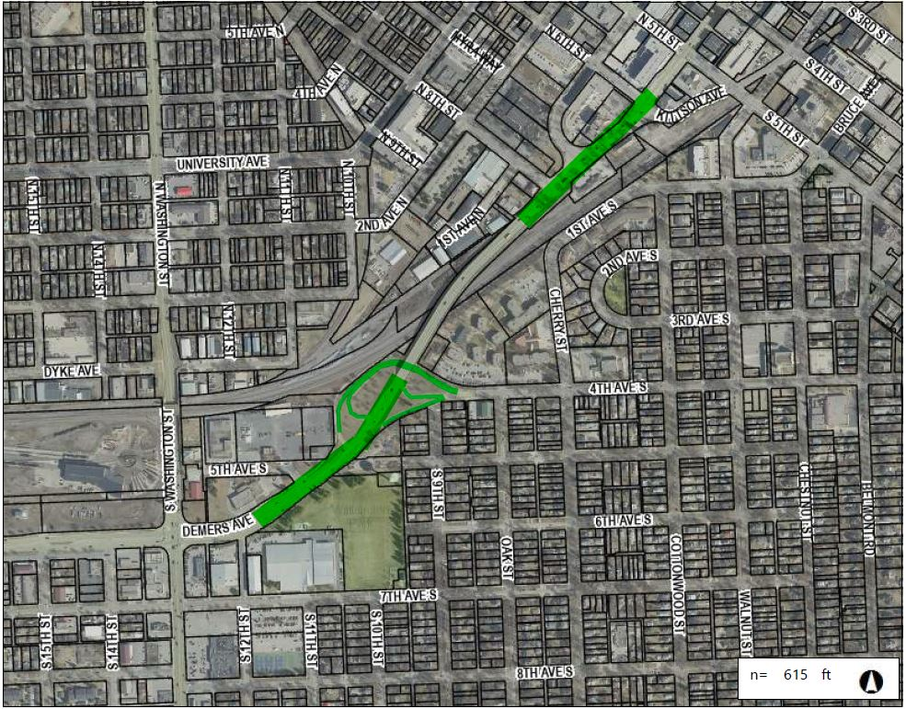
This project consists of concrete panel repairs, grinding, and selective dowel bar retrofitting along Demers Ave (ND Highway 297) from the Central Fire Station near Washington Street to N 6th Street. Along with concrete repairs, the project includes milling of existing asphalt surfaces within the project limits including the overpass ramps and adding a new 2.0” asphalt overlay. The overpass is excluded from project work.

Interviews will be conducted tentatively 14 days from the due date of this RFP.

The project must be completed on or before the Bid Ready Date of May 1, 2025.

Attached with the RFP is the Project Scoping Worksheet, Milestone, a Progress Report example spreadsheet, and the Risk Management Appendix.

SCOPE OF SERVICES
The NDDOT is requesting engineering services for all work necessary to provide environmental studies and documentation, preliminary engineering, preliminary and final design, permitting, right of way acquisition, utility accommodations, and construction plans for the stated project.

The NDDOT intends to execute one cost plus fixed fee contract requiring monthly billings with the selected consultant. The NDDOT reserves the right to assign work in phases and have the selected consultant perform any additional work not initially assigned. Project work items may be added or removed from the contract by work authorization or supplement agreement.

Proposals must include a proposed work plan and project schedule, milestone of activities, and staffing plan through project completion. The work plan must include all work activities and deliverables to be completed by the consultant and approved during scoping in Phase I.

Consultants will allow 14 days for the review and/or approval of project deliverables by the NDDOT. The schedule will indicate which project phase the deliverable will begin. All deliverables must be submitted to allow time for approval from the NDDOT and all permitting agencies prior to the bid ready date. The NDDOT is not responsible for added cost or lost time for the rework of the project deliverables.

PROJECT PHASING
Phase I, Scoping
Phase I will include conducting a scoping meeting, field review meeting, preliminary survey, and developing an approved scope of work and hours for Phase II. The scoping/kickoff meeting will include a discussion of the environmental document and work completed to date.

The consultant will have 30 days, from the date that the Phase I contract is executed, to conduct the scoping and kickoff meeting and to secure an approved scope of work and hours. A preliminary scope of work and hours shall be provided by the consultant within 21 days of signing the contract. Pending NDDOT approval of the scope of work and hours completed in Phase I, the NDDOT may authorize the consultant to perform Phase II and any additional work not currently assigned or completed in Phase I.

Phase II, Environmental Document and Preliminary Design
Phase II consists of all activities necessary to complete the environmental document (including FHWA concurrence and approval), perform preliminary design, analyze right of way impacts, and coordinate utility location and conflict plans. Environmental studies may be initiated in Phase I. Coordinate the environmental study and environmental checklist requirements with ETS Division. Phase II will be considered complete upon receiving environmental approval from FHWA and NDDOT approval of all other deliverables. Phase III may be negotiated and authorized based on the outcome of Phase II, consultant’s proposal, consultant’s performance, and available funding.

Phase III, Final Design
Phase III will consist of design activities following approval of preliminary design and preparation of final construction plans, specifications, and estimates, final utility conflict plans for adjustments and relocations, final right of way acquisition, and final mitigation plans and permitting. Phase III will be considered complete upon delivery and approval of final construction plans, specifications, estimates, certifications, and NDDOT, FHWA, and FRA approval of all other deliverables. Phase IV may be negotiated and authorized based on the outcome of Phase III, consultant’s proposal, consultant’s performance, and available funding.

Phase IV, Engineer of Record
Phase IV, if necessary, will consist of engineering services associated with Engineer of Record activities including, but not limited to, consultation and questions, pre-job meetings, plan revisions & change orders, and shop/work drawings. Phase IV does not include construction engineering.

PROJECT SCHEDULE
A proposed work plan and work schedule must be completed by the consultant and approved by the NDDOT. The work plan and schedule must include the completion date, bid ready date, work activities, and deliverables. If the consultant’s proposed schedule differs from the preliminary milestone (attached), the proposed schedule will be submitted to the Milestone Committee by the Contract Administrator for a milestone committee review. Once approved, the revised proposed milestone dates will be revised in the RIMS Milestone Program.

PROJECT SUBMITTALS
All design and project data will become the property of the NDDOT upon completion of the final submittal. All project information will be generated in the following formats and standards:
- MS Word and MS Excel
- MicroStation CE 10.17.2.61
- OpenRoads Designer 10.11.03.02
- NDDOT CADD Manual
- Microsoft “Project”
- NDDOT Consultant Services Manual Chapter 19
- NDDOT Procedure for Creating Right of Way Plats Manual Chapter 20
- NDDOT CADD Editing Manual Chapter 21
- NDDOT Data Collection Codes and Procedures
- NDDOT Design Manual and Plan Preparation Guide Website
- NDDOT Right of Way Manual
- Adobe Acrobat (standard or compatible)

RIGHT OF WAY (If needed)
Scope of Work
Project Coordination
- Prior to commencing valuation work, a preliminary meeting will be held with the consultant and the NDDOT Review Appraiser. A Preliminary Valuation Review form must be completed for every project requiring an Appraisal, Waiver Valuation, Short Form Report and/or Basic Data Book. http://www.dot.nd.gov/forms/sfn61346.pdf

- Prior to commencing initial right of way work, a preliminary meeting will be held with the consultant, sub consultant (negotiator), NDDOT ROW tech support, NDDOT Design tech support, NDDOT Designer and any additional participants as needed. This will include reviewing forms, package submission, process review and reporting requirements.

- Prior to commencing right of way relocations, a preliminary meeting will be held with the consultant, sub consultant (relocation officer), NDDOT ROW tech support, NDDOT Design tech support, NDDOT Designer and any additional participants as needed. This will include reviewing education, experience, and process to conduct relocations.

It is preferred that key personal performing right of way work are certified through a professional ROW service – IRWA or similar – or have a real estate license. At a minimum, the consultant shall indicate in Appendix B (staffing plan) not only who will perform the ROW tasks but who is responsible for the Quality Control of all ROW work. ROW quality should also be addressed directly in the QCQA plan (Appendix C).

EVALUATION AND SELECTION PROCESS
Consultants interested in performing the work must submit one electronic copy in PDF format. The electronic copy must be submitted prior to the date and time listed on the cover of this RFP to be considered. Late proposals will not be considered.

Submit proposals by email to Chad Taylor cataylor@nd.gov with copies to Joy Glasoe jglasoe@nd.gov and Andy Ayash aayash@nd.gov.

Each proposal must contain a cover letter signed by an authorized officer who can sign contracts for the consultant. The pages of the cover letter will not be counted as a part of the pages. Also include the individuals email address below each signature on the cover letter.

The proposal pages must be numbered and must be limited to five pages in length. Proposals that exceed the page length requirement will not be considered. This section should contain your approach and project specific plan.

Include an updated Federal Standard Form 330 if you do not have one on file with CAS.

The consultant’s proposal must include the following appendices. The pages in these appendices will not be counted as a part of the five-page limit. The appendix must be included in the following order:

Appendix A
A schedule/milestone for the project. The schedule will be included as part of the contract.

Appendix B
A staffing plan identifying the key project personnel (including titles, education, and work experience) and the respective roles and responsibilities for the project.

Any consultant or sub consultant performing right of way acquisition negotiations and/or relocations must submit a biography, including a certificate of completion for the following class:
FHWA – NHI Course # 141045, Real Estate Acquisition under the Uniform Act: An Overview
https://www.nhi.fhwa.dot.gov/training/course_search.aspx?sf=0&course_no=141045

Appendix C
Project Specific QC/QA Plan including check lists, persons, responsibilities, proposed submittals and reviews, and DOT response timelines. The QC/QA Plan will be reviewed by the NDDOT and become part of the project after the contract has been signed.

Appendix D
Subconsultants and associated activities to be completed by the subconsultants. Attach proposed sublet form SFN 60232 for each sub at the end of this section.

Additional appendices may be added as supplementary information following the required appendices. Follow the appendix sequence format and clearly label any additional info.

Each proposal will be evaluated by a selection committee consisting of NDDOT staff members and/or representatives. The NDDOT reserves the right to limit the interviews to a minimum of three consultants whose proposals most clearly meet the RFP requirements. Consultants not selected to be interviewed will be notified in writing.

Selection will be based on the following weighted criteria:
- __10%__ i. Past performance
- __15%__ ii. Ability of professional personnel
- __10%__ iii. Willingness to meet time and budget requirements
- __ 5%__ iv. Location
- __10%__ v. Recent, current, and projected workloads of the persons/consultants
- __15%__ vi. Related experience on similar projects.
- __10%__ vii. Recent and current work for the agency
- __25%__ viii. Project understanding, issues, and approach
- ___5%__ ix. DBE: Up to 5 points for utilizing DBE’s in case of tied scores

Weights for each criterion are assigned independently for each specific RFP by CAS and the
Project Technical Representative. Maximum total weight is 100 points. Five additional points
may be awarded for good faith efforts to utilize DBE’s in the event of a tie.

Consultants are strongly encouraged to use DBE subconsultant services where applicable. The proposal must contain a list of any tasks that may be let to subconsultants should the consultant be awarded the contract. It must also contain the specific good faith efforts made by the consultant, to achieve DBE participation, in the areas intended for subconsultants.

Consultant interviews may include questions regarding good faith efforts (see 49 CFR Part 26, Appendix A: Guidance Concerning Good Faith Efforts, Paragraph IV. A-H) to achieve DBE participation. DBE participation will be a consideration during the negotiation stage of each contract.

Shortlisting
Depending on the amount of interest for this solicitation, proposals may be subject to shortlisting. Following a review and evaluation of submitted proposals, the top three aggregate scorers will automatically earn an interview. Scoring categories match those stated previously. Any firm within 10% of the third-place score will be invited to interview. Shortlist scoring is independent of the interview scoring.

All firms that responded to the advertisement will be notified of the agency selection committee's determination for will be interviewed by email following a review and evaluation of all submitted proposal materials.

PROJECT PROGRESS REPORTS
A bi-weekly progress report is required for all projects. The report must state the project number, PCN, the reporting period dates, and be numbered in sequential order. The report will identify the percentage of progress on the contract, describe in detail the work performed by each task, and identify the remaining tasks. The report will identify any activity that is not completed or anticipated not to be completed on time. The report will include the reasons why any date was missed and what actions will be taken to get the project back on schedule.

The report must contain a spreadsheet style breakdown of activities. For each milestone activity and/or deliverable detail the following:
- Project status according to the NDDOT Project Status Report (PSR) reporting Section I-04.02 of the Design Manual
- Percent complete at the start of reporting period, end of reporting period, and for the next reporting period
- Projected start date
- NDDOT milestone date
- Adjusted milestone date (if applicable)
- Actual completion date
- Explanation of delays for the given activity
- Plan to correct issues and get activity back on track

REQUEST TO SUBLET
Subconsultants that have been contacted and agree to be listed on the prime consultant’s project proposal must submit one copy of SFN 60232, Proposed Subconsultant Request to be attached to the proposal. This form is used for informational purposes only.

Prime consultants shall include a SFN 60233, Prime Consultant Request to Sublet form for each subconsultant prior to execution of the contract. The form assures that the contract between the prime consultant and all subconsultants contains all the pertinent provisions and requirements of the prime contract with the NDDOT.

If the prime consultant has a Disadvantaged Business Enterprise (DBE) as a subconsultant, they shall submit SFN 61412, Prime Consultant Request To Sublet, DBE Consultant – Commercially Useful Function (CUF) Certification.

CIVIL RIGHTS
The North Dakota Department of Transportation, in accordance with the provisions of Title VI of the Civil Rights Act of 1964 (78 Stat. 252, 42 U.S.C. §§ 2000d to 2000d-4) and the regulations, hereby notifies all bidders that it will affirmatively ensure that any contract entered into pursuant to this advertisement, disadvantaged business enterprises will be afforded full and fair opportunity to submit bids in response to this invitation and will not be discriminated against on the grounds of race, color, or national origin in consideration for an award.

Disadvantaged Business Enterprise (DBE)
49 Code of Federal Regulations Part 26 (CFR) states that the consultant, subrecipient, or subconsultant shall not discriminate on the basis of race, color, national origin, or sex in the performance of this contract. Consultants shall carry out applicable requirements of 49 CFR Part 26 in the solicitation, award, and administration of USDOT-assisted contracts. Failure by the consultant, to carry out these requirements is a material breach of the contract, which may result in the termination of the contract or such other remedy as the recipient deems appropriate. For information regarding the DBE Program, see the DBE Program Manual at http://www.dot.nd.gov/divisions/civilrights/docs/dbe/dbe-program-admin-manual.pdf

Title VI/Nondiscrimination and ADA
Title VI assures that no person or group of persons may, on the grounds of race, color, national origin, sex, age, or disability, be excluded from participation in, be denied the benefits of, or be otherwise subjected to discrimination under any and all programs or activities administered by the Department. For information regarding Title VI, see the Title VI/Nondiscrimination and ADA Program at https://www.dot.nd.gov/divisions/civilrights/docs/titlevi/Title-VI-Nondiscrimination-ADA-Program-Implementation-Plan.pdf

The two paragraphs above apply to every consultant on the project, including every tier of subconsultant. It is the consultant’s or subconsultant’s responsibility to include the two above paragraphs in every subcontract.

PROMPT PAYMENT
Consultants will be required to make prompt payment to subconsultants as required by 49 CFR 26.29. The Consultant must make payment to all subconsultants within thirty (30) calendar days from receipt of payment from the State. Such payment must be certified by the Consultant by submittal of the subsequent Consultant Contract Billing Form to the State. The State may withhold subsequent payment(s) to the Consultant if any subconsultants have not been paid for work satisfactorily completed.

RIGHT OF REJECTION
The North Dakota Department of Transportation reserves the right to reject any or all proposals.

DISCLOSURE OF PROPOSAL
At the conclusion of the selection process, the contents of the short-listed proposals will be subject to North Dakota's Open Records Law and may be open to inspection by interested parties. Any information included in the proposal that the proposing party believes to be a trade secret or proprietary information must be clearly identified in the proposal. Any identified information recognized as such and protected by law may be exempt from disclosure.

RISK MANAGEMENT FOR PROFESSIONAL SERVICES
The Risk Management Appendix/Addendum will be incorporated into the agreement between NDDOT and the consultant. Consultants must be able to provide a proper Certificate of Insurance within 15 days of notification of Selection.

AUDIT
Consultants proposing to do work for the NDDOT must have a current audit rate no older than 12 months from the close of the consultant’s Fiscal Year. Consultants that do not meet this requirement will not qualify to propose or contract for NDDOT projects until the requirement is met. Consultants that have submitted all the necessary information to the NDDOT and are waiting for the completion of the audit will be qualified to submit proposals for work. Information submitted by a consultant that is incomplete will not qualify. Out of state consultants can submit a current accepted FARS audit rate from a cognizant agency. Under certain conditions NDDOT may offer a Safe Harbor Rate of 110% to consultants that do not have a compliant rate.

CONSULTANT EMAIL CONTACTS
If necessary, please update contact information for receiving emails and phone calls.

