REQUEST FOR PROPOSAL
December 2, 2022

TO PERFORM
PRELIMINARY ENGINEERING SERVICES
FOR

PROJECT 5-094(152)900, PCN 23114
MEDORA BUSINESS LOOP & CITY SECTION

ronald J. henke, pe

DIRECTOR

NORTH DAKOTA DEPARTMENT OF TRANSPORTATION

PROPOSALS MUST BE DELIVERED TO
ANDY AYASH
ENVIRONMENTAL AND TRANSPORTATION SERVICES DIVISION
By
12:00 PM Central Time december 23, 2022
REQUEST FOR PROPOSAL

PROJECT OVERVIEW
The North Dakota Department of Transportation (NDDOT) is requesting the services of a qualified consultant to perform engineering and affiliated services to complete the project 5-094(152)900, PCN 23114. The project is along I-94 Business Loop/Pacific Avenue through Medora, North Dakota.

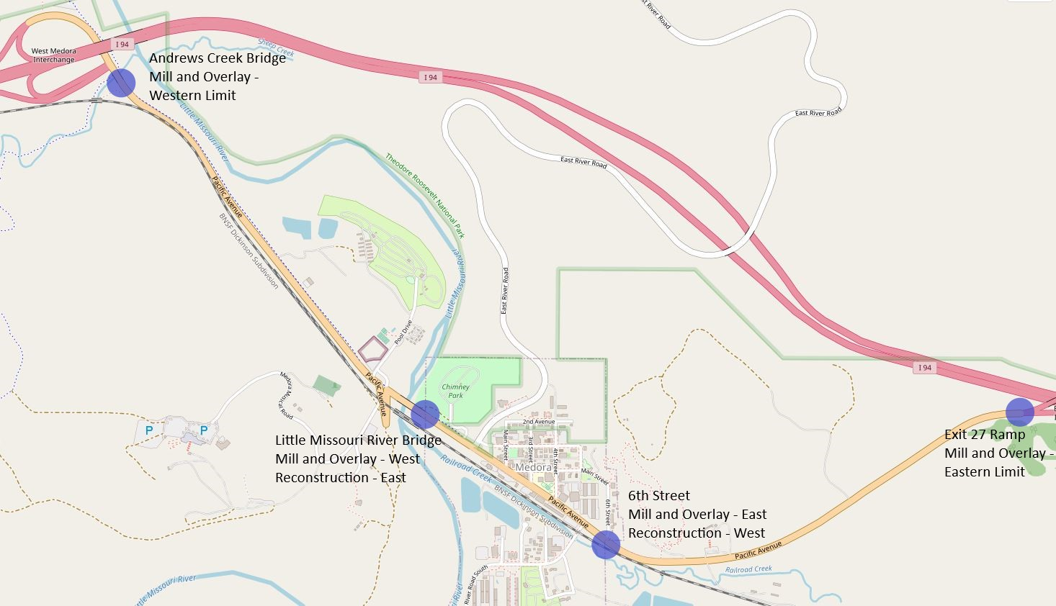

The project includes reconstruction of the city section from the Little Missouri River Bridge to 6th Street and a mill and overlay for the portion of roadway outside the city section. The Little Missouri River Bridge (Structure # 0094-901.376) will be widened to accommodate a 44 foot three-lane section and a sidewalk on the south side of the bridge and a multi-use trail on the north side of the bridge.

The NDDOT is currently completing a Medora Transportation Planning Study to evaluate concepts and alternatives for improvements along the corridor including future work not pertaining to this project. Only work on Pacific Avenue to the interstate ramps as shown above is to be included on this proposal. Much public/stakeholder outreach has taken place regarding improvements to the area, and this public/stakeholder outreach will continue as part of this project. The study is anticipated to be completed by May 1, 2023. It is anticipated that a draft report will be available and provided to the consultant upon selection, and the approved study will be provided when it is complete.

The concepts and alternatives are based on a Complete Streets approach. The proposed alternatives include roundabouts with two lanes and a flex trolley lane, and roundabouts with three lanes with sharrows and bulb-outs. The Pacific Avenue alternatives are illustrated below. The consultant, on behalf of and with guidance from the NDDOT, will work with stakeholders to explore public and private transit systems options. Decisions will be disclosed in the environmental document.

Pacific Avenue Roundabouts
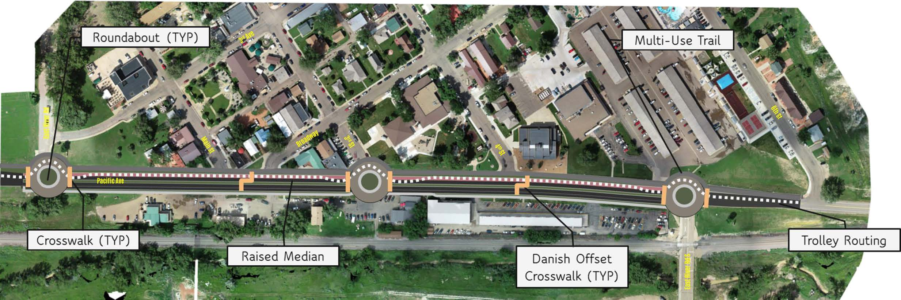

Pacific Avenue Concept 1a – Roundabouts with two lanes and flex trolley lane
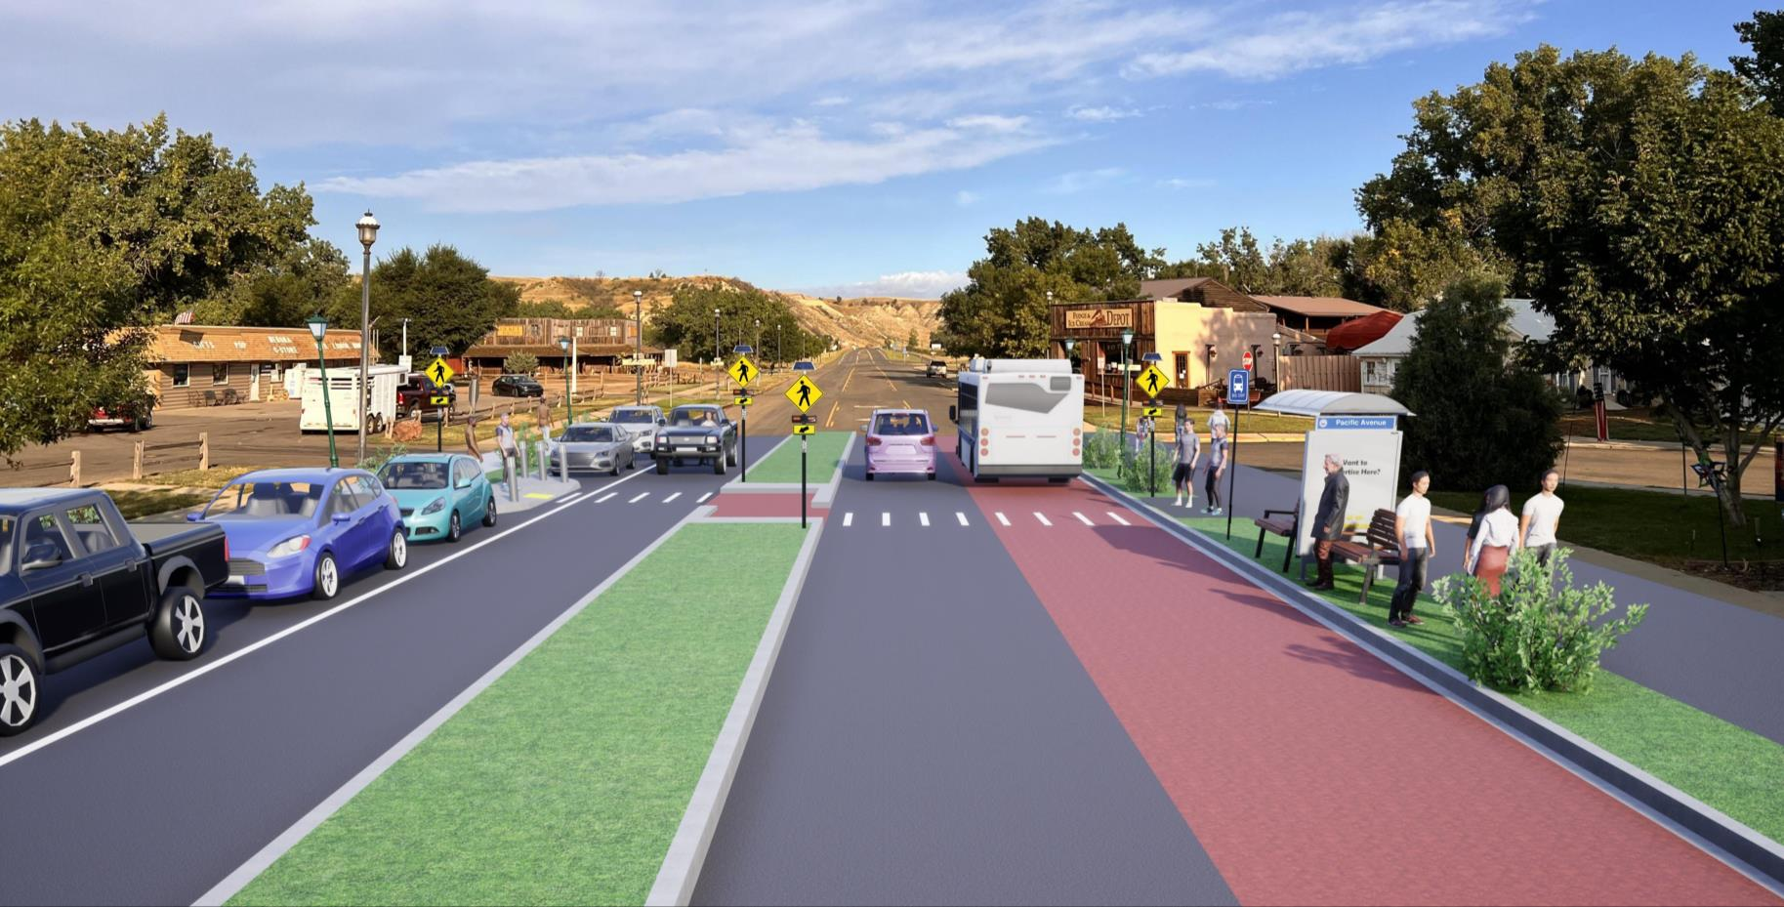

Pacific Avenue Concept 1b – Roundabouts with three lanes with sharrows and bulb-outs
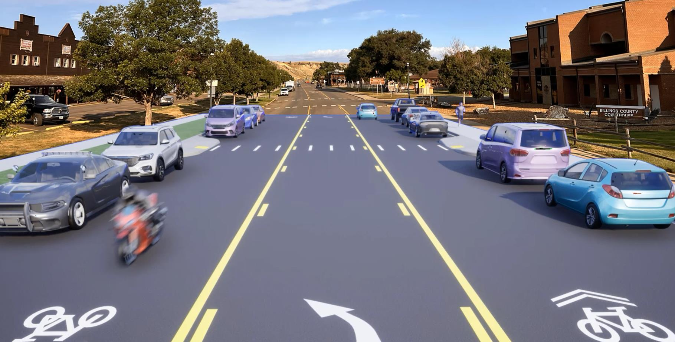

SCOPE OF SERVICES
The NDDOT is requesting roadway and bridge engineering services for all work necessary to provide environmental studies and documentation, constructability reports, preliminary engineering, preliminary and final design, permitting, right of way acquisition, and construction plans for the stated project.

The NDDOT intends to execute one cost plus fixed fee contract requiring monthly billings with the selected consultant. The NDDOT reserves the right to assign work in phases and have the selected consultant perform any additional work not initially assigned. Project work items may be added or removed from the contract by work authorization or supplement agreement.

Proposals must include a proposed public/stakeholder outreach plan, project schedule, milestone of activities, and staffing plan through project completion.

Proposals must include the consultant’s approach for maintaining the western heritage of the region through design and aesthetic concepts for this project.

Proposals must include a proposed work plan with a schedule for a final plan completion date that will accommodate a substantial completion of construction work for the soft opening of the Theodore Roosevelt Presidential Library in the Fall of 2025 and a completion of all construction work by the grand opening of July 4, 2026. The work plan must include all work activities and deliverables to be completed by the consultant and approved during scoping in Phase I. Consultants will allow 14 days for the review and/or approval of project deliverables by the NDDOT. The schedule will indicate which project phase the deliverable will begin. All deliverables must be submitted to allow time for approval from the NDDOT and all permitting agencies prior to the bid ready date. The NDDOT is not responsible for added cost or lost time for the rework of the project deliverables.
PROJECT PHASING
Phase I, Scoping
Phase I will include conducting a scoping meeting, field review, preliminary survey, and developing an approved scope of work and hours for Phase II. The scoping/field review will include a discussion of the planning study and work completed to date.

The consultant will have 30 days, from the date that the Phase I contract is executed, to conduct the scoping meeting and field review and to secure an approved scope of work and hours. A preliminary scope of work and hours shall be provided by the consultant within 21 days of signing the contract. Pending NDDOT approval of the scope of work and hours completed in Phase I, the NDDOT may authorize the consultant to perform Phase II and any additional work not currently assigned or completed in Phase I.

Following the scoping meeting and field review, the consultant will have 14 days to submit a public/stakeholder outreach plan to the NDDOT. The plan will detail a preliminary schedule, tentative agenda, and required attendees for public input/engagement meetings, stakeholder meetings, and design charettes through the entirety of the project. This report will be updated and resubmitted as part of the bi-weekly progress report.

Preliminary survey activities should be conducted for a roadway alignment, section corners, property corners, existing right of way limits, and draft existing right of way plats by June 1, 2023.

The consultant will complete a Constructability Report. The Constructability Report is intended to facilitate project decisions and define design criteria necessary to deliver a project that will accommodate a substantial completion of construction work for the soft opening of the Theodore Roosevelt Presidential Library in the Fall of 2025 and a completion of all construction work by the grand opening of July 4, 2026. The Constructability Report will include, but is not limited to, detailed analysis and planning on the following items:
- Contracting methods and timelines for bidding project components (i.e. bridge beams, bridge widening, light poles, pipe) to facilitate fabrication and construction (innovative construction concepts)
- Bridge concepts and recommendations (Hydraulic Report and widening concepts with pros and cons)
- Traffic Operations study and report
- Roundabout concepts and criteria with pros and cons.
- Construction phasing and sequence, methods of traffic control, access, and timelines (emphasis on construction sequencing to facilitate construction outside of the tourist season and maintenance of traffic and access to the adjacent businesses)
- Identify utility location and potential conflicts and relocations
- Identify city utilities including sanitary and watermain and phasing to replace if necessary
- Design and aesthetic concepts that complement the western heritage
- Coordination of public comments and decision making
- Parking alternatives and mitigation concepts

The Constructability Report must be completed by June 1, 2023.

Phase II, Environmental Document and Preliminary Design
Phase II consists of all activities necessary to complete the environmental document (including FHWA concurrence and approval), conduct public/stakeholder outreach, perform preliminary design, analyze parking and right of way and relocation impacts, and coordinate utility location and conflict plans. It is anticipated the project will require a Documented Categorical Exclusion (DCE). Environmental studies may be initiated in Phase I. Coordinate the environmental study and environmental checklist requirements with ETS Division. Phase II will be considered complete upon receiving environmental approval from FHWA and NDDOT approval of all other deliverables. Phase III may be negotiated and authorized based on the outcome of Phase II, consultant’s proposal, consultant’s performance, and available funding.

The Environmental Document must be complete and approved by September 15, 2023.

Phase III, Final Design
Phase III will consist of design activities following preliminary design and preparation of final construction plans, specifications, and estimates, final utility conflict plans for adjustments and relocations, final right of way acquisition, and final mitigation plans and permitting. Phase III will be considered complete upon delivery and approval of final construction plans, specifications, estimates, certifications, and NDDOT approval of all other deliverables. Phase IV may be negotiated and authorized based on the outcome of Phase III, consultant’s proposal, consultant’s performance, and available funding.

Parking alternatives, if necessary, will include all engineering services to complete the design of a selected parking, multi-modal alternative, and/or trolley alternative as detailed in the Medora Transportation Study. Design decisions for the corridor will affect which parking alternative is chosen. At the direction of the NDDOT, this work may begin during another project phase by supplement and work authorization request and will then be required to be included in all subsequent project schedules and reports. All parking alternatives are to be included in the environmental document, but additional design work is dependent on the chosen alternative.

The final construction plans must be complete to meet the schedule of substantial completion of construction work for the soft opening of the Theodore Roosevelt Presidential Library in the Fall of 2025 and a completion of all construction work by the grand opening of July 4, 2026.

Phase IV, Engineer of Record
Phase IV, if necessary, will consist of engineering services associated with Engineer of Record activities including, but not limited to, consultation and questions, pre-job meetings, plan revisions & change orders, and shop/work drawings. Phase IV does not include construction engineering.

Interviews will be conducted tentatively on the week of January 9, 2023.

Attached with the RFP are presentation slides from a Medora public meeting, 2017 bridge load ratings, 2021 bridge inspection report, river channel profiles, Little Missouri Bridge existing plans, a Progress Report example spreadsheet, and the Risk Management Appendix.

ProJECT Deliverables:
The list of deliverables may be modified by adding or deleting deliverables as needed.

Phase I Deliverables
- Field review meeting and report with recommendations for added work
- Pre-survey meeting and report
- Proposed work plan and work schedules for all parties
- Ground survey for section corners, roadway alignment, easements, and additional data needed for boundary survey
- Preliminary plats for existing right of way
- Public involvement/stakeholder engagement plan
- Preliminary bridge concepts and hydraulic report
- Traffic operations study and report
- Constructability Report

Phase II Deliverables
- Final Ground Survey, Process LiDAR imagery/data
- Wetland delineation survey and report
- Stream impacts and mitigation
- Utility location survey, coordination, and report
- Engineering studies – safety review, geotechnical
- Preliminary roadway design – meeting and report
- Section 106 studies and report
- Final environmental report

Phase III Deliverables
- Roadway and bridge design and plans
- Utility location and conflict plans for adjustments and relocations
• Right of way limits
• Preliminary right of way plats with existing and proposed right of way
• Right of way costs
- Right of way appraisals
- Right of way acquisition
• Final permit applications and/or agreements
• Plans in hand PS&E review
• Final plan delivery
• ROW, utility, and railroad certifications

NDDOT Deliverables:

Phase I Deliverables
- Preliminary Engineering agreement
- Aerial LiDAR/Imagery survey data collection
- Right of way title work

Phase II Deliverables
- Pavement design
- Section 106 concurrence
- Medora Transportation Planning Study
- Approve Constructability Report

Phase III Deliverables
- ROW authorization
- Right of way acquisition documents
• Utility agreements
• Cost maintenance agreement
• ROW, utility, and railroad certifications

PROJECT SUBMITTALS
All design and project data will become the property of the NDDOT upon completion of the final submittal. All project information will be generated in the following formats and standards:
- MS Word and MS Excel
- MicroStation OpenRoads Designer CE (10.10.21.04)
- NDDOT CADD Manual
- Microsoft “Project”
- NDDOT Consultant Services Manual Chapter 19
- NDDOT Procedure for Creating Right of Way Plats Manual Chapter 20
- NDDOT CADD Editing Manual Chapter 21
- NDDOT Data Collection Codes and Procedures
- NDDOT Design Manual and Plan Preparation Guide Website
- NDDOT Right of Way Manual
- Adobe Acrobat (standard or compatible)

PROJECT PROGRESS REPORTS
A bi-weekly progress report is required for all projects. The report must state the project number, PCN, the reporting period dates, and be numbered in sequential order. Detail the activities completed during the reporting period, describe issues encountered, list any added work not contemplated in the Request For Proposal or original contract, and actions required and/or directives given by the NDDOT.

The report must contain a spreadsheet style breakdown of activities. For each milestone activity and/or deliverable detail the following:
- Project status according to the NDDOT Project Status Report (PSR) reporting Section I-04.02 of the Design Manual
- Percent complete at the start of reporting period, end of reporting period, and for the next reporting period
- Projected start date
- NDDOT milestone date
- Adjusted milestone date (if applicable)
- Actual completion date
- Explanation of delays for the given activity
- Plan to correct issues and get activity back on track

A Progress Report spreadsheet example is attached to this Request For Proposal.

PROPOSED SUBCONSULTANT REQUEST
Subconsultants that have been contacted and agree to be listed on the Prime Consultants Project Proposal for work with the NDDOT must submit original form and one copy to be attached to the Prime Consultants Proposal. This form is used for informational purposes only. See the NDDOT website for form SFN 60232. http://www.dot.nd.gov/dotnet/forms/forms.aspx

PRIME CONSULTANT REQUEST TO SUBLET
The successful consultant will be required to include the attached ‘Prime Consultant Request to Sublet’ form for each subconsultant listed on the contract prior to execution of the contract. The form assures that the contract between the Prime consultant and all subconsultants contains all the pertinent provisions and requirements of the prime contract with the NDDOT. See NDDOT web site for form SFN 60233. If the Prime consultant has a DBE as a subconsultant then they will also be required to submit SFN 61412-DBE Consultant-Commercially Useful Function (CUF). https://www.dot.nd.gov/forms/sfn61412.pdf

CIVIL RIGHTS
The North Dakota Department of Transportation, in accordance with the provisions of Title VI of the Civil Rights Act of 1964 (78 Stat. 252, 42 U.S.C. §§ 2000d to 2000d-4) and the Regulations, hereby notifies all bidders that it will affirmatively ensure that any contract entered into pursuant to this advertisement, disadvantaged business enterprises will be afforded full and fair opportunity to submit bids in response to this invitation and will not be discriminated against on the grounds of race, color, or national origin in consideration for an award.

Disadvantaged Business Enterprise (DBE)
49 Code of Federal Regulations Part 26 (CFR) states that the consultant, subrecipient, or subconsultant shall not discriminate on the basis of race, color, national origin, or sex in the performance of this contract. Consultants shall carry out applicable requirements of 49 CFR Part 26 in the solicitation, award, and administration of USDOT-assisted contracts. Failure by the consultant, to carry out these requirements is a material breach of the contract, which may result in the termination of the contract or such other remedy as the recipient deems appropriate. For information regarding the DBE Program, see the DBE Program Manual at http://www.dot.nd.gov/divisions/civilrights/docs/dbe/dbe-program-admin-manual.pdf

Title VI/Nondiscrimination and ADA
Title VI assures that no person or group of persons may, on the grounds of race, color, national origin, sex, age, or disability, be excluded from participation in, be denied the benefits of, or be otherwise subjected to discrimination under any and all programs or activities administered by the Department. For information regarding Title VI, see the Title VI/Nondiscrimination and ADA Program at https://www.dot.nd.gov/divisions/civilrights/docs/titlevi/Title-VI-Nondiscrimination-ADA-Program-Implementation-Plan.pdf

The two paragraphs above apply to every consultant on the project, including every tier of subconsultant. It is the consultant’s, or subconsultant’s responsibility to include the two above paragraphs in every subcontract.

RIGHT OF WAY (If needed)

Scope of Work
Project Coordination
- Prior to commencing valuation work, a preliminary meeting will be held with the consultant and the NDDOT Review Appraiser. A Preliminary Valuation Review form must be completed for every project requiring an Appraisal, Waiver Valuation, Short Form Report and/or Basic Data Book. http://www.dot.nd.gov/forms/sfn61346.pdf

- Prior to commencing initial right of way work, a preliminary meeting will be held with the consultant, sub consultant (negotiator), NDDOT ROW tech support, NDDOT Design tech support, NDDOT Designer and any additional participants as needed. This will include reviewing forms, package submission, process review and reporting requirements.

- Prior to commencing right of way relocations, a preliminary meeting will be held with the consultant, sub consultant (relocation officer), NDDOT ROW tech support, NDDOT Design tech support, NDDOT Designer and any additional participants as needed. This will include reviewing education, experience, and process to conduct relocations.

Consultant’s proposal
Appendix
Any consultant or sub consultant performing right of way acquisition negotiations and/or relocations must submit a biography, including a certificate of completion for the following class:

FHWA – NHI Course # 141045, Real Estate Acquisition under the Uniform Act: An Overview
(https://www.nhi.fhwa.dot.gov/training/course_search.aspx?sf=0&course_no=141045)

Please refer to the attached biography as a referenced example.
https://www.dot.nd.gov/divisions/environmental/docs/RFP%20Biography.pdf

EVALUATION AND SELECTION PROCESS
Consultants interested in performing the work must submit one electronic copy in PDF format. The electronic copy must be submitted prior to the date and time listed on the cover of this RFP to be considered. Late proposals will not be considered.

Submit proposals by email to:
Andy Ayash aayash@nd.gov with copies to Joy Glasoe jglasoe@nd.gov and Chad Taylor cataylor@nd.gov.

- Each proposal must contain a cover letter signed by an authorized officer who can sign contracts for the consultant. The pages of the cover letter will not be counted as a part of the pages. Also include the individuals email address below each signature on the cover letter.

- The proposal pages must be numbered and must be limited to 5 pages in length. Proposals that exceed the page length requirement will not be considered. This section should contain your approach and project specific plan.

- The consultant’s proposal shall include an appendix. The appendix may include updated Federal form 330 if you do not have one on file with CAS. The pages in the appendix will not be counted as a part of the pages. The appendix shall include the following in this order:

Appendix A
  - A schedule/milestone for the project. The schedule will be included as part of the contract.

Appendix B
  - A staffing plan identifying the key project personnel (including titles, education, and work experience) and the respective roles and responsibilities for the project.

Appendix C
  - Project Specific QC/QA Plan including check lists, persons, responsibilities, proposed submittals and reviews, and DOT response timelines. The QC/QA Plan will be reviewed by the NDDOT and become part of the project after the contract has been signed.

Appendix D
  - Subconsultants and associated activities to be completed by the subconsultants. Attach proposed sublet form SFN 60232 for each sub at the end of this section.

Each proposal will be evaluated by a selection committee consisting of NDDOT staff members and/or representatives. NDDOT reserves the right to limit the interviews to a minimum of three consultants whose proposals most clearly meet the RFP requirements. Consultants not selected to be interviewed will be notified in writing.

Selection will be based on the following weighted criteria:

Weight
- __10%__ i. Past performance
- __15%__ ii. Ability of professional personnel
- __10%__ iii. Willingness to meet time and budget requirements
- __ 5%__ iv. Location
- __10%__ v. Recent, current, and projected workloads of the persons/consultants
- __15%__ vi. Related experience on similar projects
- __10%__ vii. Recent and current work for the agency
- __25%__ viii. Project understanding, issues, and approach
- ___5%__ ix. DBE: Up to 5 points for utilizing DBE’s in case of tied scores

Weights for each criterion are assigned independently for each specific project by CAS and the
Project Technical Representative. Maximum total weight is 100 points. Five additional points
may be awarded for good faith efforts to utilize DBE’s in the event of a tie.

Consultants are strongly encouraged to use DBE subconsultant services where applicable. The proposal must contain a list of any tasks that may be let to subconsultants should the consultant be awarded the contract. It must also contain the specific good faith efforts made by the consultant, to achieve DBE participation, in the areas intended for subconsultants.

Consultant interviews will include questions regarding good faith efforts (see 49 CFR Part 26, Appendix A: Guidance Concerning Good Faith Efforts, Paragraph IV. A-H) to achieve DBE participation. DBE participation will be a consideration during the negotiation stage of each contract.

PROMPT PAYMENT
Consultants will be required to make prompt payment to subconsultants as required by 49 CFR 26.29. The Consultant must make payment to all subconsultants within thirty (30) calendar days from receipt of payment from the State. Such payment must be certified by the Consultant by submittal of the subsequent Consultant Contract Billing Form to the State. The State may withhold subsequent payment(s) to the Consultant if any subconsultants have not been paid for work satisfactorily completed.

RIGHT OF REJECTION
The North Dakota Department of Transportation reserves the right to reject any or all proposals.

DISCLOSURE OF PROPOSAL
At the conclusion of the selection process, the contents of the short-listed proposals will be subject to North Dakota's Open Records Law and may be open to inspection by interested parties. Any information included in the proposal that the proposing party believes to be a trade secret or proprietary information must be clearly identified in the proposal. Any identified information recognized as such and protected by law may be exempt from disclosure.

RISK MANAGEMENT FOR PROFESSIONAL SERVICES
The Risk Management Appendix/Addendum will be incorporated into the agreement between NDDOT and the consultant. Consultants must be able to provide a proper Certificate of Insurance within 15 days of notification of Selection.

AUDIT
Consultants proposing to do work for the NDDOT must have a current audit rate no older than 12 months from the close of the consultant’s Fiscal Year. Consultants that do not meet this requirement will not qualify to propose or contract for NDDOT projects until the requirement is met. Consultants that have submitted all the necessary information to the NDDOT and are waiting for the completion of the audit will be qualified to submit proposals for work. Information submitted by a consultant that is incomplete will not qualify. Out of state consultants can submit a current accepted FARS audit rate from a cognizant agency. Under certain conditions NDDOT may offer a Safe Harbor Rate of 110% to consultants that do not have a compliant rate.

CONSULTANT EMAIL CONTACTS
If necessary, please update contact information for receiving emails and phone calls.

