REQUEST FOR PROPOSAL
NOVEMBER 17, 2022

TO PERFORM
PRELIMINARY ENGINEERING SERVICES
FOR PROJECT:

Project SU-6-986-(137) PCN 23646
gRAND fORKS columbia road overpass
City Project #8557

PROPOSALS MUST BE DELIVERED TO
CHRISTIAN DANIELSON
CITY OF GRAND FORKS ENGINEERING DEPARTMENT
By
4:00 PM Central Time DeCEMBER 9, 2022

REQUEST FOR PROPOSAL

PROJECT OVERVIEW

The city of Grand Forks is requesting the services of qualified engineering consultant to perform engineering and affiliated services to complete the following project.

Project SU-6-986(137) PCN: 23646, Columbia Road Overpass Rehabilitation, located in Grand Forks, North Dakota.

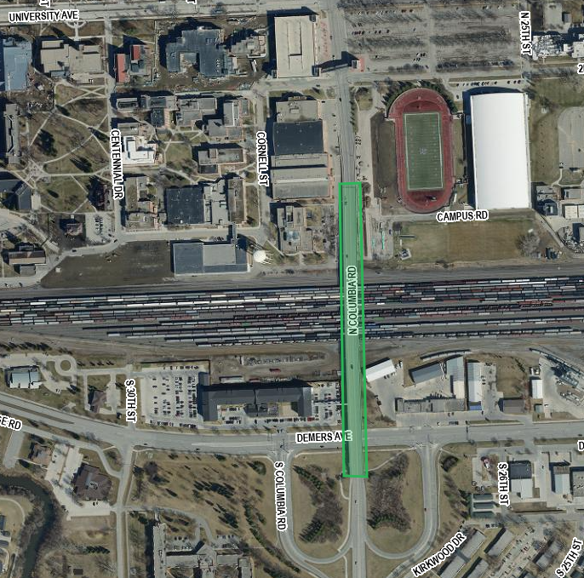
North

SCOPE OF SERVICES
The City of Grand Forks is requesting roadway design and structure design services for all work necessary to provide environmental studies and documentation, preliminary engineering, right of way acquisition, permitting, roadway and bridge structure design and final design with construction plans for the stated project. The project includes rehabilitation of the bridge overpass approximately 0.4 miles in length in the City of Grand Forks, North Dakota.

The City of Grand Forks intends to select one consultant and to execute a cost-plus fixed fee contract requiring monthly billings to complete the proposed work. The contract is for environmental studies and documents, final roadway and structure design, construction plans and engineer of record responsibilities.

Each proposal shall include a proposed work plan and work schedule for the project. The work plan shall identify the major work activities and deliverables for both the consultant and City of Grand Forks. The work schedule shall identify the project deliverables and critical milestone dates.

The City of Grand Forks reserves the right to assign work in phases and have the consultant selected perform any additional work not currently assigned. Project work items may be added or removed from the contract by work authorization or supplementary agreement.

The consultant shall allow 14 days for the review and/or approval of project deliverables by the City and NDDOT. All deliverables shall be submitted in a manner to allow for review and decisions by the City and NDDOT, and submission to and receipt from third parties and permitting agencies, as applicable, by the proposed bid ready date. The City and NDDOT shall not be responsible for added cost or lost time for the rework of the project deliverables.

The project must be completed on or before the Bid Ready Date of August 18, 2023.

ProJECT DELIVERABLES
The list of deliverables may be modified by adding or deleting deliverables as needed.

Preliminary Engineering Deliverables
• Field review meeting and report with recommendations for added work
• Pre-survey meeting and report
• Proposed work plan and work schedules for all parties

Environmental Document Deliverables
- Finalize wetland delineation survey and report
- Utility location survey, coordination, and report
- Type, Size, and Location (TS&L) report for structure
- Preliminary design and construction alternative meeting
- Public involvement materials and report
- Finalize Engineering/Environmental Surveys/Studies/Reports (safety review, traffic operations as needed, section 106 survey and report, utility coordination and engineering, roadway/structure hydraulics, geotechnical surveys and reports)
• Environmental document

Final Design Deliverables
- Utility conflict plans
- Preliminary right of way listing and cost estimates
- Right of way plats, appraisals, negotiation, and acquisitions (as needed)
- Final permit applications and agreements
- Cost estimates and cost participation information
- Plans in hand PS&E review
- Final plan delivery
- ROW, utility, and railroad certifications

Engineer of Record:
Engineer of Record responsibilities shall consist of engineering services associated with Engineer of Record activities including, but not limited to, consultation and questions, pre-job meetings, plan revisions and change orders, and shop drawings. This contract does not include construction engineering.

Consultants interested in performing the work must be qualified to perform roadway and structural design.

Interviews will be conducted tentatively 14 days from the due date of this proposal.

Attached with the RFP is a Risk Management Appendix.

PROJECT SUBMITTALS
All design and project data will become the property of the City upon completion of the final submittal. All project information will be generated in the following formats and standards:

- MS Word and MS Excel
- MircoStation SS4 (8.11.09.832) or SS10 (8.11.09.919)
- Geopak SS4 (8.11.09.903) or SS10 (8.11.09.918)
- NDDOT CADD Manual
- Microsoft “Project”
- NDDOT Consultant Services Manual Chapter 19
- NDDOT Procedure for Creating Right of Way Plats Manual Chapter 20
- NDDOT CADD Editing Manual Chapter 21
- NDDOT Data Collection Codes and Procedures
- NDDOT Design Manual and Plan Preparation Guide Website
- NDDOT Right of Way Manual
- Adobe Acrobat (standard or compatible)

Alternative formats may be used so long as they are easily convertible to those listed above and approved by the City prior to use.

PROJECT PROGRESS REPORTS
A bi-weekly progress report is required for all projects. The report must state the project number, PCN, the reporting period dates, and be numbered in sequential order. Detail the activities completed during the reporting period, describe issues encountered, list any added work not contemplated in the Request For Proposal or original contract, and actions required and/or directives given by the NDDOT or The City of Grand forks.

The report must contain a spreadsheet style breakdown of activities. For each milestone activity and/or deliverable detail the following:
- Project status according to the NDDOT Project Status Report (PSR) reporting Section I-04.02 of the Design Manual
- Percent complete at the start of reporting period, end of reporting period, and for the next reporting period
- Projected start date
- Milestone date
- Actual completion date
- Explanation of delays for the given activity
- Plan to correct issues and get activity back on track

A Progress Report spreadsheet example is attached to this Request for Proposal.

PROJECT SCHEDULE
The environmental document, rehabilitation design, and construction plans shall be completed on or before the bid ready date identified above. Work shall be in accordance to the approved schedule identifying the project deliverables, critical milestone dates, and bid ready date.

PROPOSED SUBCONSULTANT REQUEST
Subconsultant firms that have been contacted and agree to be listed on the Prime Consultants Project Proposal for work with the City must submit original form and one copy to be attached to the Prime Consultants Proposal. This form is used for informational purposes only. See NDDOT web site for form SFN 60232. http://www.dot.nd.gov/dotnet/forms/forms.aspx

PRIME CONSULTANT REQUEST TO SUBLET
The successful consultant will be required to include the attached ‘Prime Consultant Request to Sublet’ form for each subconsultant listed on the contract prior to execution of the contract. The form assures that the contract between the Prime consultant and all subconsultants contains all the pertinent provisions and requirements of the prime contract with the North Dakota Department of Transportation (NDDOT) and City. See NDDOT web site for form SFN 60233. If the Prime consultant has a DBE as a subconsultant then they will also be required to submit SFN 61412-DBE Consultant-Commercially Useful Function (CUF) https://www.dot.nd.gov/forms/sfn61412.pdf

CIVIL RIGHTS
The North Dakota Department of Transportation and City, in accordance with the provisions of Title VI of the Civil Rights Act of 1964 (78 Stat. 252, 42 US.C.§§ 2000d to 2000d-4) and the Regulations, hereby notifies all bidders that it will affirmatively ensure that any contract entered into pursuant to this advertisement, disadvantaged business enterprises will be afforded full and fair opportunity to submit bids in response to this invitation and will not be discriminated against on the grounds of race, color, or national origin in consideration for an award.

Disadvantaged Business Enterprise (DBE)
49 Code of Federal Regulations Part 26 (CFR) states that the consultant, subrecipient, or subconsultant shall not discriminate on the basis of race, color, national origin, or sex in the performance of this contract. Consultants shall carry out applicable requirements of 49 CFR Part 26 in the solicitation, award, and administration of USDOT-assisted contracts. Failure by the consultant, to carry out these requirements is a material breach of the contract, which may result in the termination of the contract or such other remedy as the recipient deems appropriate. For information regarding the DBE Program, see the DBE Program Manual at http://www.dot.nd.gov/divisions/civilrights/docs/dbe/dbe-program-admin-manual.pdf

Title VI/Nondiscrimination and ADA
Title VI assures that no person or group of persons may, on the grounds of race, color, national origin, sex, age, or disability, be excluded from participation in, be denied the benefits of, or be otherwise subjected to discrimination under any and all programs or activities administered by the Department and City. For information regarding Title VI, see the Title VI/Nondiscrimination and ADA Program at https://www.dot.nd.gov/divisions/civilrights/docs/titlevi/Title-VI-Nondiscrimination-ADA-Program-Implementation-Plan.pdf

The two paragraphs above apply to every consultant on the project, including every tier of subconsultant. It is the consultant’s, or subconsultant’s responsibility to include the two above paragraphs in every subcontract.

Consultant proposal
Appendix
Any consultant or subconsultant performing right of way acquisition negotiations must submit a biography, including a certificate of completion for the following class:

FHWA – NHI Course # 141045, Real Estate Acquisition under the Uniform Act: An Overview
(https://www.nhi.fhwa.dot.gov/training/course_search.aspx?sf=0&course_no=141045)

Please refer to the attached biography as a referenced example.
https://www.dot.nd.gov/divisions/environmental/docs/RFP%20Biography.pdf

EVALUATION AND SELECTION PROCESS
Consultants interested in performing the work must submit one electronic copy in PDF format. The electronic copy must be submitted prior to the date and time listed on the cover of this RFP to be considered. Late proposals will not be considered.

Proposals shall be submitted by email to:
Christian Danielson Cdanielson@grandforksgov.com

- Each proposal shall contain a cover letter signed by an authorized officer who can sign contracts for the consultant. The pages of the cover letter will not be counted as a part of the pages. Also include the individuals email address below each signature on the cover letter.

- The proposal pages shall be numbered and must be limited to 5 pages in length. Proposals that exceed the page length requirement will not be considered. This section should contain your approach and project specific plan.

- The consultant’s proposal shall include an appendix. The appendix may include updated Federal form 330 if you do not have one on file with NDDOT or the City. The pages in the appendix will not be counted as a part of the pages. The appendix shall include the following in this order:
Appendix A
  - A schedule/milestone for the project. The schedule will be included as part of the contract.
Appendix B
  - A staffing plan identifying the key project personnel (including titles, education, and related work experience) and the respective roles and responsibilities for the project.
Appendix C
  - Submit a list of five projects of similar work completed in the last four years that demonstrates experience with this type of project. (list owner, type of work, and the key personnel involved).
Appendix D
  - Project Specific QC/QA Plan including check lists, persons, responsibilities, proposed submittals and reviews, and DOT response timelines. The QC/QA Plan will be reviewed by the NDDOT and become part of the project after the contract has been signed.
Appendix E
  - Subconsultants and associated activities to be completed by the subconsultants. Attach proposed sublet form SFN 60232 for each sub at the end of this section.

Each proposal will be evaluated by a selection committee consisting of City of Grand Forks and NDDOT staff members and/or representatives. NDDOT and The City of Grand Forks reserves the right to limit the interviews to a minimum of three consultants whose proposals most clearly meet the RFP requirements. Consultants not selected to be interviewed will be notified in writing.

Selection will be on the basis of the following weighted criteria:

Weight

- __10%__ i. Past performance
- __10%__ ii. Ability of professional personnel
- __15%__ iii. Willingness to meet time and budget requirements
- ___5%__ iv. Location
- __10%__ v. Recent, current, and projected workloads of the persons/consultants
- __10%__ vi. Related experience on similar projects
- __10%__ vii. Recent and current work for the agency
- __30%__ viii. Project understanding, issues, and approach
- ___5%__ ix. DBE: Up to 5 points for utilizing DBE’s in case of tied scores

Weights for each criterion are assigned independently for each specific project. Maximum total weight is 100 points. 5 additional points
may be awarded for good faith efforts to utilize DBE’s in the event of a tie.

Consultants are strongly encouraged to use DBE subconsultant services where applicable. The proposal must contain a list of any tasks that may be let to subconsultants should the consultant be awarded the contract. It must also contain the specific good faith efforts made by the consultant, to achieve DBE participation, in the areas intended for subconsulting. Consultant interviews will include questions regarding good faith efforts (see 49 CFR Part 26, Appendix A: Guidance Concerning Good Faith Efforts, Paragraph IV. A-H) to achieve DBE participation. DBE participation will be a consideration during the negotiation stage of each contract.

PROMPT PAYMENT
Consultants will be required to make prompt payment to subconsultants as required by 49 CFR 26.29. The Consultant shall make payment to all subconsultants within thirty (30) calendar days from receipt of payment from the State. Such payment shall be certified by the Consultant by submittal of the subsequent Consultant Contract Billing Form to the State. The State may withhold subsequent payment(s) to the Consultant if any subconsultants have not been paid for work satisfactorily completed.

RIGHT OF REJECTION
The North Dakota Department of Transportation and The City of Grand Forks reserve the right to reject any or all proposals.

DISCLOSURE OF PROPOSAL
At the conclusion of the selection process, the contents of the short-listed proposals will be subject to North Dakota's Open Records Law and may be open to inspection by interested parties. Any information included in the proposal that the proposing party believes to be a trade secret or proprietary information must be clearly identified in the proposal. Any identified information recognized as such and protected by law may be exempt from disclosure.

RISK MANAGEMENT FOR PROFESSIONAL SERVICES
The Risk Management Appendix/Addendum will be incorporated into the agreement between NDDOT, the City and the consultant. Consultants must be able to provide a proper Certificate of Insurance within 15 days of notification of Selection.

AUDIT
Consulting firms proposing to do work for the City and NDDOT must have a current audit rate no older than 12 months from the close of the consultant’s Fiscal Year. Consultants that do not meet this requirement will not qualify to propose or contract for NDDOT projects until the requirement is met. Consultants that have submitted all the necessary information to the NDDOT and are waiting for the completion of the audit will be qualified to submit proposals for work. Information submitted by a consultant that is incomplete will not qualify. Out of state consultants can submit a current accepted FARS audit rate from a cognizant agency. Under certain conditions NDDOT may offer a Safe Harbor Rate of 110% to consultants that do not have a compliant rate.

